**C3**

**FT/HT:**

3) When zinc reacts with sulphuric acid hydrogen gas forms. During an experiment on this the following results were obtained.

|  |  |  |  |  |  |  |
| --- | --- | --- | --- | --- | --- | --- |
| **Volume of hydrogen (cm3)** | 21 | 38 | 51 | 58 | 60 | 60 |
| **Time (minutes)** | 2 | 4 | 6 | 8 | 10 | 12 |

a) Plot a graph of these results. (5).

b) From the graph estimate i) the volume of gas formed after 1 minute. (1).

ii) the volume of gas after 5 minutes. (1).

iii) the time taken to collect 45cm3 of gas. (1).

c) How long does it take for all the zinc to be used up? (1).

**FT/HT:**

4) Which of the following would **NOT** speed up the reaction of calcium carbonate & hydrochloric acid:

A) Increasing the temperature 20oC to 40oC. B) Grinding up the calcium carbonate.

C) Putting it in a bigger beaker. D) Using more concentrated acids.

E) Adding lead carbonate.

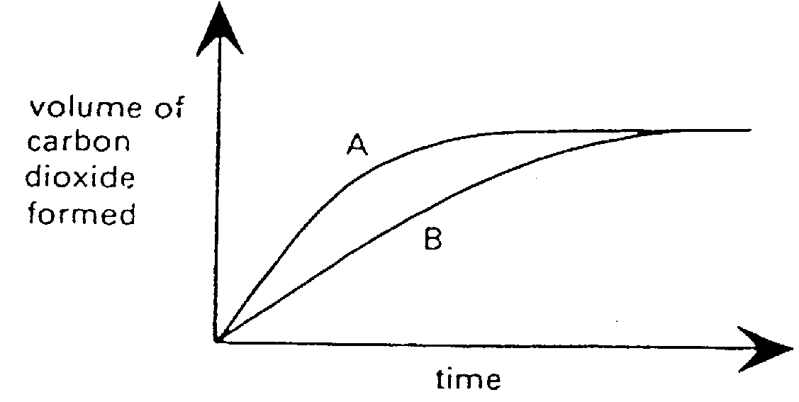

**FT/HT:**

5) Calcium carbonate reacts with hydrochloric

acid to form carbon dioxide gas. In experiment

1 a lump of calcium carbonate was allowed to

react with 50cm3 of acid & the volume of carbon

dioxide plotted at various time intervals.

Experiment 2 was a repeat of experiment 1. The

**ONLY difference** was that powdered calcium

carbonate was used in experiment 2.

a) Which of the curves is the results of experiment 1? **Give a reason** for your answer. (2).

b) Assuming that there is calcium carbonate left over at the end of both the experiments, explain: i) **Why** the speed of both reactions gets slower & slower. (1).

ii) **How you can tell** from the graph that the same amount of acid was used in both

experiments. (1).

**FT/HT:**

6) Three separate experiments were performed in which magnesium ribbon was allowed to

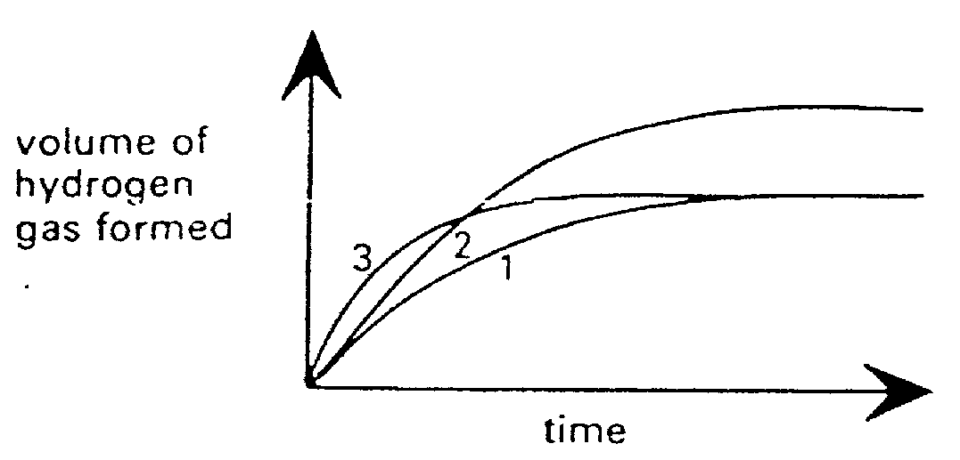

react with **EXCESS** hydrochloric acid. The

volume of hydrogen formed at different

times was plotted on a graph.

a) In which experiment was the most concentrated

hydrochloric acid used? **Explain** how you know this.(2)

b) In which experiment was the greatest amount of

magnesium ribbon used? **Give a reason** for your for

your answer. (2).

**FT/HT:**

7) **Explain why**:

1. Magnesium ribbon reacts faster with concentrated hydrochloric acid than dilute hydrochloric acid. (2).
2. Magnesium powder reacts faster than magnesium ribbon. (2).
3. Both of the above react even faster if they are heated. (2).

10) "When potassium chlorate is heated, oxygen is given off much more quickly if manganese (IV) oxide is used as a catalyst".

a) What is a catalyst? (2).

b) A catalyst is not supposed to be used up during a reaction. If manganese (IV) oxide is the only insoluble chemical here, suggest how you could prove that this was true. (3)

13) The enzyme catalase catalyses the decomposition of hydrogen peroxide to oxygen gas & water. In an investigation into the activity of the enzyme at 20oC, 0.1g was added to a known amount of hydrogen peroxide. The volume of oxygen produced was measured every minute & the results plotted on the left-hand graph below.

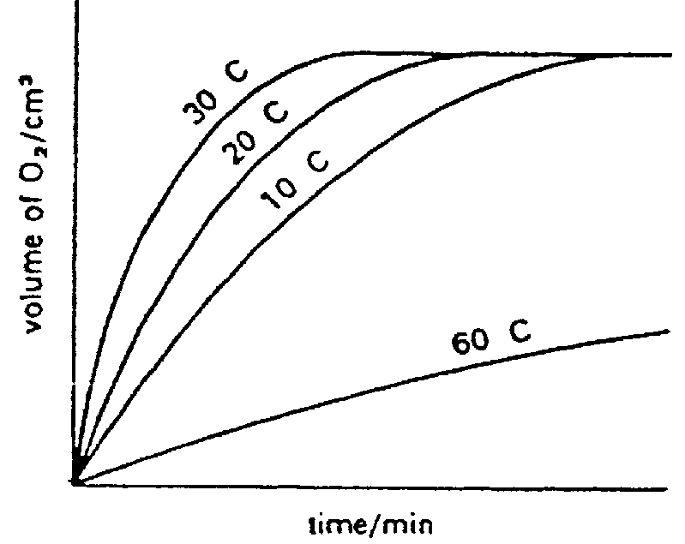

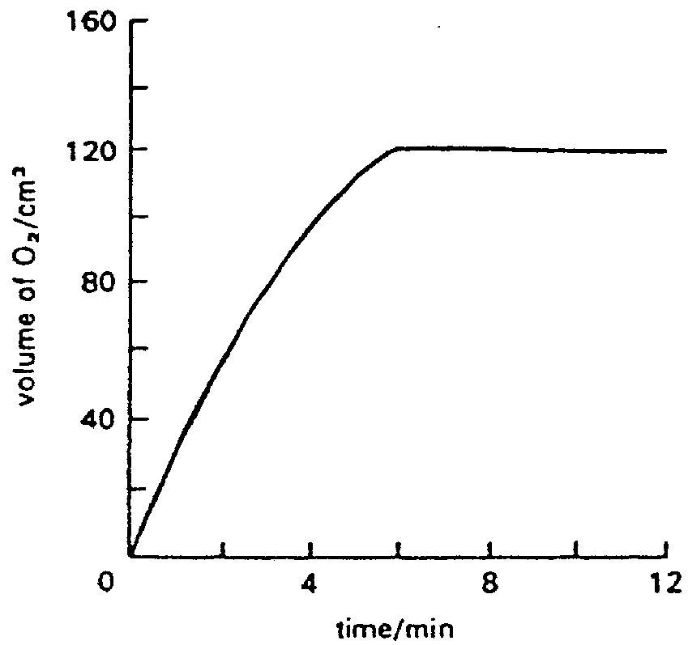

i) On the graph above add on the line you would expect if the reaction had been done with no enzyme. (Assume that the reaction was finished after 12 minutes). (2)

ii) What would be the final volume of oxygen produced a) in the catalysed reaction & b) in the uncatalysed reaction? (2)

iii) What mass of enzyme would remain at the end of the catalysed reaction? (1)

iv) The effect of temperature on the enzyme catalysed reaction was now studied & the results are shown on the right-hand graph. Explain why the result at 60oC is so different from the others. (2)

v) Iron(II) sulphate can also catalyse this reaction. The activation energies are as follows:

**Activation energy**

**Compound for reaction (KJ)**

No catalyst 75

Iron (II) sulphate 49

Catalase 7.1

Which appears to be the most efficient catalyst? **Explain** your reasoning. (2)

**FT/HT:**

50) Calculate the formula mass of each of the following:

a) Cl2, b) SO2, c) Na2CO3, d) CuO, e) Zn(NO3) 2,

f) CaCl2, g) MgCO3 h) MnO2, i) C2H6, j) C2H4O2. (10).

**FT/HT:**

58) Fe + CuSO4 **** FeSO4 + Cu

1. How many grammes of iron are needed to form 8g of copper? (4).
2. What mass of iron sulphate will form from 28g of iron? (4).
3. What mass of copper sulphate will be needed to react with 14g of iron? (4).
4. What mass of iron sulphate can be made from 16g of copper sulphate? (4).

**FT/HT:**

68)

a) Epsom salts is MgSO4.7H2O. This means each magnesium sulphate has 7 water molecules **attached to it**. Calculate the percentage of **water** in epsom salts. (2)

b) Copper sulphate is similar CuSO4.5H2O. Calculate the percentage of water in copper sulphate. (2)

**C4**

6. The following table lists the properties of five elements. The letters used are not the symbols for the elements.

|  |  |  |  |  |
| --- | --- | --- | --- | --- |
| Element | Solubility in water | Melting Point (oC) | Conduct electricity? | Conduct heat? |
| A  B  C  D  E | Reacts  Soluble  Insoluble  Insoluble  Insoluble | 39  -101  113  -39  -157 | Yes  No  No  Yes  No | Good  Poor  Poor  Good  Poor |

a) Which of the elements are metals?

b) Which of the non-metals are gases at room temperature (25 oC)?

c) Which of the elements is mercury?

d) Which element has the highest melting point?

10. (a) Name the **two** particles that are found in the nucleus of an atom.

1. Name the particle found in an atom that is **not** found in the nucleus
2. (a) Copy and complete using the words in bold:

## **identical Dalton’s compounds different mass particles**

______ atomic theory explained why there are different elements using the following ideas:-

* Elements are made up of small, indestructible _________ which can be called atoms
* Atoms of a particular element are ________, for example in size and ____
* Atoms of different elements are _________
* _________ are formed by atoms of different elements joining together

(b) Dalton’s ideas also explained other important scientific observations of the eighteenth century. Scientists had noticed that there was never any change in mass when a chemical reaction occurs in a closed container. Explain this observation using Dalton’s ideas.

12. Copy and complete this table.

|  |  |  |
| --- | --- | --- |
| Particle | Mass | Charge |
| Electron | nearly 0 |  |
|  | 1 | 0 |
| Proton |  | +1 |

14. Choose words from the list to fill in the missing gaps in the following passage (you can use each word more than once):

**electrons isotope protons neutrons nucleus**

All atoms are made up of a small dense ___(a)__ surrounded by shells containing ___(b)__ . Most atoms contain three different types of particle ___(d)__ ,___(e)__ and ___(f)__ . ___(g)__ are positively charged, ___(h)__ are negatively charged and ___(i)__ are uncharged. The lightest of these is the ___(j)__ . All atoms of the same element contain the same number of ___(k)__ and ___(l)__ . Atoms of the same element with different numbers of neutrons are known as ___(m)__ .

15. Copy and complete the following sentences, choosing the correct words form this list:

**atoms electrons ions molecules neutrons**

a) A sample of water contains many millions of H2O________ .

b) ________ always carry negative charge.

c) ________ are found in atomic nuclei.

d) Positively or negatively charged particles are called ________ .

16. a) what is meant by:

i) the proton number,

ii) the mass number,

b) Copy and complete the following table.

|  |  |  |  |  |
| --- | --- | --- | --- | --- |
| Name of element | Proton number | Mass number | Number of protons | Number of neutrons |
| sulphur  chlorine  iron  sodium  bromine  oxygen  aluminium  magnesium | 16  26  8  12 | 32  23  80  27  24 | 17  11  13 | 18  30  45  8 |

17. Atoms of the same element containing different numbers of neutrons are called __________.

18. Draw diagrams to represent the atoms of the following elements:

a) Lithium b) Carbon

c) Oxygen d) Sodium

23. There are **two** common isotopes of chlorine.

35-chlorine atomic no. = 17 mass no. = 35

37-chlorine atomic no. = 17 mass no. = 37

(a) How many protons does each atom of the two isotopes have?

(b) How many electrons does each atom of the two isotopes have?

(c) How many neutrons does each atom of the two isotopes have?

(d) Write down a definition of what an isotope is.

29. Use the information in the table below to answer the following question.

|  |  |  |  |
| --- | --- | --- | --- |
| Particle | No.of protons | No.of neutrons | No.of electrons |
| A | 17 | 18 | 17 |
| B | 11 | 12 | 10 |
| C | 10 | 10 | 10 |
| D | 8 | 8 | 10 |
| E | 17 | 20 | 17 |
| F | 12 | 12 | 12 |
| G | 16 | 16 | 16 |

(a) Which particle has more protons than electrons?

(b) Which particle has more electrons than protons?

(c) Which is the heaviest particle?

(d) Which is the lightest particle?

(e) Name two particles that are neutral atoms.

(f) Which of the particles is an atom with two electrons in its outer level?

(g) Which of the particles is an atom with six electrons in its outer level?

(h) Which of the particles is negatively charged?

(i) Which of the particles is positively charged?

1. Which of the particles are isotopes of the same element?
2. Copy and complete using the words in bold:

**Ions Shared Gains Shells Charged Gained Electrons Noble gas Loses**

Chemical reactions involve electrons from the outer s_____ of the atoms involved being lost, ______ or ______. When atoms react by gaining and losing _________ they become electrically _______ and are known as ____. Ions have the electronic structure of a _________. Positive ions form when an atom _____ electrons and negative ions form when an atom _____ electrons.

31. Sodium chloride (NaCl) is a solid with a high melting point. Carbon tetrachloride (CCl4) is a volatile liquid which is used in industry as a solvent.

a) In which group of the periodic table is:

i) sodium? ii) carbon?

b) The electron arrangement of a carbon atom can be written as 2.4. What is the electron arrangement of:

i) sodium ii) chlorine

c) What type of bonding is present in:

i) sodium chloride ii) carbon tetrachloride?

32. A sodium atom contains 11 electrons. Chlorine atoms contain 17 electrons.

(a) Draw diagrams to show the arrangement of electrons in .....

(i) a sodium atom (ii) a chlorine atom

1. Draw a diagram to show the electron arrangements in the compounds (include brackets and charges):
2. sodium chloride ii) magnesium oxide
3. calcium chloride iv) aluminium oxide

(c) For the compounds in (b) give the number version of the electron arrangements for the ions (include brackets and charges again).

33. Draw diagrams to show the arrangement of electrons in the following particles (include brackets and charges where appropriate).

(a) a magnesium atom (b) a carbon atom

(c) a sodium ion (Na+) (d) an oxide ion (O2-)

(e) a magnesium ion (f) an aluminium ion

(g) a hydrogen atom (h) a hydrogen ion

38. Look at this table and answer the following questions.

|  |  |
| --- | --- |
| Element | Electron arrangement |
| A | 2.8.2 |
| B | 2.8.4 |
| C | 2.8.6 |
| D | 2.8.8 |

(a) In which groups of the periodic table would you find each element?

(b) Which element will form a 2+ ion?

(c) Which element will form a 2- ion?

(d) Which element does not form any compounds?

(e) Which of the two elements will react to form an ionic compound?

43. Draw ‘dot & cross’ diagrams for the following ionic compounds.

(a) potassium fluoride (KF) (b) lithium oxide (LiO)

(c) magnesium sulphide (MgS) (d) sodium sulphide (Na2S)

(e) aluminium fluoride (AlF3)

44. Draw ‘dot & cross’ diagrams for the following covalent compounds.

(a) hydrogen chloride (HCl) (b) ammonia (NH3)

(c) carbon tetrachloride (CCl4) (d) phosphorus trifluoride (PF3)

(e) nitrogen (N2) (e) boron oxide (B2O3)

48. The following table lists some properties of the five substances **V** - **Z**.

|  |  |  |  |  |  |
| --- | --- | --- | --- | --- | --- |
| Substance | Melting point | Solubility in water | Electrical conductivity | | |
| Solid | Liquid | Dissolves in water |
| **V**  **W**  **X**  **Y**  **Z** | Low  Low  High  High  Low | Very soluble  Insoluble  Insoluble  Very soluble  Reacts | Nil  Nil  Good  Nil  Good | Nil  Nil  Good  Good  Good | Good  -  -  Good  - |

a) Which of the substances are metals?

b) Which of the substances has a giant ionic structure?

c) Which of the substances is present as ions only when dissolved in water?

d) Which substance could be sodium?

e) Which substance could be hydrogen chloride?

51. The diagrams below show the structure of five solids, A - E.



+

+

+

+

+

+

+

+

+

+

+

+

+

+

+

**A** Sulphur **B**

Lithium

# C Caesium Bromide

-

-

-

-

-

-

-

-

-

-

-

-

-

-

-

-

-

-

-

-

-

-

-

-

-

**+**

**+**

**+**

**+**

**+**

**+**

**+**

**+**

**+**

**+**

**+**

**+**

**+**

**+**

**+**

**+**

**+**

**+**

**+**

**+**

**+**

**+**

**+**

**+**

**+**

-

-

**+**

**+**

**++**

**D**

Carbon

**E**

Carbon Dioxide

a) Which of the substances are elements?

b) Write down the letters of the substances which have:

i) a giant structure (give a further example)

ii) a molecular structure (give a further example)

1. Which substance will have the lowest melting point? Explain your choice.
2. Which substance will have the highest melting point? Explain your choice

e) Which letter could represent the structure of iron?

f) Write down the letter of one substance which:

i) conducts electricity only when molten or dissolved in water.

ii) conducts electricity when solid.

1. i) Name the form of carbon shown in **D**.

ii) Name the other form(s) of carbon.

h) Explain how each of the substances are held together (describe the bonding in detail)

52. Below is a portion of the periodic table which has been divided into 4 parts.



In which part (A - D) would you find:

a) a metal which reacts violently with cold water?

b) an element which doesn't form a compound?

c) the element chlorine?

d) a non-metal which conducts electricity?

e) a gas which reacts with oxygen to form water?

g) the metal with the highest melting point?

h) an element X which forms an oxide X2O3?

53. In the periodic table shown below, the letters used are not the symbols of the elements. Choose the letter corresponding to an element which:



a) forms a hydroxide which is strongly alkaline.

b) forms a gaseous, acidic oxide in which atoms of the element and oxygen are in the ratio 1:2.

c) has atomic number 14.

d) has electron arrangement 2,8,7.

e) readily forms an ion carrying the charge -2.

f) has similar chemical properties to element L.

h) is a non-metal which conducts electricity.

i) has the largest relative atomic mass.

j) an element which does not form any compound.

k) readily forms an ion which has the same electron arrangement as X.

55. The reactions of group 7 elements (the halogens) are very similar, but as you go down the group the elements become more reactive. All group 7 elements have 7 electrons in their outer electron level. When they react they all attract an extra electron (to make 8 - a full outer level) and become a 1- ion in the process. Looking at the diagrams below, explain why fluorine forms 1- ions more easily than chlorine does.

Fluorine Chlorine

63. Below is the structural formula of dichloromethane, a solvent used to remove caffeine from coffee,



a) How many atoms are there in one molecule of dichloromethane?

b) What is the molecular formula of dichloromethane?

1. What type of bonding is present in this compound?
2. Would you expect dichloromethane to have low or high melting and boiling points? Explain your answer.
3. State the flame colours for lithium, sodium and potassium.

1. 1. Write the balanced symbol equation for the reaction between chlorine water and potassium iodide solution.
   2. Explain why iodine solution will not react with potassium chloride.
2. 1. What is the usual colour of:
      1. iron(II) compounds
      2. iron(III) compounds
      3. copper(II) compounds
   2. Describe what will be seen when sodium hydroxide solution is added to solutions containing:
      1. iron(II) ions
      2. iron(III) ions
      3. copper(II) ions

1. Describe the method, and give the results, of the test for halide ions.
2. Barium chloride was added to a solution of sodium sulphate.
   1. What would be observed?
   2. What is the significance of this test?
   3. Write a balanced symbol equation for the reaction and include states of matter.
3. Describe and explain the reactivity of the Group 1 metals lithium, sodium and potassium with water. Include balanced symbol equations.