ATOMS, ELEMENTS & COMPOUNDS
- Do you know the difference between atoms, molecules, elements, compounds & mixtures?
Give as much detail as to the nature and identity of the following substances by completing the table below.
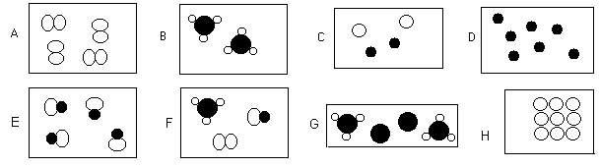

 | Atom or molecule? | Element, compound or mixture | Physical state | Possible identity of substances present.
A
B
C
D
E
F
G
H

- The diagram shows five particles of elements and compounds. Each circle represents an atom of an element. Match the pictures A to E to the following questions.
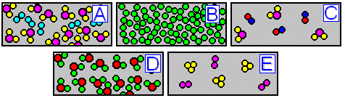

(a) Which particle picture represents a mixture of two compounds? ____
(b) Which particle picture represents a pure compound? ____
(c) Which particle picture represents a mixture of an element and a compound? ____
(d) Which particle picture represents a pure element? ____
(e) Which particle picture represents a mixture of two elements? ____
(f) Which particle picture could represent pure water? ____
(g) Which particle picture could represent something dissolved in water? ____

- The diagram below shows a sample of air. Identify the gases present and justify your choices.
