ATOMS, ELEMENTS & COMPOUNDS
- Do you know the difference between atoms, molecules, elements, compounds & mixtures?
Give as much detail as to the nature and identity of the following substances by completing the table below.
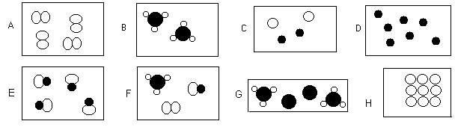

 | Atom or molecule? | Element, compound or mixture | Physical state | Possible identity of substances present.
A | Molecule | Element | Gas | O₂, N₂, Cl₂, etc.
B | Molecule | Compound | Gas | NH₃
C | Atoms | Mixture | Gas | Any two noble gases, e.g. Ar, Ne
D | Atoms | Element | Gas | Any noble gas, e.g. Ar
E | Molecule | Compound | Gas | HCl, HBr, HI, CO, NO, etc.
F | Molecules | 1x element 2x compound | Gas | NH₃ HCl, HBr, HI, CO, NO, etc. O₂, N₂, Cl₂, etc.
G | Molecules and Atoms | 1x element 1x compound | gas | Any noble gas, e.g. Ar  NH₃
H | Atoms | Element | Solid | Any metal, e.g. Na, Mg, Fe, etc.

- The diagram shows five particles of elements and compounds. Each circle represents an atom of an element. Match the pictures A to E to the following questions.
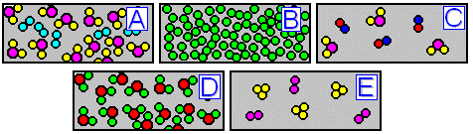

(a) Which particle picture represents a mixture of two compounds? _C___
(b) Which particle picture represents a pure compound? _ D___
(c) Which particle picture represents a mixture of an element and a compound? __ A __
(d) Which particle picture represents a pure element? __ B __
(e) Which particle picture represents a mixture of two elements? __ E __
(f) Which particle picture could represent pure water? __ D __
(g) Which particle picture could represent something dissolved in water? __ A __

- The diagram below shows a sample of air. Identify the gases present and justify your choices.
