Moles and empirical formulae
1 Calculate the molar mass of the following:
(Relative atomic masses: H = 1; N = 14; O = 16; Na = 23; S = 32; Cl = 35.5; K =39.)
(a) nitric acid, HNO₃ (b) sodium sulfate, Na₂SO₄ (c) ammonia, NH₃
(d) potassium chloride, KCl (e) chlorine, Cl₂
2 John says that there is no change in mass during a chemical reaction. Anna disagrees. She says that when calcium carbonate reacts with hydrochloric acid to form carbon dioxide, calcium chloride and water, the mass of the reaction vessel and contents decreases. Who is right, John or Anna? Explain your answer.
3 When 200 g of calcium nitrate, Ca(NO₃)₂.2H₂O is heated at 120ºC the mass decreases by 36 g.
(a) Why does the mass decrease?
(b) How much calcium nitrate is left after heating?
4 Calculate the molar mass of these compounds:
(relative atomic masses: H = 1; N = 14; O = 16; S = 32; Cu = 64; Br = 80; Pb = 207)
(a) copper nitrate, Ca(NO₃)₂ (b) lead bromate, Pb(BrO₃)₂
(c) ammonium sulfate, (NH₄)₂SO₄
5 The equation for the complete combustion of methane is shown below.
CH₄ + 2O₂ → CO₂ + 2H₂O
When 80 g of methane is completely combusted, 220 g of carbon dioxide and 180 g of water are formed.
(a) Why is the mass of carbon dioxide formed greater than the mass of methane burnt?
(b) Calculate the mass of oxygen that reacted.
(c) Calculate the mass of water formed when 20 g of methane undergoes complete combustion.
6 Deduce the empirical formulae of the following:
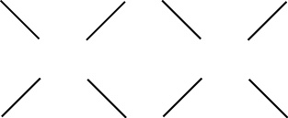
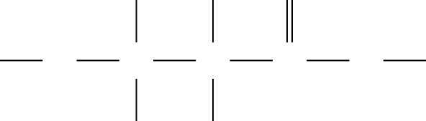
b)ClClCl
ClClCl
AlCl
a)HHO
HOCCCOH
HH

Moles and empirical formulae
1 Calculate the molar mass of these compounds. (Relative atomic masses H = 1; N = 14; O = 16; Mg = 24; S = 32; Ca = 40; K =39; Cr = 52; Fe = 56.)
(a) calcium ethanoate, Ca(CH₃CO₂)₂ (b) chromium sulfate Cr₂(SO₄)₃
(c) magnesium hydroxide, Mg(OH)₂ (d) potassium cyanoferrate(III), K₃Fe(CN)₆
2 When 2.4 g of magnesium reacts with excess copper(II) sulfate solution, 6.4 g of copper are deposited.
Mg + CuSO₄ → Cu + MgSO₄
How many grams of copper are deposited when 14.4 g of magnesium are used with excess copper(II) sulfate solution?
3 Deduce the empirical formulae of these two compounds:
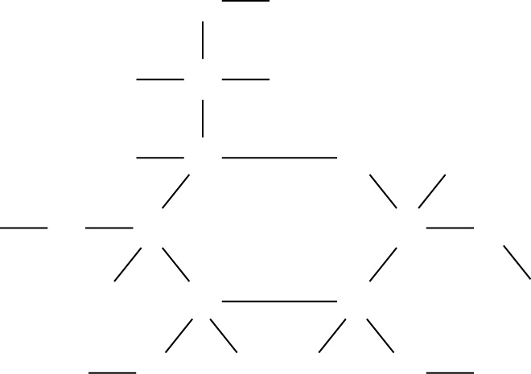
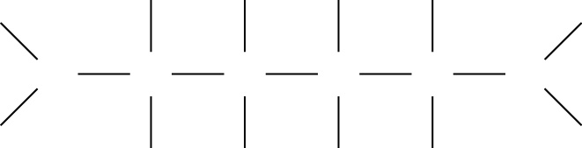
(a) (b)
HOHHOH
OH
HCH
HCOH
HCCH
HOCCO
HHHH
HHHH
NCCCCN
H
H
H
H

4 Calculate the number of moles of atoms in the following:
(Relative atomic masses S = 32; Cu = 64; Zn =65.)
(a) 3.2 g S (b) 13 g Zn (c) 576 g Cu
5 Calculate the number of moles of molecules in the following:
(Relative atomic masses H = 1; C = 12; N = 14; O = 16; Na = 23; S = 32.)
(a) 132 g (NH₄)₂SO₄ (b) 7 g C₂H₄ (c) 17.75 g Na₂SO₄
6 What is the mass in grams of 0.4 moles of copper(II) sulfate, CuSO₄?
(O =16; S =32; Cu =64)
7 Compound X contains 40% carbon, 13.3% hydrogen and 46.7% nitrogen.
(a) Calculate the empirical formula of compound X. (H = 1; C = 12; N = 14)
(b) The molar mass of compound X is 60. Calculate the molecular formula of X.
8 Magnesium burns in air to form magnesium oxide.
2Mg + O₂ → 2MgO (O = 16; Mg = 24)
How many grams of magnesium oxide are formed when 12 g of magnesium is burnt?

Electrolysis
1 What do you understand by the term electrolysis?
2 Lead iodide is a solid that can be melted using a Bunsen burner. Draw a diagram of the apparatus used to electrolyse molten lead iodide. On your diagram label the electrolyte, the anode, the cathode and the positive and negative terminals on the power pack.
3 Predict the decomposition products at (i) the anode and (ii) the cathode when the following molten salts are electrolysed.
(a) lead bromide (b) calcium chloride (c) aluminium oxide
4 Copper sulfate can be electrolysed using copper electrodes
(a) What do you observe at (i) the anode and (ii) the cathode during this electrolysis?
(b) How do each of the following affect your observations at the cathode during this electrolysis?
(i) increasing the current
(ii) carrying out the electrolysis for a longer time
5 The apparatus below can be used to electrolyse aqueous solutions.
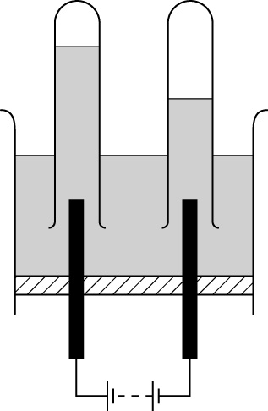
A
B
X
Y
Z
+–

(a) Name the parts X, Y and Z.
(b) Solution X is a solution of potassium sulfate in water. State the name of the gases that collect at A and B.
(c) State the name of one other solution that produces the same gases on electrolysis.
6 Solid sodium chloride does not conduct electricity.
(a) Under what conditions does sodium chloride conduct electricity?
(b) Give a reason for your answer.

Electrolysis
1 A solution of copper sulfate is electrolysed using copper electrodes.
(a) Draw a diagram of this electrolysis.
(b) Describe what happens at each electrode during this electrolysis.
2 Calcium chloride does not conduct electricity when solid.
(a) Explain why solid calcium chloride does not conduct electricity.
(b) What condition is needed to electrolyse pure calcium chloride? State the electrode products at the anode and cathode.
(c) Predict the electrode products when a very dilute solution of calcium chloride in water is electrolysed. Explain why these products differ from those obtained by electrolysing molten calcium chloride.
3 A solution of copper sulfate in water is electrolysed using copper electrodes.
Write half equations for the electrode processes occurring at
(a) the anode.
(b) the cathode.
4 Molten lead bromide contains lead ions, Pb²⁺, and bromide ions, Br⁻. Write half equations for the electrode processes occurring at (a) the anode and (b) the cathode during the electrolysis of molten lead bromide using inert electrodes.
5 When molten lead iodide is electrolysed using a current of 12 A for 50 minutes, approximately 39 g of lead is deposited.
(a) What mass of lead is produced using a current of 12 A for 25 minutes?
(b) What mass of lead is produced using a current of 3 A for 50 minutes?
(c) What charge in coulombs is transferred using a current of 12 A for 50 minutes?
(d) What mass of lead is produced using a current of 10 A for 12 minutes?
(e) In another experiment, a student finds that it requires 920 C to deposit 1 g of lead. How long will it take to deposit 1 g of lead using a current of 1.84 A?

Quantitative analysis
1 Convert the following to dm³.
(a) 250 cm³ (b) 20 cm³ (c) 24 000 cm³ (d) 5 cm³
2 Convert the following to cm³.
(a) 0.5 dm³ (b) 200 dm³ (c) 0.004 dm³ (d) 0.03 dm³
3 You need to dilute 10 cm³ of a solution of hydrochloric acid of concentration 1 mol/dm³ so that its concentration is 0.1 mol/dm³. Describe how to do this with the details of the apparatus you would use.
4 The label shown below gives some information about the contents of a tin of tomato paste.
Contents per 100 g
Pure dried tomatoes 70 g
Sugar 5 g
Basil/thyme 3 g
Water 20 g
Yeast extract 2 g
Added salt 0.4 g
(recommended daily allowance of sodium = 1.6 g)
(a) How many grams of tomato paste would you have to eat to exceed the recommended daily allowance of sodium?
(b) Why are recommended daily allowances important?
(c) Suggest why the added sodium is not necessarily a good guide to how much sodium the food contains.
5 Medicines often need to be diluted. Explain why, when diluting them, it is important that the dose is not too dilute or too concentrated.
6 Draw two diagrams to show:
(a) a concentrated solution of sodium chloride.
(b) a dilute solution of sodium chloride.
(In your diagrams show water molecules as >; sodium ions as ● and
chloride ions as o.)

Quantitative analysis
Use the following relative atomic masses for these questions where necessary:
H = 1; N = 14; O = 16; Na = 23; S = 32; Cl = 35.5; Cu = 64; Br = 80
1 Convert the following to mol/dm³:
(a) 22.4 g copper bromide, CuBr₂, in 1 dm³
(b) 60 g sodium hydroxide, NaOH, in 1 dm³
(c) 146 g hydrochloric acid, HCl, in 1 dm³
(d) 15.3 g ammonia, NH₃, in 1 dm³
2 Convert the following to g/dm³:
(a) 0.2 mol/dm³ sodium hydroxide, NaOH (b) 1.5 mol/dm³ sodium nitrate, NaNO₃
(c) 0.1 mol/dm³ sodium sulfate, Na₂SO₄ (d) 0.2 mol/dm³ copper sulfate, CuSO₄
3 According to its label, a tube of tomato paste contains tomatoes, water, yeast and herbs. It also contains 0.4 g of added sodium. The sodium is present as salt (sodium chloride, NaCl).
(a) Why is it important not to have too much salt in the diet?
(b) Explain why the amount of sodium on the label may not be an accurate indication of the amount of salt in the tomato paste.
(c) Calculate the mass of sodium chloride present if the mass of sodium in the sodium chloride is 0.4 g.
4 Calculate the concentration of the following solutions:
(a) A solution containing 0.03 moles in 200 cm³.
(b) A solution containing 0.5 moles in 4 dm³.
(c) A solution containing 0.02 moles in 25 cm³.
5 Convert the following into concentrations:
(a) 250 cm³ of a solution containing 5 g of sodium hydroxide, NaOH.
(b) 50 cm³ of a solution containing 1.2 g of copper(II) sulfate, CuSO₄.
6 Calculate the volume of these solutions:
(a) A solution of concentration 0.1 mol/dm³ that contains 1 mol of sodium chloride.
(b) A solution of concentration 0.5 mol/dm³ that contains 0.1 mol of sodium nitrate.
(c) A solution of concentration 0.1 mol/dm³ that contains 0.25 mol of copper sulfate.

Titrations
1 Petra wants to find the pH of some pond water. Describe how the she can use universal indicator to estimate the pH of the pond water.
2 Describe in detail how to find the concentration of a sodium hydroxide solution of unknown concentration using hydrochloric acid and a titration method.
3 The table gives the results of several titrations of sodium hydroxide with hydrochloric acid. The sodium hydroxide was in the flask.
 | Burette reading (cm³)
 | run 1 | run 2 | run 3 | run 4 | run 5
Initial reading | 0 | 0 | 22.5 | 0 | 22.4
Final reading | 24 | 22.5 | 45.2 | 22.4 | 44.8
Titre

(a) Write down the titres for runs 1 to 5
(b) Suggest why the first run was so much higher than the others.
(c) Calculate the average titre using the results for titres 2 to 5.
(d) Explain why you would not use universal indicator for this titration.
(e) Phenolphthalein indicator was used to find the end point of the titration.
Why is this a suitable indicator and what is the colour change at the end point?
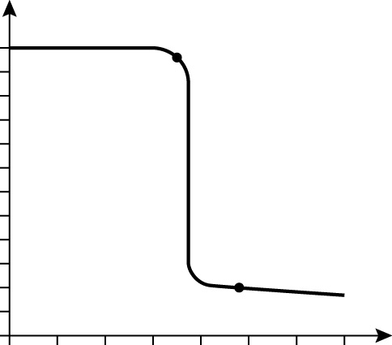
4 The diagram shows the change in pH when an acid is added to an alkali.
5101520253035
Volume of acid added
12
10
8
6
4
2
0
pH
A
B

(a) What volume of acid is needed to exactly neutralise the alkali?
(b) What is the pH of the alkali at the start of the reaction?
(c) What is the pH of the solution when 25 cm³ of acid has been added?
(d) Litmus was used as an indicator in this reaction. What colour was the litmus at point A and point B on the titration curve.
(e) Explain the shape of this pH curve.

Titrations
1 Sketch the pH titration curve for reaction of hydrochloric acid with sodium hydroxide. The acid is in the flask and the sodium hydroxide is in the burette. The end point of the titration is reached when 30 cm³ of the sodium hydroxide has been added to the acid.
2 (a) Explain the shape of the pH curve you have drawn in question 1.
(b) (i) Suggest an indicator you could use for this titration and give the colour change expected at the end point.
(ii) suggest why this indicator is suitable for this titration.
3 A solution of fermented blackcurrant juice has a pH of 3.5.
(a) Suggest why you cannot use an indicator to find out the concentration of acid present in the blackcurrant juice using a titration technique.
(b) The pH of the solution can be measured using a pH meter. Suggest how a pH titration curve can help you to find the end point of this reaction without using an indicator.
4 24 cm³ of a solution of sodium hydroxide of concentration 0.1 mol/dm³ was required to exactly neutralise 15 cm³ of hydrochloric acid of unknown concentration.
NaOH + HCl → NaCl + H₂O
(a) Calculate the number of moles of sodium hydroxide solution.
(b) Use the equation to suggest how many moles of hydrochloric acid react with the number of moles you calculated in part (a).
(c) Calculate the concentration of the hydrochloric acid in mol/dm³.
5 (a) What volume of 2 mol/dm³ hydrochloric acid is required to neutralise 0.03 moles of sodium hydroxide?
(b) 160 cm³ of hydrochloric acid neutralises exactly 20 cm³ of 0.4 mol/dm³ sodium hydroxide. Calculate the concentration of the hydrochloric acid.
(c) How many grams of sodium hydroxide are there in a solution that is exactly neutralised by 36 cm³ of 0.2 mol/dm³ hydrochloric acid?
(Molar mass of sodium hydroxide = 40.)

Gas volumes
1 The reaction between calcium carbonate and hydrochloric acid can be monitored by measuring the mass of the reaction mixture.
calcium carbonate + hydrochloric acid → calcium chloride + carbon dioxide + water
(a) Explain why this method can be used to monitor the reaction.
(b) Describe the experimental procedure for monitoring this reaction.
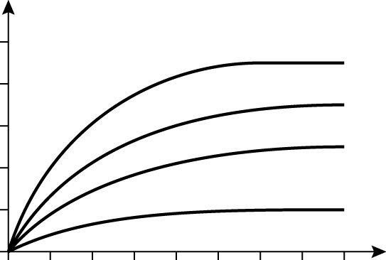
2 The graph shows the volume of hydrogen gas given off when different amounts of magnesium react with hydrochloric acid. The hydrochloric acid is in excess.
010203040
Time (s)
100
80
60
40
20
0
0.09 g Mg
0.07 g Mg
0.05 g Mg
0.02 g Mg
D
C
B
A
Volume of hydrogen (cm³)

(a) Which graph, A, B, C or D, has the fastest initial rate of reaction?
(b) By referring to the graph, explain how you know that magnesium is the limiting reactant.
(c) What is the total volume of gas produced in reaction B?
(d) At what time does reaction D finish?
(e) What volume of gas is produced after 10 seconds in reaction D?
(f) Suggest the maximum volume of gas produced by using 0.01 g of magnesium.
(g) How does the volume of hydrogen given off depend on the mass of magnesium used?
3 Draw a diagram of the apparatus you can use to follow a gas reaction by using a gas syringe.
4 A different method of following a gas reaction is shown below. Identify the pieces of apparatus labelled A, B, C and D and suggest why this apparatus cannot be used to collect a gas that is soluble in water.
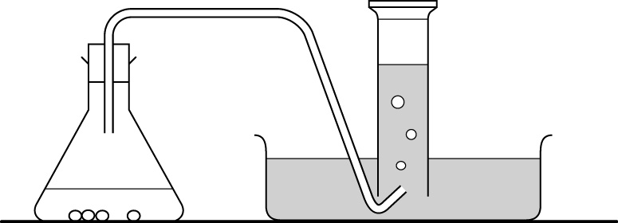
B
C
A
D

Gas volumes
1 Sketch a graph to show how the volume of gas produced during the course of a reaction changes with time. Label the axes of the graph and show where the rate is fastest and where the reaction stops.
2 Describe the method involving an upturned measuring cylinder that can be used to calculate the rate of the reaction:
Mg + 2HCl → MgCl₂ + H₂
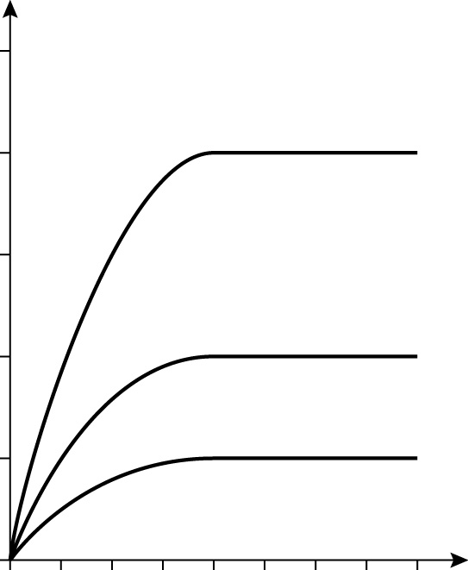
3 The graph shows the volume of hydrogen gas given off when different amounts of magnesium react with hydrochloric acid.
010203040
Time (s)
100
80
60
40
20
0
0.08 g Mg + 20 cm³
2 mol/dm³ HCl
0.04 g Mg + 20 cm³
2 mol/dm³ HCl
0.02 g Mg + 20 cm³
2 mol/dm³ HCl
Volume of hydrogen (cm³)

(a) How does the volume of hydrogen produced depend on the mass of magnesium used?
(b) Which reactant is limiting? Explain your answer. (Mg = 24)
(c) Calculate the initial rate of reaction when 0.08 g of magnesium reacts with 20 cm³ of 2 mol/dm³ hydrochloric acid.
(d) 1 mole of gas occupies 24 dm³ at room temperature. Calculate the volume of gas produced by the reaction of 0.2 g magnesium with excess hydrochloric acid.
(e) What is the minimum volume of 2 mol/dm³ hydrochloric acid that could react with 0.096 g of magnesium?
4 (a) Calculate the mass of carbon dioxide present in 600 cm³ carbon dioxide gas.
(C = 12; O =16)
(b) What is the volume occupied by 200 g of sulphur dioxide gas? (S = 32; O =16)

Equilibria
1 Name the raw materials used to make sulfuric acid.
2 Write the word equation for the reaction between sulphur dioxide and oxygen.
3 The equation shows the reaction between dinitrogen tetroxide and nitrogen dioxide.
N₂O₄ ⇌ 2NO₂
yellow liquid brown gas
(a) How do you know that this reaction is reversible?
(b) What colour is the mixture when the equilibrium reaction is over to the right?
4 Describe two features of an equilibrium reaction.
5 State three factors that might affect the yield of a product at equilibrium.
6 The graph shows the effect of temperature on the reaction
CaCO₃(s) → CaO(s) + CO₂(g)
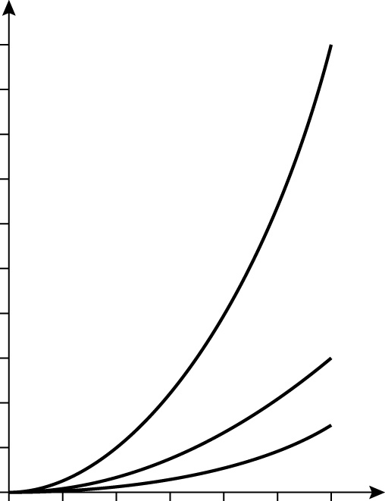
Percentage yield of calcium oxide
100
90
80
70
60
50
40
30
20
10
0
1 atm pressure

20 atm pressure
40 atm pressure
0 200 400 600 800 1000 1200
Temperature (°C)

(a) Describe how the yield of calcium oxide varies with temperature.
(b) At what temperature is the yield 80%?
(c) Describe the effect of pressure on this equilibrium.
(d) Use the information in the equation to suggest why the reaction is not carried out in a closed container if a high yield of calcium oxide is required.
7 State three conditions used in the Contact Process.

Equilibria
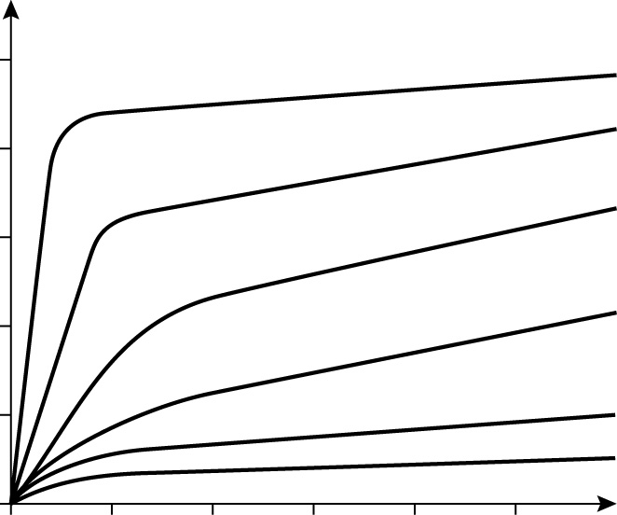
- The graph gives information about the effect
of temperature and pressure on the yield of
ammonia in the Haber Process.
02004006008001000
Pressure (atm)
100
80
60
40
20
200°C
300°C
400°C
500°C
600°C
700°C
Percentage ammonia
N₂ + 3H₂ → 2NH₃

(a) What is the percentage yield of ammonia at a pressure of 600 atmospheres and a temperature of 400ºC?
(b) Describe how pressure and temperature affect the equilibrium yield of ammonia.
(c) The synthesis of ammonia is carried out in a closed system. What is meant by the term closed system?
(d) At the start of the reaction only hydrogen and nitrogen are present. Describe how the rate of the forward and back reactions change as equilibrium is established.
2 The reaction shown below is endothermic.
CO₂(g) + H₂(g) → H₂O(g) + CO(g)
(a) How do the following affect the yield of products? In each case explain your answer. (i) removing water; (ii) increasing the pressure.
(b) State one other factor that will affect the position of the equilibrium.
(c) Suggest how the water can be removed from the reaction mixture.
3 Calcium oxide (lime) is made by the thermal decomposition of calcium carbonate.
CaCO₃ → CaO + CO₂
Explain why this reaction is not carried out in a closed system.
4 (a) Write symbol equations for the reactions occurring in the Contact Process that involve the formation of sulphur dioxide and sulfuric acid.
(b) In the Contact Process explain:
(i) why an optimum temperature is used
(ii) the role of the catalyst
(iii) why a high pressure is used.

Strong and weak acids
1 Describe two chemical reactions that are common to both ethanoic acid and hydrochloric acid. State one product of each of these reactions.
2 State three ways to tell the difference between ethanoic acid and hydrochloric acid of the same concentration.
3 Explain why ethanoic acid reacts slower than hydrochloric acid.
4 When a solution of ethanoic acid is electrolysed, a few bubbles are seen around the electrodes. When hydrochloric acid is electrolysed many bubbles are seen around the electrodes. Explain:
(a) what the bubbles are and how they are formed.
(b) why there are more bubbles produced by the hydrochloric acid.
5 Why are weak acids used as descalers in preference to strong acids?
6 The table shows the volume of hydrogen released when three acids, A, B and C, react with magnesium. The volumes are recorded at particular times. In each experiment the same amount of magnesium was used as well as the same volume of acid. The acid was in excess in each case.
 | Volume of hydrogen released (cm³)
Acid | Concentration of acid (mol/dm³) | 20 s | 200 s | 1000 s | 5000 s
A | 0.1 | 3 | 10 | 80 | 100
B | 0.1 | 20 | 98 | 100 | 100
C | 0.05 | 9 | 47 | 50 | 50
(a) Which of these acids are strong and which are weak? Explain your answer.
(b) Use the information in the table to explain what factors determine the volume of hydrogen formed.

Strong and weak acids
1 A solution of dry hydrogen chloride, HCl, in methylbenzene does not turn litmus red. When this mixture is shaken with a few drops of water, the litmus turns red. Explain these observations.
2 (a) Write symbol equations for the ionisation of ethanoic acid and hydrochloric acid in water.
(b) Describe the difference between these reactions in terms of degree of ionisation.
(c) Hydrochloric acid and ethanoic acid of the same concentration both react with magnesium but the rate of reaction differs. Describe and explain how and why the rate of reaction differs.
3 A 4 mol/dm³ solution of ethanoic acid is a concentrated solution of a weak acid. Use ideas about particles to explain the difference between strength and concentration of an acid.
4 The graph shows the volume of carbon dioxide released at various times when hydrochloric acid ethanoic acid react with calcium carbonate. The same volume and concentration of acid was used in each experiment and the calcium carbonate was in excess.
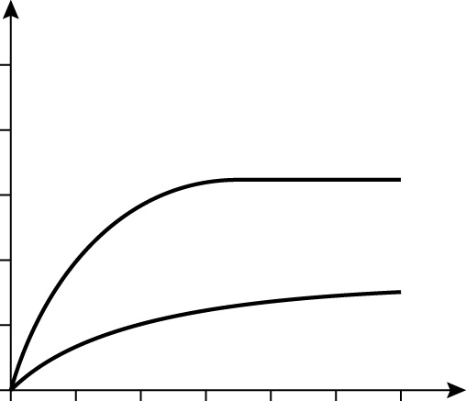
020406080100120
Time (s)
100
80
60
40
20
0
hydrochloric acid
ethanoic acid
Volume of CO₂ (cm²)

(a) Explain the difference between these two curves using ideas about ion concentration and rates of reaction.
(b) What will be the final volume of carbon dioxide produced when the reaction between the ethanoic acid and calcium carbonate is complete? Explain your answer.
5 Describe and explain the difference in the electrical conductivity of 0.1 mol/dm³ ethanoic acid and 0.1 mol/dm³ hydrochloric acid.

Ionic equations
1 (a) Describe the state of each of the following compounds.
(i) Na₂SO₄(aq) (ii) CaCO₃(s) (iii) C₆H₆(l) (iv) NO₂(g) (v) CuSO₄(aq)
(vi) Ge(OH)₂(s) (vii) C₃H₇OH(l)
(b) What is the ‘aq’ in the symbol (aq) short for?
Na⁺
2 Explain the processes involved in the following precipitation reaction. Use the diagrams to help you.
NaCl(aq) + AgNO₃(aq) → NaNO₃(aq) + AgCl(s)
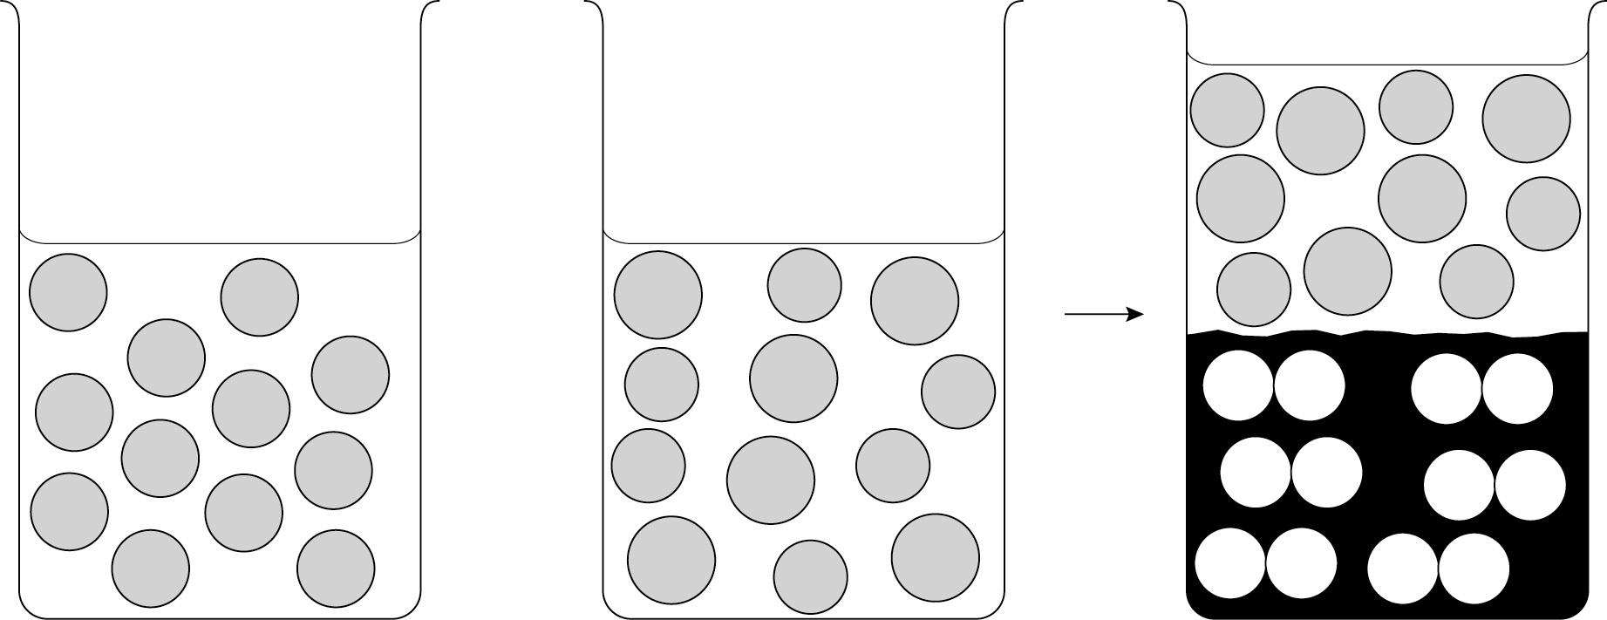
Na⁺
Na⁺
Na⁺
Na⁺
Na⁺
Na⁺
Na⁺
Na⁺
Na⁺
Na⁺
Na⁺
Cl⁻
Cl⁻
Cl⁻
Cl⁻
Cl⁻
Cl⁻
Cl
Cl
Cl
Cl
Cl
Cl
Ag⁺
Ag⁺
Ag⁺
Ag⁺
Ag⁺
Ag⁺
Ag
Ag
Ag
Ag
Ag
Ag
NO₃⁻
NO₃⁻
NO₃⁻
NO₃⁻
NO₃⁻
NO₃⁻
NO₃⁻
NO₃⁻
NO₃⁻
NO₃⁻
NO₃⁻
+

3 Write word equations for the following reactions.
(a) Silver nitrate with sodium bromide.
(b) Lead nitrate with potassium chloride.
(c) Barium nitrate with sodium sulfate.
4 A student tested separate portions of an unknown solution with barium nitrate and silver nitrate. No reaction was observed with barium nitrate but with silver nitrate a cream precipitate was observed. What deductions can be made from these tests?
5 Describe how you can prepare a pure dry sample of lead iodide from solution of lead nitrate and potassium iodide.
6 Describe the differences in the arrangement and motion of the particles in solid sodium bromide, molten sodium bromide and a solution of sodium bromide in water.

Ionic equations
1 (a) Draw diagrams to illustrate the following reaction.
AgNO₃(aq) + 2NaI(aq) → AgI(s) + NaNO₃(aq)
Show water molecules as >.
Show the ions as circles with the symbols for the ions inside the circles.
The silver ion is Ag⁺ and the sodium ion is Na⁺.
(b) Which ions remain in solution after the reaction? Explain why these are called spectator ions.
(c) Comment on the speed of the reaction between silver nitrate and sodium iodide.
2 Write symbol equations for the following reactions. Include state symbols.
(a) Silver nitrate with sodium bromide.
(b) Lead nitrate with potassium chloride.
(c) Barium nitrate with sodium sulfate.
3 Write balanced ionic equations for the following reactions. Include state symbols.
Symbols for ions: lead = Pb²⁺; nitrate = NO₃⁻; sodium = Na⁺; chloride = Cl⁻;
silver = Ag⁺; magnesium = Mg²⁺; iron(II) = Fe²⁺; hydroxide = OH⁻
(a) Lead nitrate with sodium chloride.
(b) Silver nitrate with magnesium chloride.
(c) Iron(II) chloride with sodium hydroxide.
4 The list gives some information about the solubility of various compounds in mol/dm³.
antimony sulfate 0.000001 barium chloride 1.5 barium sulfate 0.00001 calcium bromide 6 calcium hydroxide 0.015
iron(II) hydroxide 0.00007 iron(II) sulfate 1 magnesium sulfate 2
sodium bromide 10 sodium hydroxide 10
Use this data to explain:
(a) why no reaction is observed when antimony sulfate and barium chloride are mixed.
(b) that there is a precipitation reaction when barium chloride and magnesium sulfate are mixed.
(c) that when added to a solution of sodium hydroxide, calcium bromide is less likely to form a precipitate than iron(II) sulfate.

C5a Moles and formulae

Foundation
1 (a) 63 (b) 142 (c) 17 (d) 74.5 (e) 71 [5]
2 John; mass not lost in a chemical reaction; carbon dioxide escapes; carbon dioxide not weighed [4]
3 (a) water lost (b) 164 g [2]
4 (a) 188 (b) 463 (c) 132 [3]
5 (a) two oxygen atoms heavier than four hydrogen atoms [1]
(b) 320 g [1]
(c) 45 g [1]
6 (a) CH₂O [1]
(b) AlCl₃ [1]

Higher
1 (a) 158 (b) 392 (c) 58 (d) 329 [4]
2 38.4 g [1]
3 (a) C₂H₆N (b) CH₂O [2]
4 (a) 0.1 mol (b) 0.2 mol (c) 9 mol [3]
5 (a) 4 mol (b) 0.25 mol (c) 0.125 mol [3]
6 64 g [1]
7 (a) divide % by molar mass; divide by smallest number (3.33); CH₄N [3]
(b) C₂H₈N₂ [1]
8 20 g [1]

C5b Electrolysis

Foundation
1 Decomposition/breakdown of electrolyte/
ionic substance; using electricity [2]
2 Container with lead iodide heated by Bunsen; power pack with + and −; anode connected to +; cathode connected to − [4]
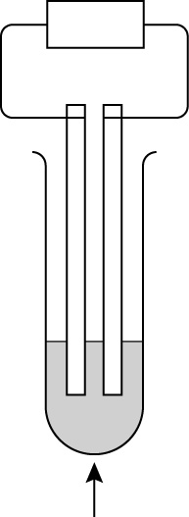
power pack
+–
cathode
anode
electrolyte
(molten lead iodide)
heat

3 (a) (i) bromine (ii) lead [2]
(b) (i) chlorine (ii) calcium [2]
(c) (i) oxygen (ii) aluminium [2]
4 (a) anode gets smaller/dissolves; cathode gets thicker/plated with copper [2]
(b) (i) more copper deposited [1]
(ii) more copper deposited [1]
5 (a) X electrolyte; Y anode; Z cathode [3]
(b) A hydrogen; B oxygen [2]
(c) any suitable e.g. potassium nitrate/sulfuric acid [1]
6 (a) melt it; dissolve it in water [2]
(b) in solid ions can’t move; when molten or in solution (in water) ions can move [2]

Higher
1 (a) Copper sulfate in beaker with two copper electrodes; power pack with + and −; anode connected to +; cathode connected to − [4]
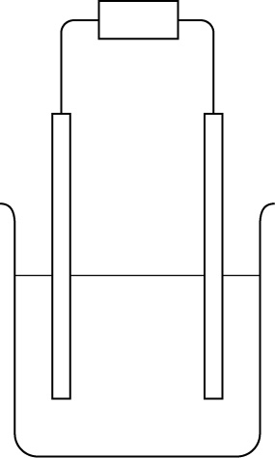
power pack
cathode
copper sulphate
solution
+–

copper
anode

(b) anode gets smaller/dissolves; cathode gets thicker/plated with copper [2]
2 (a) ions nor free to move [1]
(b) heat (to make it molten) [1]
(c) anode oxygen; cathode oxygen (allow chlorine); easier to discharge ions from water than from the calcium/ chloride [3]
3 (a) Cu → Cu²⁺ + 2e⁻ [1]
(b) Cu²⁺ + 2e⁻ → Cu [1]
4 (a) 2Br⁻ + 2e⁻ → Br₂ [1]
(b) Pb²⁺ + 2e⁻ → Pb [1]
5 (a) 19.5 g [1]
(b) 9.75 g [1]
(c) 36 000 C [1]
(d) 7.8 g [1]
(e) 500 s [1]

C5c Quantitative analysis

Foundation
1 (a) 0.25 dm³ (b) 0.02 dm³ (c) 24 dm³
(d) 0.005 dm³ [4]
2 (a) 500 cm³ (b) 200 000 cm³ (c) 4 cm³
(d) 30 cm³ [4]
3 put 10 cm³ of 1 M acid into measuring cylinder; add 9 cm³; water; mix/shake [3]
4 (a) 400 g [1]
(b) so you don’t eat too much of particular substance; that might be harmful to your health [2]
(c) there may be sodium in one of the other ingredients/yeast [1]
5 if too dilute may not be beneficial enough; if too concentrated may harm patient/produce unwanted effects [2]
6 concentrated → ions random and spread out; approx. = number of ions; few water molecules/more ions
dilute → ions random and spread out; approx = number of ions; many water molecules/few ions [6]
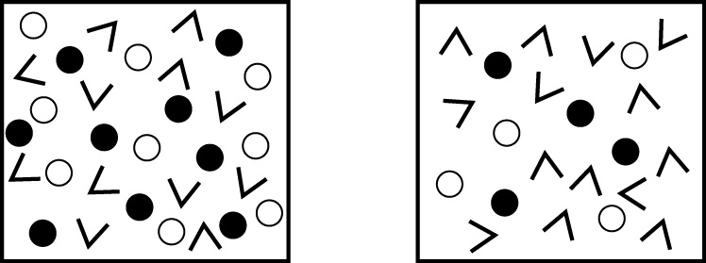
(b)
(a)

Higher
1 (a) 0.1 mol/dm³ (b) 1.5 mol/dm³
(c) 4 mol/dm³ (d) 0.9 mol/dm³ [4]
2 (a) 8 g/dm³ (b) 127.5 g/dm³
(c) 14.2 g/dm³ (d) 32 g/dm³ [4]
3 (a) causes high blood pressure/contributes to heart disease [1]
(b) may be salt in the yeast/other ingredients; salt is sodium chloride not just sodium/chloride ion not accounted for [2]
(c) 58.5/23; x4 = 1.017 g/1.02 g [2]
4 (a) 0.15 mol/dm³ (b) 0.125 mol/dm³
(c) 0.8 mol/dm³ [3]
5 (a) 0.5 mol/dm³ (b) 0.15 mol/dm³ [2]
6 (a) 10 dm³ (b) 200 cm³ (c) 2.5 dm³ [3]

C5d Titrations

Foundation
1 dip universal indicator paper in water; observe the colour; compare with standard colour chart [3]
2 HCl in burette; use volumetric pipette to deliver known amount of alkali; indicator in flask; named indicator (not universal); add acid slowly to alkali; until colour change in indicator; take reading on burette; repeat for accuracy; adding HCl drop-wise near end point [9]
3 (a) 24, 22.5 22.7, 22.4, 22.4 (all correct = 2, 1 error = 1) [2]
(b) rangefinder/rough titration [1]
(c) 22.5 cm³ [1]
(d) continuous colour change; no sharp end point [2]
(e) sudden colour change at end point; changes from pink; to colourless [3]
4 (a) 20 cm³ [1]
(b) 12 [1]
(c) 2 [1]
(d) A, blue ; B, red [2]
(e) starts at alkaline pH; pH falls rapidly/
gets less alkaline/more acid; because of neutralisation reaction ; acid + alkali → salt + water; low pH due to excess acid [5]

Higher
1 axes correct; pH starts low e.g. 2; ends high, e.g. 12/13; sudden swing in pH near equivalence point; end point at 30 cm³ [5]
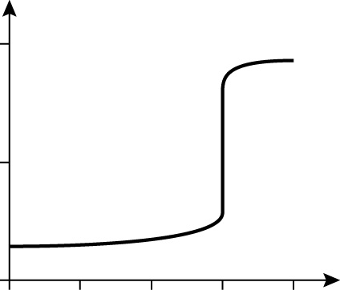
010203040
Volume of NaOH added
14

7

0
pH

2 (a) starts at acid pH; pH rises rapidly/ gets more alkaline/ less acid; because of neutralisation reaction ; acid + alkali → salt + water; high pH due to excess alkali [5]
(b) (i) suitable indicator e.g. litmus; correct colour change e.g. red; to blue [3]
(ii) colour changes rapidly with change in pH [1]
3 (a) Blackcurrant juice is coloured; so can’t see the colour change of the indicator [2]
(b) measure pH as acid added to alkali; draw titration curve; point where curve suddenly drops is end point [3]
4 (a) 2.4 x 10⁻³ (b) 2.4 x 10⁻³
(c) 0.16 mol/dm³ [3]
5 (a) volume = mol x concentration; 60 cm³ [2]
(b) 1 correct use of mol = vol/con; mol NaOH/HCl= 8 x 10⁻³;
conc HCl = 0.05 mol/dm³ [3]
(c) 7.2 x 10⁻³ moles; x 40; = 0.288 g [3]

C5e Gas volumes

Foundation
1 (a) carbon dioxide given off/carbon dioxide is a gas; so apparatus decreases in mass [2]
(b) 5 of: HCl in flask put on balance; add calcium carbonate to start reaction (or vice versa); cotton wool at mouth of flask; take initial reading of balance; then readings at time intervals; until reaction stops [5]
2 (a) A [1]
(b) final volume of gas; increases as mass of Mg increases [2]
(c) 50 cm³ [1]
(d) 30 s [1]
(e) 60 cm³ [1]
(f) about 10 cm³ [1]
(g) as mass of magnesium increases, volume of hydrogen increases/doubles [1]
3 flask; reaction mixture in flask; delivery tube connecting flask to; gas syringe; no gaps in apparatus [5]
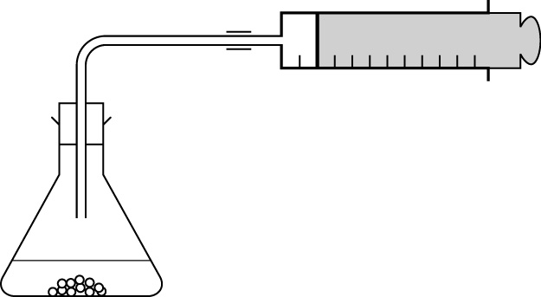
gas
gas syringe
reaction mixture
conical
flask

4 A = measuring cylinder; B = flask;
C = delivery tube; D = trough; because the gas is collected over water; so will dissolve in it [6]

Higher
1 axes labelled with time on horizontal; curve; which levels off; rate fastest at start of reaction; time taken to
finish = where graph levels off [5]
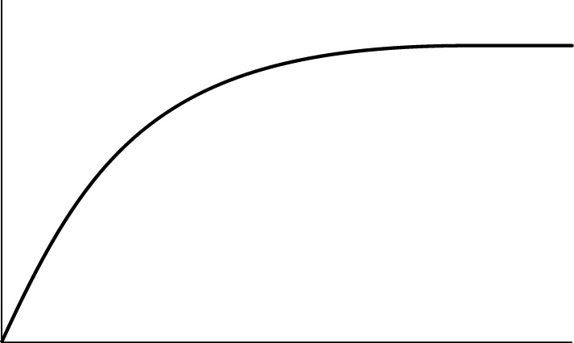
reaction stops
here
rate fastest
Time
Volume of gas (cm³)

2 flask; reactants in flask; connected to delivery tube; upturned measuring cylinder full of water; in trough of water; start reaction by adding Mg to acid in flask; measure volume of gas in measuring cylinder; at different time intervals; rate = cm³ gas/time [8]
3 (a) greater mass of Mg gives greater volume of gas (1 mark); doubling mass of Mg doubles the amount of gas
(2 marks) [2]
(b) magnesium; moles Mg 3.3 x 10⁻³; moles of HCl = 0.04; Mg much lower (even taking into account the requirement for 2 moles of HCl per mole Mg) [4]
(c) 80/5 (or other suitable working);
= 16; cm³/s (allow 14–18 cm³/s) [3]
(d) 0.2 g = 0.2/24 mol ; X 24 dm³;
= 200 cm³ [3]
(e) moles Mg = 0.004; moles HCl reacting 0.008 mol; vol = mol x conc;
= 16 cm³ [4]
4 (a) 600/24 000 mol ; x44 ; =1.1 g [3]
(b) 200/64 mol; x24; = 75 dm³ [3]

C5f Equilibria

Foundation
1 sulfur; air; water [3]
2 sulfur dioxide + oxygen ⇌ sulfur trioxide
equilibrium sign; sulphur trioxide [2]
3 (a) equilibrium sign [1]
(b) brown [1]
4 rate of forward = rate of back reaction; concentrations of products/reactants don’t change (allow other suitable characteristics) [2]
5 temperature; pressure; concentration of reactants/products [3]
6 (a) the higher the temperature the more product formed; rate of increase is more with increase in temperature [2]
(b) 1100 °C [1]
(c) increasing pressure decreases yield/pushes reaction to left [1]
(d) carbon dioxide can escape; reaction goes further to the right [2]
6 V₂O₅; 450 °C; atmospheric pressure [3]

Higher
1 (a) 50% [1]
(b) increase in temperature decreases yield; increase in pressure increases yield; not proportionately/rapidly at first [3]
(c) apparatus which does not allow escape of reactants or products [1]
(d) initially rate of forward reaction high; and backward reaction low; as equilibrium is approached rate of forward reaction decreases; and backward reaction increases; until they are equal; at equilibrium [6]
2 (a) (i) more products; decreasing concentration of product pushes reaction to the right; in direction to counteract the change [3]
(ii) no effect; equal number of molecules/moles on each side of the equation [2]
(b) lower the temperature; below boiling point of water [2]
3 carbon dioxide removed; because it is a gas; so equilibrium shifts to the right [3]
4 (a) 2SO₂ + O₂ ⇌ 2SO₃ correct formulae; balance; equilibrium sign [3]
SO₃ + H₂O → H₂SO₄
correct equation; not equilibrium [2]
(b) (i) high temperature decreases equilibrium yield; higher temperature increases rate; so compromise between these two [3]
(ii) increases only the rate [1]
(iii) 2 of : position of equilibrium already on the right; higher pressure expensive; greater probability of corrosion [2]

C5g Strong and weak acids

Foundation
1 reaction with Mg; product hydrogen/magnesium chloride; reaction with calcium carbonate; product carbon dioxide (or water or magnesium chloride) (ALLOW reaction with alkali + product) [4]
2 ethanoic acid has lower pH; reaction slower with Mg/CaCO₃; lower electrical conductivity (or reverse for HCl) [3]
3 Fewer H⁺ ions (for same volume) in ethanoic acid/doesn’t ionise completely; more H⁺ ions in HCl (for same volume)/ionises completely; fewer H⁺ ions means fewer collisions with other reactant (or reverse for HCl) [3]
4 (a) hydrogen; formed at cathode; from H⁺ ions; oxygen formed at anode (allow Cl at anode for HCl); acid contains H⁺ ions in solution [5]
(b) ethanoic acid is weak acid; so fewer H⁺ ions in solution; so less hydrogen gas [3]
5 limescale is calcium carbonate; weak acids react with calcium carbonate; slow reaction with surface; strong acids may react with/pit the surface [4]
6 (a) A weak; B strong; C strong; rate of reaction of A slow; rate of reaction of B/C fast [5] [3]
(b) 6 from: amount determined by limiting reactant; Mg is limiting reactant; final volume in C is half that in D; since half the number of particles of acid; amount of hydrogen produced by A smaller at first; so it must be a weak acid; but final volume the same; as same amount of magnesium in each case. [6]

Higher
1 no water in solution in methylbenzene; no ionisation of HCl; so no acidic properties; addition of water ionises the acid; to form H⁺ ions; H⁺ responsible for acidic properties [5]
2 (a) CH₃CO₂H ⇌ CH₃CO₂⁻ + H⁺
1 mark for left hand side; 1 for right hand side; 1 for equilibrium sign
HCl → H⁺ + Cl⁻
1 for equation; 1 for arrow [5]
(b) ethanoic acid incompletely ionized; HCl completely ionised [2]
(c) Fewer H⁺ ions (for same volume) in ethanoic acid/doesn’t ionise completely; more H⁺ ions in HCl (for same volume)/ionises completely; fewer H⁺ ions means fewer collisions with other reactant (or reverse for HCl) [3]
3 Strong acid entirely ionised; weak acid partially ionised; concentration of acid particles high in concentrated acid; low in weak acid [4]
4 (a) HCl faster; because strong acid; so concentration of H⁺ ions higher; so greater collision frequency with CaCO₃ (or reverse argument with ethanoic acid) [4]
(b) 70 cm³; same number of moles of acid as hydrochloric; because same concentration and volume of solutions [3]
5 ethanoic acid is weak and hydrochloric acid strong; greater concentration of H⁺ ions in HCl; H⁺ carry charge/have high conductivity [3]

C5h Ionic equations

Foundation
1 (a) 7 of: sodium ions and chloride ions; in solution in water; silver ions and nitrate ions; in solution in water; when added ions collide; ppt formed; of silver chloride; which falls to bottom; sodium and nitrate ions remain in solution [7]
(b) aqueous [1]
2 8 of: sodium ions and chloride ions; are in solution in water; idea of random distribution of ions; silver ions and nitrate ions; in solution in water; ions mix when solutions added; ions collide and react; insoluble silver chloride formed; so this precipitates; sodium and nitrate ions remain in solution [8]
3 (a) → silver bromide + sodium nitrate [1]
(b) → lead chloride + potassium nitrate [1]
(c) → barium sulfate + sodium nitrate [1]
4 no ppt with barium nitrate – no sulfate ions present; cream ppt with silver nitrate – bromide ions present [2]
5 mix the two solutions; stir and allow to ppt; filter off (lead iodide); wash ppt with water/alcohol; allow to dry in air [4]
6 solid – regular arrangement; no motion/only vibrate; molten – random arrangement; random motion/sliding over each other; solution – randomly arranged; random/free motion [6]

Higher
1 (a) silver and nitrate ions; dispersed randomly throughout water; sodium and iodide ions; dispersed randomly and throughout water; in separate tube/beaker; mixture shows ppt; with silver and iodide ions or AgI molecules; sodium and nitrate ions dispersed randomly throughout water [8]
(b) because they do not take part in the reaction/can be cancelled in ionic equation [1]
(c) very fast [1]
2 (a) AgNO₃(aq) + NaBr(aq) → AgBr(s) + NaNO₃(aq); 1 reactants; 1 products;
1 state symbols [3]
(b) Pb(NO₃)₂(aq) + 2KCl(aq) → PbCl₂(s) + 2KNO₃(aq); 1 reactants;
1 products; 1 state symbols [3]
(c) Ba(NO₃)₂(aq) + Na₂SO₄(aq) → BaSO₄(s) + 2NaNO₃(aq); 1 reactants;
1 products; 1 state symbols [3]
3 (a) Pb²⁺(aq) + 2Cl⁻ (aq) → PbCl₂(s)
1 reactants; 1 products; 1 state symbols [3]
(b) Ag⁺(aq) + Cl⁻ (aq) → AgCl(s)
1 reactants; 1 products; 1 state symbols [3]
(c) Fe²⁺(aq) + 2OH⁻ (aq) → Fe(OH)₂(s)
1 reactants; 1 products; 1 state symbols [3]
4 (a) antimony sulfate is very insoluble; so no ions in solution to react with barium chloride [2]
(b) ppt formed; of barium sulfate; barium sulfate insoluble/low solubility; magnesium sulfate and barium chloride are very soluble [4]
(c) calcium bromide forms calcium hydroxide; which is slightly soluble/has a higher solubility than iron hydroxide; iron sulphate forms iron hydroxide; which is insoluble/has lower solubility [4]

Moles and empirical formulae
1 12 g of magnesium reacts exactly with 8 g of oxygen to form magnesium oxide. What is the mass of magnesium oxide formed? Underline the correct answer. [F]
8 g 10 g 12 g 20 g 96 g
2 Calculate the molar mass of sulfuric acid, H₂SO₄ (atomic masses H = 1, S =32, O =16). [F]
Molar mass = ___
3 20 g of calcium carbonate contains 2.4 g of carbon and 8 g of calcium. How many grams of oxygen does it contain? ___ [F]
4 Write down the empirical formula for the compound that has the following structure: [F]
HOOC − CH₂ − CH₂ − COOH. The empirical formula is _________
5 True or false? Put T or F in the boxes. [F]
Relative atomic mass is the average mass of an atom compared with the average mass of an oxygen atom.
The unit for the amount of substance is grams.
Mass (in g) = moles x molar mass.
The empirical formula can be found by dividing the percentage composition by mass of each element by their molar masses.
6 16 g of methane burns completely to form 44 g of carbon dioxide.
CH₄ + 2O₂ → CO₂ + 2H₂O
How many grams of carbon dioxide are formed when 2 g of methane is completely burnt? __________________ [H]
7 Calculate the number of moles of magnesium bromide in 11.5 g of magnesium bromide, MgBr₂. (Atomic masses Mg = 24; Br =80.) [H]
____________________________________
8 (a) How many moles of sulfur dioxide are formed by the complete combustion of 12.8 g of sulfur? (Atomic masses S = 32; O =16.) S + O₂ → SO₂ [H]
____________________________________
(b) How many grams of SO₂ is this? [H]
____________________________________
9 A compound contains 54.5% carbon, 9.1% hydrogen and 36.4% oxygen. Calculate the empirical formula of this compound. (Atomic masses C =12; H = 1; O =16.) [H]
C = 54.5/12 = 4.54 O = 36.4/16 = 2.275 H = 9.1/1 =9.1
______________________________________________________________

Electrolysis
1 Label the diagram, which shows the apparatus used for electrolysis. [F]
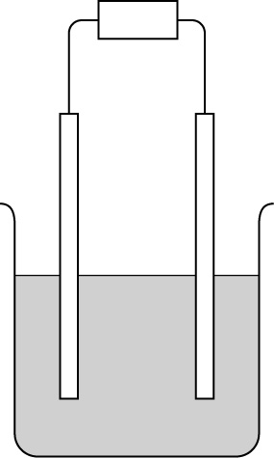
__________
__________
________
+−
____________

2 Select words from the list to fill in the blank spaces. [F]
copper dissolve electrodes insulators larger negative positive
smaller sulfate
When copper(II) sulfate solution is electrolysed using copper , the __________ electrode gets _________ and dissolves and the _________ electrode gets plated with _________.
3 Name the two products formed when molten lead bromide is electrolysed. [F]
______________ and ______________.
4 True or false? Put T or F in the boxes. [F]
When copper(II) sulfate solution is electrolysed
as time increases both electrodes gain mass.
gain in mass at one electrode = loss in mass at the other electrode.
as the current increases, the amount of copper deposited increases.
copper ions move to the negative electrode.
5 State the two electrode products when an aqueous solution of sodium nitrate is electrolysed. [H]
______________ and ______________.
6 Complete these electrode equations for the electrolysis of aqueous potassium sulfate. [H]
(i) __ H⁺ + _____→ H₂ (ii) ___ OH– → O₂ + 2H₂O + _____
7 In an electrolysis cell a current of 0.5 amps was passed through the electrolyte for 120 seconds. Calculate the amount of charged transferred in coulombs. [H]
_____ _ coulombs.

Quantitative analysis
1 Solve the clues across. The shaded column describes what you do when you add water to a solution. [F]
1
2
3
4
5
6
1 A unit of volume is this unit ‘cubed’.
2 It is important that hospital patients be given the right dilution of these substances.
3 The side of food packaging sometimes gives recommended daily _______.
4 The number of cm³ in one dm³.
5 This can be measured in g/dm³.
6 The volume of a liquid can be found using by a using a _________ cylinder.
2 True or false? Put T or F in the boxes. [F]
The more concentrated a solution, the more crowded the particles.
2.5 cm³ = 0.025 dm³
A solution of 0.1 mol/dm³ is formed by adding 10 cm³ water to 1 cm³ solution of concentration 1 mol/dm³.
3 0.2 g of sodium chloride is dissolved in 100 cm³ of water. What is the concentration of sodium chloride in (a) g/dm³ and (b) mol/dm³? (Molar mass of sodium chloride = 58.5) [H]
(a) ______________ (b) ______________
4 Complete these sentences. [H]
On a food label, the stated amount of added salt may not give a correct guide to the amount of salt the food contains because the raw food may _____________________.
The amount of sodium is not the same as the amount of salt because salt also contains ______________.
5 How many moles of calcium chloride are there in 10 cm³ of a solution of concentration 0.5 mol/dm³? Underline the correct answer. [H]
0.0005 mol 0.005 mol 0.02 mol 0.05 mol 20 mol

Titrations
1 Label these pieces of apparatus. [F]
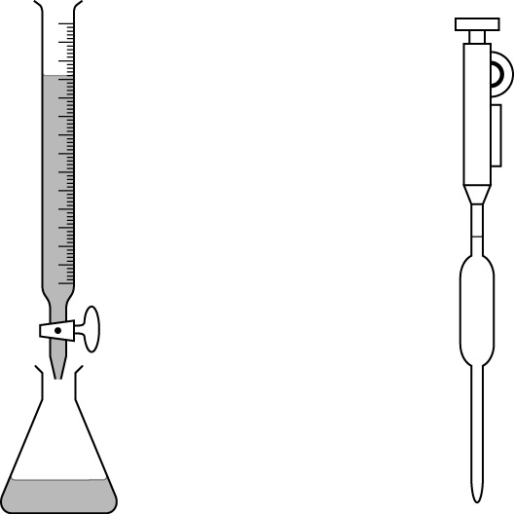
_____________
__________________
__________________
___________

2 State the colour of the following indicators: [F]
(a) phenolphthalein (i) in acid solution: ________; (ii) in alkaline solution: ________.
(b) litmus (i) in acid solution: ________; (ii) in alkaline solution: ________.
3 True or false? Put T or F in the boxes. [F]
The word equation for neutralisation is: acid + alkali → salt + hydrogen.
There is a sudden change in pH at the end point of a titration.
When an acid is added to an alkali the pH increases.
Universal indicator is often used to find the end point of a titration.
4 Complete the following by putting ÷ or x in the box. [H]
moles = concentration |  | volume (in dm³)
volume (in dm³) = moles |  | concentration
concentration = moles |  | volume (in dm³)
5 20 cm³ of a solution of 0.1 mol/dm³ sodium hydroxide solution is neutralised by 8 cm³ of hydrochloric acid. Calculate (a) the concentration of the sodium hydroxide solution and (b) the concentration of the hydrochloric acid. [H]
(a) ________________________ mol/dm³ NaOH
(b) ________________________ mol/dm³ HCl
6 How many cm³ of 1.2 mol/dm³ sodium hydroxide contains 0.3 moles of sodium hydroxide? [H]
________________

Gas volumes
1 Name these pieces of apparatus used in the measurement of gas volumes. [F]
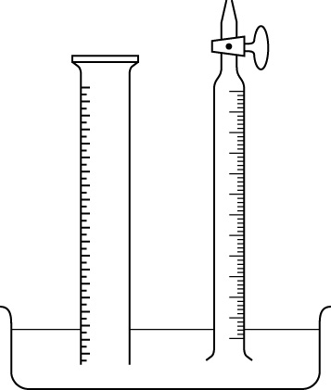
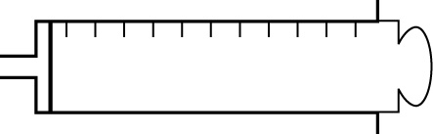
__________
__________
__________
__________
__________

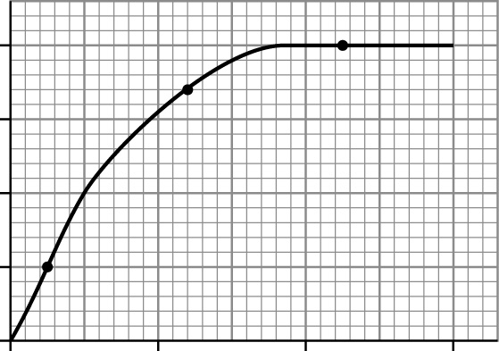
2 When calcium carbonate reacts with hydrochloric acid, carbon dioxide is given off. The graph on the left shows a plot of the volume of carbon dioxide given off against time. Put the answers in the boxes on the right. [F]
0204060
Times (s)
40
30
20
10
0
Volume of CO₂ (cm³)
A
B
C
The total volume of gas produced in is __ cm³
The reactions stops at __ seconds
At which of the points A, B or C, is the reaction fastest? __
The volume of gas released after 10 seconds is __ cm³
3 Select words from the list to fill in the blank spaces. [F]
concentration directly first inversely last limiting product reactant volume
The _____ reactant is the one that is used up _____ of all. In a gas reaction the volume of gas produced is ______ proportional to the amount of limiting ______ present.
4 True or false? Put T or F in the boxes. [F]
Change in mass can be used to monitor the amount of gas given off in a reaction.
When magnesium reacts with excess acid, the reaction stops when the acid is used up.
Rate of reaction is fastest at the start of a reaction.
5 A container of volume 5.00 dm³ is filled with pure oxygen at atmospheric pressure. Calculate the number of moles of oxygen present in the jar. (1 mol of gas occupies 24 dm³ at atmospheric pressure.) ____________ mol [H]
6 What volume (in dm³) will 0.022 g of carbon dioxide gas occupy at atmospheric pressure? (Atomic masses: C = 12, O = 16.) [H]
__________________________________________________________________ dm³

Equilibria
1 Solve the clues across. The shaded column gives the name of a substance used to make sulfuric acid. [F]
1
2
3
4
5
1 Sulfur and air are two of the ____ materials used to make sulfuric acid.
2 In a reversible reaction the equation products → reactants represents the _________ reaction.
3 The name of the process for making sulfuric acid.
4 Certain types of ‘balanced’ reversible reactions are called _________ reactions.
5 A reaction that can go in both directions.
2 True or false? Put T or F in the boxes. [F]
In an equilibrium reaction:
the rate of the forward reaction equals the rate of the backward reaction.
the concentrations of the reactants and products do not change at equilibrium.
when the concentration of the products is greater than the reactants, equilibrium is to the left.
changing the concentration of the reactants alters the concentration of products.
changing the temperature has no effect on the position of equilibrium.
3 Underline the conditions used in the Contact Process. [F]
The temperature is 50°C 250°C 450ºC 850°C
The catalyst is Fe Fe₂O₃ Ni V₂O₃ V₂O₅
4 State the effect of the following on the position of equilibrium in the reaction [H]
N₂O₄ ⇌ 2NO₂.
Increasing the concentration of N₂O₄ ___________________________.
Removing NO₂ ___________________________.
Increasing the pressure ___________________________.
5 Complete these equations for the manufacture of sulfuric acid. [H]
(a) _SO₂ + O₂ ⇌ 2___ (b) SO₃ + ___ ⇌ ____
6 Complete the following sentence: [H]
In the Contact Process a ____ temperature decreases the yield and ________ the rate of reaction, so an ________ temperature is used for the process.

Strong and weak acids
1 Solve the clues across. The shaded column describes mineral acids such as sulfuric and hydrochloric acid. [F]
1
2
3
4
5
6
1 Equal volumes of 0.1 mol/dm³ hydrochloric and ethanoic acids produce the _____ volume of hydrogen with excess magnesium.
2 E________ acid is a weak acid.
3 ________ dioxide is released when acids react with calcium carbonate.
4 Ethanoic acid has a lower electrical _____________ than hydrochloric acid.
5 N_______ acid is a strong acid.
6 When ethanoic acid is electrolysed, hydrogen is formed at the ___________ electrode.
2 Select words from the list to fill in the blank spaces. [F]
faster higher lower more slower stronger weak
Ethanoic acid reacts _______ than hydrochloric acid of the same concentration because hydrochloric acid is a _______ acid and forms _______ hydrogen ions in solution. This results in a _______ collision frequency of the ions for hydrochloric acid.
3 True or false? Put T or F in the boxes. [H]
Acids ionise in water to produce hydrogen ions.
Solutions of 0.1 mol/ dm³ of ethanoic acid and nitric acid have the same number of H⁺ ions.
Strong acids are inappropriate as descaling agents.
The ionisation of a weak acid produces an equilibrium mixture.
Hydrochloric acid is incompletely ionised in aqueous solution.
4 Complete the equations for the ionisation of ethanoic acid and hydrochloric acid. [H]
CH₃CO₂H | ⇌ |  | +

HCl | → |  | +

Ionic equations
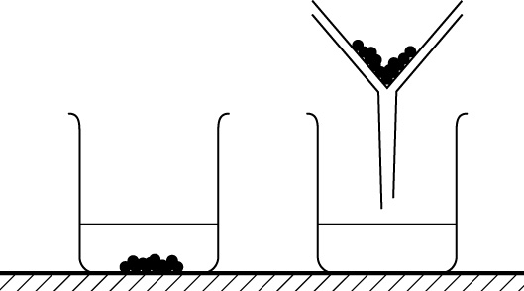
1 Label these pieces of apparatus, which are used to prepare an insoluble compound. [F]
__________
__________
__________
__________

2 Solve the clues across. The shaded column gives the colour of the precipitate when silver nitrate solution is added to a solution containing chloride ions. [F]
1
2
3
4
5
1 The colour of precipitate when iodide ions are added to lead ions.
2 The general name for chloride, bromide and iodide ions.
3 The particles that react rapidly in precipitation reactions.
4 Barium nitrate is used to test for this ion.
5 The state symbol aq stands for __________ solution.
2 Put these stages for the preparation of an insoluble compound in the correct order. [F]
1 Wash the precipitate
2 Separate the precipitate by filtration
3 Mix solutions of the two reactants
4 Dry the precipitate
5 Stir and allow a precipitate to form
The correct order is _________________
3 Complete the equations for these reactions and state the name of the precipitates. [F]
(a) silver nitrate + potassium bromide → ______________ + ______________
(b) _____________ + _____________ → _____________ + _____________
The precipitates are (a) _____________ and (b) _____________
4 Convert this equation into a balanced ionic equation. Include state symbols. The copper ion is Cu²⁺. CuSO₄(aq) + 2NaOH(aq)) → Cu(OH)₂(s) + Na₂SO₄(aq) [H]
__________________________________

Moles and empirical formulae
1 12 g of magnesium reacts exactly with 8 g of oxygen to form magnesium oxide. What is the mass of magnesium oxide formed? Underline the correct answer. [F]
8 g 10 g 12 g 20 g 96 g
2 Calculate the molar mass of sulfuric acid, H₂SO₄ (atomic masses H = 1, S =32, O =16). [F]
Molar mass = 98
3 20 g of calcium carbonate contains 2.4 g of carbon and 8 g of calcium. How many grams of oxygen does it contain? 9.6 g [F]
4 Write down the empirical formula for the compound that has the following structure: [F]
HOOC − CH₂ − CH₂ − COOH. The empirical formula is C₂H₃O₂
5 True or false? Put T or F in the boxes. [F]
Relative atomic mass is the average mass of an atom compared with the average mass of an oxygen atom. | F
The unit for the amount of substance is grams. | F
Mass (in g) = moles x molar mass. | T
The empirical formula can be found by dividing the percentage composition by mass of each element by their molar masses. | T
6 16 g of methane burns completely to form 44 g of carbon dioxide.
CH₄ + 2O₂ → CO₂ + 2H₂O
How many grams of carbon dioxide are formed when 2 g of methane is completely burnt? 44 x 2/16 = 5.5 g [H]
7 Calculate the number of moles of magnesium bromide in 11.5 g of magnesium bromide, MgBr₂. (Atomic masses Mg = 24; Br =80.) [H]
11.5/24 + (2 x 80) = 0.0625 moles
8 (a) How many moles of sulfur dioxide are formed by the complete combustion of 12.8 g of sulfur? (Atomic masses S = 32; O =16.) S + O₂ → SO₂ [H]
12.8 g S = 12.8/32 moles S = 0.4 moles SO₂
(b) How many grams of SO₂ is this? [H]
0.4 x [32 + (2 x 16)] = 25.6 g SO₂
9 A compound contains 54.5% carbon, 9.1% hydrogen and 36.4% oxygen. Calculate the empirical formula of this compound. (Atomic masses C =12; H = 1; O =16.) [H]
C = 54.5/12 = 4.54 O = 36.4/16 = 2.275 H = 9.1/1 =9.1
Divide each by lowest number (2.275). Empirical formula is C₂H₄O

Electrolysis
1 Label the diagram, which shows the apparatus used for electrolysis. [F]
power pack
cathode
electrolyte
anode
+−

2 Select words from the list to fill in the blank spaces. [F]
copper dissolve electrodes insulators larger negative positive
smaller sulfate
When copper(II) sulfate solution is electrolysed using copper electrodes, the positive electrode gets smaller and dissolves and the negative electrode gets plated with copper.
3 Name the two products formed when molten lead bromide is electrolysed. [F]
lead and bromine.
4 True or false? Put T or F in the boxes.
When copper(II) sulfate solution is electrolysed [F]
as time increases, both electrodes gain mass | F
gain in mass at one electrode = loss in mass at the other electrode | T
as the current increases, the amount of copper deposited increases | T
copper ions move to the negative electrode | T
5 State the two electrode products when an aqueous solution of sodium nitrate is electrolysed. [H]
hydrogen and oxygen.
6 Complete these electrode equations for the electrolysis of aqueous potassium sulfate. [H]
(i) 2H⁺ + 2e– → H₂ (ii) 4OH⁻ → O₂ + 2H₂O + 4e–
7 In an electrolysis cell a current of 0.5 amps was passed through the electrolyte for 120 seconds. Calculate the amount of charged transferred in coulombs. [H]
0.5 x 120 = 60 coulombs

Quantitative analysis
1 Solve the clues across. The shaded column describes what you do when you add water to a solution. [F]
 |  |  |  |  |  | 1 | d | E | C | I | M | E | t | r | E | S
 |  |  | 2 | M | E | D | i | C | I | N | E | S
 |  |  |  | 3 | A | L | L | O | W | A | N | C | E | S
 |  |  | 4 | T | H | O | u | S | A | N | D
5 | C | O | N | C | E | N | t | R | A | T | I | O | N
 |  |  |  |  | 6 | M | e | A | S | U | R | I | N | G
1 A unit of volume is this unit ‘cubed’.
2 It is important that hospital patients be given the right dilution of these substances.
3 The side of food packaging sometimes gives recommended daily _______.
4 The number of cm³ in one dm³.
5 This can be measured in g/dm³.
6 The volume of a liquid can be found using by a using a _________ cylinder.
2 True or false? Put T or F in the boxes. [F]
The more concentrated a solution, the more crowded the particles. | T
2.5 cm³ = 0.025 dm³ | F
A solution of 0.1 mol/dm³ is formed by adding 10 cm³ water to 1 cm³ solution of concentration 1 mol/dm³. | F
3 0.2 g of sodium chloride is dissolved in 100 cm³ of water. What is the concentration of sodium chloride in (a) g/dm³ and (b) mol/dm³? (Molar mass of sodium chloride = 58.5) [H]
(a) 0.2 x 1000/100 = 2 g/dm³ (b) 2/58.5 = 0.034 mol/dm³
4 Complete these sentences. [H]
On a food label, the stated amount of added salt may not give a correct guide to the amount of salt the food contains because the raw food may already contain salt.
The amount of sodium is not the same as the amount of salt because salt also contains chloride ions.
5 How many moles of calcium chloride are there in 10 cm³ of a solution of concentration 0.5 mol/dm³? Underline the correct answer. [H]
0.0005 mol 0.005 mol 0.02 mol 0.05 mol 20 mol

Titrations
1 Label these pieces of apparatus. [F]
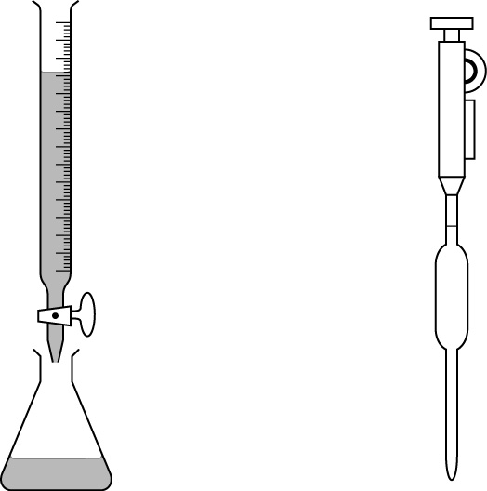
burette
pipette filler

(conical) flask
pipette

2 State the colour of the following indicators: [F]
(a) phenolphthalein (i) in acid solution: colourless; (ii) in alkaline solution: pink.
(b) litmus (i) in acid solution: red; (ii) in alkaline solution: blue.
3 True or false? Put T or F in the boxes. [F]
The word equation for neutralisation is: acid + alkali → salt + hydrogen. | F
There is a sudden change in pH at the end point of a titration. | T
When an acid is added to an alkali the pH increases. | F
Universal indicator is often used to find the end point of a titration. | F
4 Complete the following by putting ÷ or x in the box. [H]
moles = concentration | x | volume (in dm³)
volume (in dm³) = moles | ÷ | concentration
concentration = moles | ÷ | volume (in dm³)
5 20 cm³ of a solution of 0.1 mol/dm³ sodium hydroxide solution is neutralised by 8 cm³ of hydrochloric acid. Calculate (a) the concentration of the sodium hydroxide solution and (b) the concentration of the hydrochloric acid. [H]
(a) 0.1 x 20/1000 = 2 x 10^{–3} mol/dm³ NaOH
(b) 2 x 10^{–3} x 1000/8 = 0.25 mol/dm³ HCl
6 How many cm³ of 1.2 mol/dm³ sodium hydroxide contains 0.3 moles of sodium hydroxide? [H]
1000 x 0.3/1.2 = 250 cm³

Gas volumes
1 Name these pieces of apparatus used in the measurement of gas volumes. [F]
burette
trough
measuring
cylinder
gas syringe

2 When calcium carbonate reacts with hydrochloric acid, carbon dioxide is given off. The graph on the left shows a plot of the volume of carbon dioxide given off against time. Put the answers in the boxes on the right. [F]
0204060
Times (s)
40
30
20
10
0
Volume of CO₂ (cm³)
A
B
C
The total volume of gas produced in is 40 cm³
The reactions stops at 35 seconds
At which of the points A, B or C, is the reaction fastest? A
The volume of gas released after 10 seconds is 20 cm³
3 Select words from the list to fill in the blank spaces. [F]
concentration directly first inversely last limiting product reactant volume
The limiting reactant is the one that is used up first of all. In a gas reaction the volume of gas produced is directly proportional to the amount of limiting reactant present.
4 True or false? Put T or F in the boxes. [F]
Change in mass can be used to monitor the amount of gas given off in a reaction. | T
When magnesium reacts with excess acid, the reaction stops when the acid is used up. | F
Rate of reaction is fastest at the start of a reaction. | T
5 A container of volume 5.00 dm³ is filled with pure oxygen at atmospheric pressure. Calculate the number of moles of oxygen present in the jar. (1 mol of gas occupies 24 dm³ at atmospheric pressure.) 1 x 5/24 = 0.208 mol [H]
6 What volume (in dm³) will 0.022 g of carbon dioxide gas occupy at atmospheric pressure? (Atomic masses: C = 12, O = 16.) [H]
CO₂ = 44 moles of CO₂ = 0.022/44 = 5 x 10⁻⁴; volume = 5 x 10⁻⁴ x 24 = 0.012 dm³

Equilibria
1 Solve the clues across. The shaded column gives the name of a substance used to make sulfuric acid. [F]
 | 1 | R | A | W
 |  | 2 | B | A | C | K | W | A | R | D
3 | C | O | N | T | A | C | T
 |  |  | 4 | E | Q | U | I | L | I | B | R | I | U | M
 |  |  | 5 | R | E | V | E | R | S | I | B | L | E
1 Sulfur and air are two of the ____ materials used to make sulfuric acid.
2 In a reversible reaction the equation products → reactants represents the _________ reaction.
3 The name of the process for making sulfuric acid.
4 Certain types of ‘balanced’ reversible reactions are called _________ reactions.
5 A reaction that can go in both directions.
2 True or false? Put T or F in the boxes. [F]
In an equilibrium reaction:
the rate of the forward reaction equals the rate of the backward reaction. | T
the concentrations of the reactants and products do not change at equilibrium. | T
when the concentration of the products is greater than the reactants, equilibrium is to the left. | F
changing the concentration of the reactants alters the concentration of products. | T
changing the temperature has no effect on the position of equilibrium. | F
3 Underline the conditions used in the Contact Process. [F]
The temperature is 50°C 250°C 450°C 850°C
The catalyst is Fe Fe₂O₃ Ni V₂O₃ V₂O₅
4 State the effect of the following on the position of equilibrium in the reaction [H]
N₂O₄ ⇌ 2NO₂.
Increasing the concentration of N₂O₄ Equilibrium shifted to the right.
Removing NO₂ Equilibrium shifted to the right.
Increasing the pressure Equilibrium shifted to the left.
5 Complete these equations for the manufacture of sulfuric acid. [H]
(a) 2SO₂ + O₂ ⇌ 2SO₃ (b) SO₃ + H₂O ⇌ H₂SO₄
6 Complete the following sentence: [H]
In the Contact Process a high temperature decreases the yield and increases the rate of reaction, so an optimum temperature is used for the process.

Strong and weak acids
1 Solve the clues across. The shaded column describes mineral acids such as sulfuric and hydrochloric acid. [F]
 |  | 1 | S | A | M | E
 | 2 | E | T | H | A | N | O | I | C
3 | C | A | R | B | O | N
 | 4 | C | O | N | D | U | C | T | I | V | i | T | Y
 |  | 5 | N | I | T | R | I | C
6 | N | E | G | A | T | I | V | E
1 Equal volumes of 0.1 mol/dm³ hydrochloric and ethanoic acids produce the _____ volume of hydrogen with excess magnesium.
2 E________ acid is a weak acid.
3 ________ dioxide is released when acids react with calcium carbonate.
4 Ethanoic acid has a lower electrical _____________ than hydrochloric acid.
5 N_______ acid is a strong acid.
6 When ethanoic acid is electrolysed, hydrogen is formed at the ___________ electrode.
2 Select words from the list to fill in the blank spaces. [F]
faster higher lower more slower stronger weak
Ethanoic acid reacts slower than hydrochloric acid of the same concentration because hydrochloric acid is a stronger acid and forms more hydrogen ions in solution. This results in a higher collision frequency of the ions for hydrochloric acid.
3 True or false? Put T or F in the boxes. [H]
Acids ionise in water to produce hydrogen ions. | T
Solutions of 0.1 mol/ dm³ of ethanoic acid and nitric acid have the same number of H⁺ ions. | F
Strong acids are inappropriate as descaling agents. | T
The ionisation of a weak acid produces an equilibrium mixture. | T
Hydrochloric acid is incompletely ionised in aqueous solution. | F
4 Complete the equations for the ionisation of ethanoic acid and hydrochloric acid. [H]
CH₃CO₂H | ⇌ | CH₃CO₂– | + | H⁺

HCl | → | H⁺ | + | Cl–

Ionic equations
1 Label these pieces of apparatus, which are used to prepare an insoluble compound. [F]
filter paper
precipitate
filter funnel
filtrate

2 Solve the clues across. The shaded column gives the colour of the precipitate when silver nitrate solution is added to a solution containing chloride ions. [F]
 | 1 | Y | E | L | L | O | W
 |  |  |  |  |  | 2 | H | A | L | I | D | E
 |  |  |  |  |  | 3 | I | O | N | S
 | 4 | S | U | L | F | A | T | E
 |  |  | 5 | A | Q | U | E | O | U | S
1 The colour of precipitate when iodide ions are added to lead ions.
2 The general name for chloride, bromide and iodide ions.
3 The particles that react rapidly in precipitation reactions.
4 Barium nitrate is used to test for this ion.
5 The state symbol aq stands for __________ solution.
2 Put these stages for the preparation of an insoluble compound in the correct order. [F]
1 Wash the precipitate
2 Separate the precipitate by filtration
3 Mix solutions of the two reactants
4 Dry the precipitate
5 Stir and allow a precipitate to form
The correct order is 3 → 5 → 2 → 1 → 4
3 Complete the equations for these reactions and state the name of the precipitates. [F]
(a) silver nitrate + potassium bromide → silver bromide + potassium nitrate
(b) barium nitrate + sodium sulfate → barium sulfate + sodium nitrate
The precipitates are (a) silver bromide and (b) barium sulfate
4 Convert this equation into a balanced ionic equation. Include state symbols. The copper ion is Cu²⁺. CuSO₄(aq) + 2NaOH(aq)) → Cu(OH)₂(s) + Na₂SO₄(aq) [H]
Cu²⁺(aq) + 2OH–(aq) → Cu(OH)₂(s)

