Energy transfers – fuel cells
1 (a) Write a word equation for the combustion of hydrogen.
(b) Why is hydrogen regarded as a ‘clean’ fuel?
(c) State two problems involved with the use of hydrogen as a fuel.
(d) Describe a test for hydrogen and state the result of the test.
2 Fuel cells use hydrogen and oxygen to produce electricity.
(a) What is a fuel cell?
(b) Write the word equation for the overall reaction in a fuel cell.
(c) What advantages are there in using fuel cells to power a spacecraft?
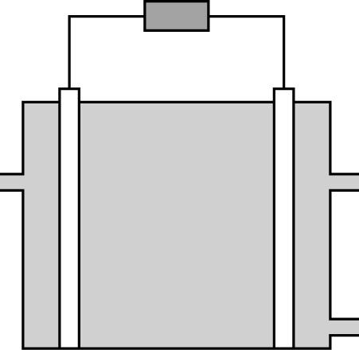
3 Fuel cells require oxygen in order to work.
(a) Describe a test for oxygen and state the result of the test.
(b) When a fuel burns in oxygen energy is given out. What name is given to a reaction that gives out energy?
(c) The diagram shows a fuel cell.
C
D
E
F
A
B

Which letters on the diagram refer to:
(i) hydrogen in (ii) oxygen in (iii) electrode (iv) potential difference developed
(v) water out (vii) electrolyte?
4 Read the following passage then answer the questions that follow.
Modern hydrogen–oxygen fuel cells can achieve a 50% fuel/electricity efficiency compared with about 20% efficiency for petrol engines. They are particularly useful for large vehicles such as lorries and buses, which may have large auxiliary power units and air conditioning systems. Because fuel cells have few moving parts, this reduces the fuel consumption and wear and tear on the vehicle. Conventional large-scale electricity generation is also less efficient and in generating 1000 kWh of electricity produces 11.4 kg of pollutants. It has been estimated that an equivalent fuel cell power plant would produce 28 g of pollutants.
(a) State two advantages of fuels cells over conventional electricity generation.
(b) What are the advantages of fuel cells over petrol engines in vehicles?
(c) What type of road vehicles benefit most from using fuel cells?

Energy transfers – fuel cells
1 (a) Write a symbol equation for the combustion of hydrogen.
(b) Sketch an energy level diagram for the reaction in part (a). On your diagram show:
the reactants and products and the energy change for the reaction.
(c) Is this reaction exothermic or endothermic? Give a reason for your answer.
2 The fuel cell principle was discovered by Sir William Grove in 1839. When investigating the electrolysis of water, he switched off the power supply and found that an electric current still flowed but in the opposite direction. Draw a diagram to show this. On your diagram show the electrolyte, the anode and cathode, oxygen gas, hydrogen gas and the direction of the current flow.
3 The diagram shows a hydrogen–oxygen fuel cell.
electrodes

(a) Describe how the fuel cell works and give an overall symbol equation for the reaction.
(b) Explain, giving relevant half equations, the changes that take place in the fuel cell at the electrodes.
(c) Explain why these reactions are redox reactions.
4 State four advantages of hydrogen–oxygen fuel cells over conventional methods of generating electricity.
5 Many years have gone by since fuel cells were first developed. Fuel cells have been used in buses in several countries for a number of years but have still not gained general acceptance for use in cars or for other general purposes. Suggest why it has taken so long for fuel cells to come into general use.

Redox reactions
1 The table shows the temperature changes when equal amounts of different metal powders are added to equal volumes of copper(II) sulfate solution.
Metal | Temperature rise (ºC)
calcium | 28
iron | 5
magnesium | 18
zinc | 12
(a) Put the metals in order of their reactivity.
(b) Manganese is between magnesium and zinc in the reactivity series. Estimate the temperature rise when manganese powder is added to copper(II) sulfate solution.
2 Complete these word equations.
(a) magnesium + copper(II) sulfate →
(b) zinc + iron(II) sulfate →
(c) ___________ + ___________ → magnesium chloride + tin
3 Three methods of preventing iron from rusting are painting, galvanising and tin plating.
(a) What conditions are needed for iron to rust?
(b) State three other ways of preventing iron from rusting.
(c) Suggest why tin plating is better than painting in preventing iron from rusting.
(d) What do you understand by the term galvanising?
(e) Write a word equation for the rusting of iron.
(f) Suggest how painting prevents iron from rusting.
4 The reaction between aluminium and iron(III) oxide is an example of a redox reaction.
2Al + Fe₂O₃ → 2Fe + Al₂O₃
(a) Explain what is meant by the term redox reaction.
(b) Explain why the reaction between aluminium and iron(III) oxide is a redox reaction.

Redox reactions
1 Write symbol equations for the following displacement reactions:
(a) magnesium + iron(III) chloride solution, FeCl₃.
(b) zinc + silver nitrate solution, AgNO₃.
(c) zinc + copper(II) sulfate solution, CuSO₄.
2 Rust is hydrated iron(III) oxide. A simplified equation for rusting is
4Fe + 3O₂ + 12H₂O → 2Fe₂O₃.6H₂O
(a) Explain why rusting is a redox reaction in terms of oxygen transfer.
(b) Explain why rusting is a redox reaction in terms of electron transfer.
(c) Write half equations for:
(i) the conversion of iron to iron(III) ions.
(ii) the conversion of oxygen to oxide ions.
3 (a) Explain why the following reaction is a redox reaction:
Zn + 2AgNO₃ → 2Ag + Zn(NO₃)₂
(b) Write two half equations for this reaction. Zinc ions are Zn²⁺ and silver ions are Ag⁺.
(c) In the reaction between zinc and silver nitrate, which is the oxidising agent and which is the reducing agent? Give a reason for your answer.
4 (a) Explain what is meant by the term sacrificial protection.
(b) Give two examples of metals that can sacrificially protect iron from rusting and write half equations for the reactions of these two metals.
5 Explain how coating iron with zinc prevents the iron from rusting.

Alcohols
1 (a) What is the difference between a molecular formula and a displayed formula?
(b) Write the molecular formula for ethanol.
(c) State two uses of ethanol other than its use in alcoholic beverages.
2 Ethanol can be produced by fermentation or by the hydration of ethene.
(a) Write word equations for these two reactions.
(b) What conditions are needed for:
(i) fermentation?
(ii) production of ethanol by hydration of ethene?
(c) Ethanol can be separated from the mixture of substances in the fermentation vessel by a particular experimental procedure. Give the name of this experimental procedure and describe how this procedure is carried out to obtain pure ethanol.
3 The apparatus shown below is used to dehydrate ethanol in the laboratory.
ethanol soaked
in ceramic wool
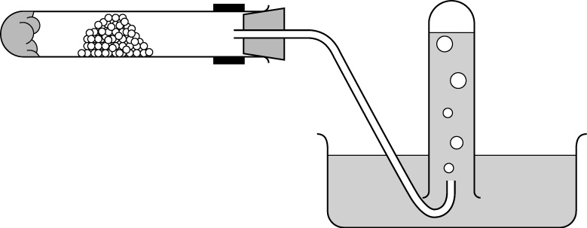
aluminium oxide

(a) What do you understand by the term dehydration?
(b) What is the purpose of the aluminium oxide?
(c) Describe how the reaction is carried out and how the product is collected.
(d) Write a word equation for the dehydration of ethanol.
4 Ethanol (alcohol) is used in alcoholic beverages. Drinking too much alcohol can damage the nervous system and cause liver damage. Despite this, many people still drink large amounts of alcohol. Suggest why.

Alcohols
1 (a) Ethanol can be made by fermentation using yeast. Give details of the conditions used and explain how the ethanol can be purified from the fermentation mixture.
(b) Explain why the temperature of the fermentation mixture must be carefully controlled.
(c) Explain why air must be excluded from the fermentation mixture.
2 Ethanol can be dehydrated by passing its vapour over heated aluminium oxide.
(a) What is the purpose of the aluminium oxide?
(b) Write a symbol equation for the dehydration of ethanol.
(c) When ethanol is dehydrated in the laboratory, the gaseous product is collected over water. Draw a diagram to show how this gas is collected.
(d) What does this method of gas collection tell you about the solubility of the gaseous product of the reaction?
3 Ethanol can be made by the hydration of ethene.
(a) How does this method of ethanol production differ from the production of ethanol by fermentation?
(b) State two advantages of making ethanol by hydration rather than by fermentation.
(c) Write a symbol equation for the hydration of ethene.
4 Families of organic chemicals have a general formula.
(a) What do you understand by the term general formula?
(b) Write down the general formula for the alcohols.
(c) Draw the displayed formula for propan-1-ol, an alcohol containing three carbon atoms.
(d) Germanium, Ge, forms a series of compounds like the alkanes, alkenes and alcohols, where germanium replaces carbon.
Write the molecular formula for germanoethanol, the germanium equivalent of ethanol.

Chemistry of sodium chloride
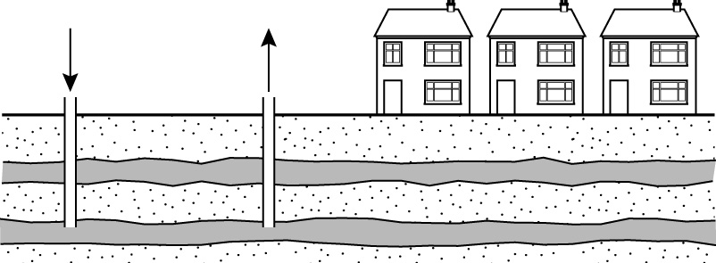
1 The diagram shows a salt mine.
rocks
layers of salt
salt
solution
water

(a) What is the chemical name for salt?
(b) Describe how a pure dry sample of salt can be produced from this salt mine without the need to employ miners to extract it from below ground.
(c) Suggest one problem that can arise from salt mining.
2 Chlorine and sodium hydroxide are produced on a large scale to make a number of commercially important compounds.
(a) State the name of a household substance made by reacting sodium hydroxide with chlorine.
(b) Give another use for (i) sodium hydroxide and (ii) chlorine.
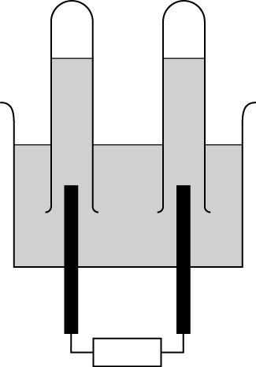
3 A solution of concentrated sodium chloride is electrolysed using the apparatus shown below.
chlorine
hydrogen

concentrated
sodium chloride
solution

power pack

(a) Which electrode is the anode? Give a reason for your answer.
(b) State a test for chlorine.
(c) Suggest a suitable material that can be used for the electrodes in this electrolysis.
(d) Explain why a solution of sodium chloride conducts electricity but solid sodium chloride does not.
(e) When red litmus paper is placed near the electrode B it turns blue quickly. It takes longer to turn blue if it is placed near electrode A. Explain these observations.

Chemistry of sodium chloride
1 The diagram shows the apparatus used to electrolyse a concentrated aqueous solution of sodium chloride.

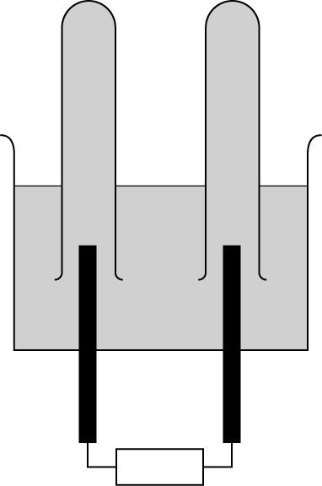
power pack
B
concentrated
sodium chloride
solution
C
graphite
electrodes
−
+

(a) Suggest why graphite is used as a material for the electrodes.
(b) Describe what you would observe in tubes A and B when the power pack is switched on.
(c) State the name of the gas formed in (i) tube A and (ii) tube B.
(d) Explain, with the aid of equations, the reactions occurring at:
(i) the cathode.
(ii) the anode.
(e) Explain why the electrolyte solution becomes alkaline during this electrolysis.
2 This question is about the electrolysis of molten sodium chloride.
(a) State the conditions needed for this electrolysis to take place.
(b) Explain why molten sodium chloride conducts electricity but solid sodium chloride does not conduct.
(c) Describe the electrode reactions that occur during this electrolysis at:
(i) the anode.
(ii) the cathode.
3 Explain why the electrode product formed at the anode when a dilute solution of sodium chloride is electrolysed is different from the electrode product formed when a concentrated solution of sodium chloride is electrolysed.

Depletion of the ozone layer
1 CFCs were fist synthesised in 1928.
(a) What does the abbreviation CFC stand for and what elements do they contain?
(b) State two uses of CFCs.
(c) In 1989 a group of European countries agreed to ban the use of CFCs by the year 2000. Why did they agree to do this?
(d) State the names of two groups of chemicals that are now used in place of CFCs.
(e) State three chemical properties of CFCs.
2 The table shows the annual production of CFCs over the last 25 years.
Year | 1980 | 1985 | 1990 | 1995 | 2000 | 2005
Mass of CFCs produced in thousands of tonnes | 680 | 780 | 570 | 130 | 30
(a) Describe and explain the changes in these figures.
(b) Suggest a value for the production of CFCs in 2005.
(c) Why have some countries continued to produce CFCs when others have stopped producing them?
3 Ozone is an important molecule present in the upper atmosphere in a layer no more than a few centimetres thick.
(a) State the chemical formula for ozone.
(b) Over the past 25 years the amount of ozone in the ozone layer has decreased considerably. Explain why the amount of ozone has decreased.
(c) Explain why the depletion of ozone affects the amount of ultraviolet light reaching the Earth’s surface.
(d) State two effects on human health caused by overexposure to ultraviolet light.
4 Many people continue to expose themselves to bright sunlight despite the fact that they know that it is harmful to them. Suggest why people do this.

Depletion of the ozone layer
1 The diagram shows the effect of ozone depletion in the ozone layer.
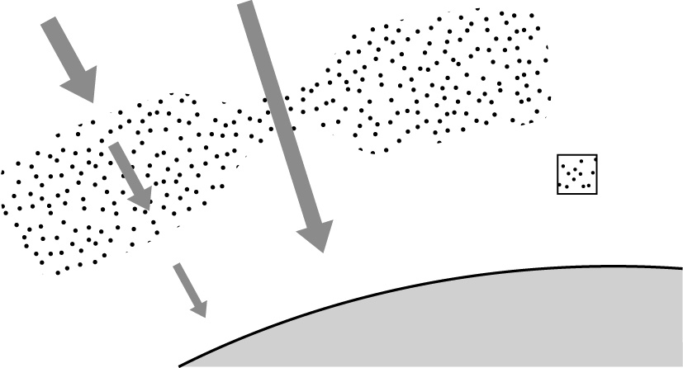
ozone layer
ozone
molecules
Earth’s surface

ultraviolet light

(a) Use the information in the diagram to suggest why it is incorrect to talk about a hole in the ozone layer.
(b) Use the diagram to explain how the depletion of ozone allows more ultraviolet light to reach the surface of the Earth.
(c) CFCs will continue to deplete ozone for a long time after they cease to be used. Explain why.
(d) In August 2006, it was reported that the ‘hole’ in the ozone layer had diminished in size in comparison with previous years. Suggest why this has happened.
2 CFCs are responsible for the breakdown of ozone.
(a) Explain why CFCs are only broken down in the stratosphere.
(b) Why do only a small number of CFC molecules break down a large number of ozone molecules?
(c) CFCs break down to form free radicals. Explain how this happens.
(d) Write symbol equations for the reactions of a chlorine free radical with ozone and a ClO free radical with oxygen atoms.
3 Many countries have banned the use of CFCs.
(a) Why have some countries not banned CFCs?
(b) Name two other types of compounds that can be used in place of CFCs in aerosol sprays and suggest why these are safe to use.
4 A well-known scientist suggests that CFCs are not responsible for the destruction of the ozone layer. He suggests that much of the chlorine in the upper atmosphere comes from wood rotting fungi. He estimates that 5.5 million tones of chloromethane, CH₃Cl, are produced annually in this way. How should other scientists respond to this suggestion?

Hardness of water
1 Equal volumes of three samples of water from different places were evaporated and the amount of solid deposited weighed. The table shows the results.
Sample | A | B | C
Mass of deposit (g) | 0.5 | 0.001 | 0.1
(a) Which of the samples contained the hardest water?
(b) What is the general name given to a deposit like this in kettles and pipes?
(c) Which sample of water, A, B or C, would produce the most lather when shaken with soap solution?
(d) State the names of two positive ions in water that are responsible for the hardness.
2 Two samples, X and Y, were taken from different sources. Each sample was divided into three portions. One portion was left untreated and the other two portions were treated as shown in the table. Each sample was shaken with three drops of soap solution before and after treatment and the height of the lather measured.
Treatment | None | Boiled | Passed through an ion exchange resin
Height of lather in water X | 1.0 cm | 1.2 cm | 2.0 cm
Height of lather in water Y | 1.5 cm | 2.8 cm | 3.0 cm
(a) Comment on the relative hardness of each of these samples of water before being treated.
(b) Explain the differences in the heights of the lather of each sample of water in terms of removal of permanent or temporary hardness.
(c) Explain the difference between temporary and permanent hardness of water in terms of the dissolved chemicals.
(d) Explain how boiling removes the hardness in water.
(e) Explain how temporary hardness in water arises. Include relevant word equations in your answer.

Hardness of water
1 Describe an experiment to compare the temporary hardness in different samples of water.
2 Ion exchange can be used to remove permanent hardness from water. The resin in the ion exchange column contains sodium ions weakly bound to the resin.
(a) Describe and explain how an ion exchange column removes the permanent hardness from water.
(b) Ion exchange resins are used in commercial filters for drinking water. Suggest why the manufacturers suggest that the ion exchange resin should be changed every month or so.
(c) Ions exchange resins can be reused if they are washed with common salt and then with pure water. Explain why they can be reused after this treatment.
3 Washing soda crystals can be used to remove the hardness from water.
(a) What is the chemical name for washing soda?
(b) What type of hardness does washing soda remove?
(c) Explain how washing soda is used to remove the hardness from water. Write an equation for this reaction.
4 One of the substances found in temporary hard water is calcium bicarbonate, Ca(HCO₃)₂.
(a) What do you understand by the term temporary hardness?
(b) Write a word equation and a balanced chemical equation to describe the effect of boiling a sample of temporarily hard water.
(c) Kettles and pipes in hard water areas become encrusted with limescale.
(i) Limescale is calcium carbonate. Write a symbol equation for the reaction of calcium carbonate with hydrochloric acid.
(ii) Explain why hydrochloric acid is not really suitable for removing limescale from kettles. What acid could you use in place of hydrochloric acid? Give a reason for your answer.

Natural fats and oils
1 The diagram shows a mixture of oil and water.
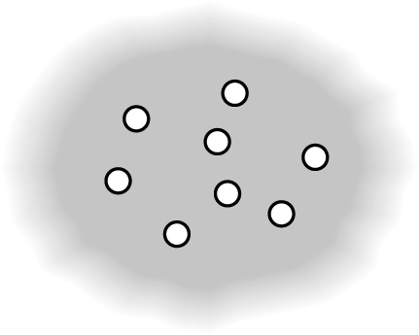
oil
water

(a) Describe this mixture of oil and water and give an everyday example of this type of mixture.
(b) Some vegetable oil is added to vinegar. The mixture is shaken and then allowed to stand for a few minutes. Describe what you would observe during this process.
(c) Most vegetable oils are unsaturated. What do you understand by the term unsaturated?
(d) How can you test for unsaturation?
2 Fats and oils are important raw materials for the chemical industry.
(a) State the name of two foods that contain animal fats.
(b) Name two plants from which vegetable oils can be extracted.
(c) To which class of chemical compounds do fats and oils belong?
(d) What is the difference between a fat and an oil?
(e) Vegetable oils are immiscible with water. What do you understand by the term immiscible?
(f) Describe how margarine is manufactured from vegetable oil.
3 Alkalis are used to make soaps from fats and oils.
(a) State the name of the alkali used in soap making.
(b) What conditions are needed to make soap?
(c) What happens to the fat when it reacts with the alkali?
(d) Apart from soap name the other product formed when a fat reacts with an alkali.
(e) What is the name given to the process of making soaps from fats and oils?
4 A diet containing a high proportion of saturated fats may harm your health. Suggest why some people continue to eat a lot of saturated fats despite the fact that they are not good for them.

Natural fats and oils
1 Fats and oils can be saturated or unsaturated.
(a) Fats and oils can be extracted from plants or animals. Which of these sources is most likely to contain saturated fats?
(b) What do you understand by the term saturated?
(c) Explain how you can test for unsaturation in fats by a chemical test.
(d) Suggest how you could use the chemical test in part (c) to compare the amount of unsaturation in a variety of fats and oils.
2 (a) Explain why unsaturated fats are healthier as part of the diet than saturated fats.
The table shows the fat and oil content of equal amounts of four butter substitutes:
A, B, C and D.
Food | Saturated fat (g) | Monounsaturated fat (g) | Polyunsaturated fat (g) | Cholesterol (mg)
A | 51 | 23 | 3 | 140
B | 13 | 45 | 16 | 3
C | 9 | 22 | 60 | 0
D | 28 | 30 | 12 | 20
(b) Which food contains most cholesterol?
(c) Which food contains most unsaturated fat? Explain your answer.
(d) What do you understand by the term polyunsaturated?
(e) Suggest why it may sometimes be difficult to tell which food contains most saturated fat by looking at figures such as these.
(f) Which food is the least healthy? Explain your answer.
3 Soaps are made from natural fats and oils.
(a) Describe how soaps are made.
(b) What is the general term that describes soap making?
(c) What type of chemical reaction occurs when soaps are made?
(d) Write a word equation that describes soap making.

Analgesics
1 Aspirin is a common painkiller.
(a) What is the scientific name for a painkiller?
(b) State the names of two other common painkillers.
(c) Describe the beneficial effects of aspirin.
(d) Why should doses of aspirin be carefully regulated?
(e) Describe two advantages of using paracetamol rather than aspirin.
2 Drugs are manufactured under very strict chemical conditions using reactants of the highest purity.
(a) What do you understand by the term drug?
(b) Explain why the reagents used to manufacture drugs must be of the highest purity.
(c) Explain why very specific chemical conditions are used to manufacture drugs.
(d) Some drugs, such as aspirin, exist in a soluble form as well as a normal, less soluble form. What advantages are there of using a drug in its soluble form?

3 Oil of wintergreen can be used to relieve muscle aches. The structures of oil of wintergreen and aspirin are shown below.
aspirin
O
O
H
C
O
O
C
C
C
C
C
C
C
C
H
H
H
H
H
H
H

H
H
H
H
H
H
H
H
O
C
C
C
C
C
C
C
C
O
O
oil of winter green

(a) Which of these structures has the same functional group as ethanol?
(b) What similarities and differences are there in the structures of oil of wintergreen and aspirin?
(c) Write the molecular formula for oil of wintergreen.
(d) Oil of wintergreen can be extracted from the wintergreen plant or made synthetically by chemical synthesis.
(i) Suggest how oil of wintergreen can be extracted from plant material.
(ii) What is the meaning of the term synthesis?

Analgesics
1 Paracetamol and aspirin are common drugs.
(a) What do you understand by the term drug?
(b) Describe two advantages of using aspirin in its soluble form.
(c) Describe two advantages of using paracetamol rather than aspirin and one advantage of using aspirin rather than paracetamol.
(d) Overdosing on aspirin and paracetamol can have harmful effects. Which organ of the body is most likely to be affected most by both these drugs?
(e) The displayed formulae for aspirin and paracetamol are shown below.
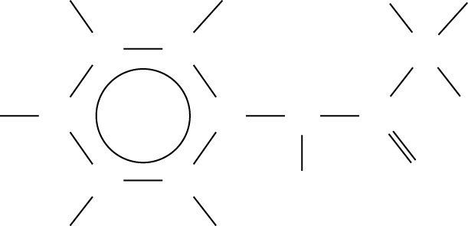
H
H
H
H
H
O
C
C
C
C
N
C
C
C
C
H
H
H
H
H
H
H
C
C
C
C
C
C
C
C
O
O
O
O
H
H
H
C
H
H

(i) What type of atom is present in paracetamol that is not present in aspirin?
(ii) What other similarities and differences are there in the structures of paracetamol and aspirin?
2 Some drugs, such as aspirin, exist in a soluble as well as in a normal, less soluble form.
(a) How does the structure of soluble aspirin (shown below) differ from the structure of normal aspirin (shown on the right in the diagram above)?

H
H
H
H
H
H
H
O
O
O
C
C
C
C
C
C
C
O⁻Na⁺
C
C

(b) Explain why these two forms of aspirin have different solubilities.
3 Aspirin is a white solid that is manufactured from salicylic acid.
(a) State the name of the chemical that is reacted with salicylic acid to make aspirin.
(b) State the conditions required for this reaction.
(c) After the reaction is complete, the aspirin is separated from the reaction mixture. Suggest how this is done.

C6a Fuel cells

Foundation
1 (a) hydrogen + oxygen → water [1]
(b) only produces water as product; water is not a pollutant [2]
(c) 2 of: needs to be stored under pressure; bulky as gas; flammable [2]
(d) lighted splint into gas; gives squeaky pop [2]
2 (a) type of energy producing cell; from reaction of; fuel/hydrogen; + oxygen; potential difference/voltage produced [5]
(b) hydrogen + oxygen → water [1]
(c) any 2 of: non-polluting/only produces water; more efficient; fewer stages in producing electricity [2]
3 (a) glowing splint into gas; relights [2]
(b) exothermic [1]
(c) (i) A/E (ii) A/E (iii) B (iv) C (v) F
(vi) D [6]
4 (a) fewer/no pollutants; more efficient [2]
(b) not polluting; fewer moving parts [2]
(c) bus/lorry [2]

Higher
1 (a) 2H₂ + O₂ → 2H₂O (1 for species; 1 for balance) [2]
(b) axes correct; reactants on left + products on right; reactants above products; enthalpy change correctly labelled [4]
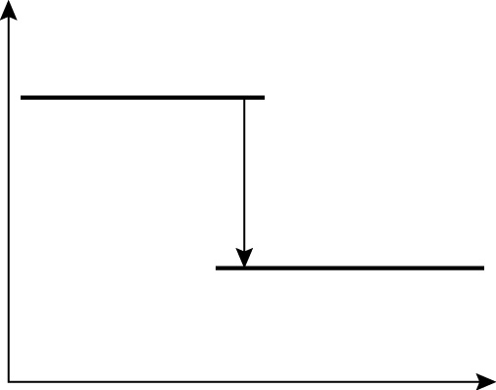
2H₂ + O₂
2H₂O
enthalpy change
Reaction progress
Energy

(c) exothermic; products have less energy than reactants/energy given out on reaction [2]
2 Suitable apparatus with two electrodes; electrolyte shown; test tubes to collect gases; oxygen and hydrogen in test tubes; hydrogen at (cell) anode and oxygen at (cell) cathode; arrow in direction hydrogen to oxygen [6]
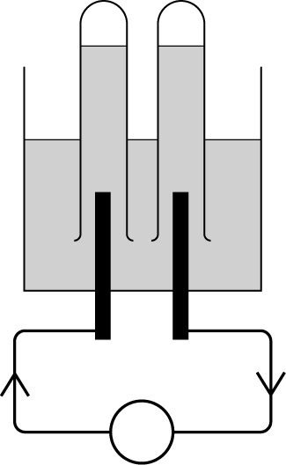
hydrogen
electrolyte
(sodium hydroxide
solution)
anode
cathode
oxygen

3 (a) 6 of: hydrogen pumped in at one electrode; oxygen pumped in at the other; electrodes permeable to gases; contain catalyst; potential developed between electrodes; water out at the bottom; 2H₂ + O₂ → 2H₂O [6]
(b) at cell anode hydrogen loses electrons; at cell cathode oxygen reacts with hydrogen ions; and gains electrons;
H₂ → 2H⁺ + 2e⁻ (or multiples)
(1 for species, 1 for balance)
O₂ + 4H⁺ +4e⁻ → 2H₂O (or multiples)
(1 for species, 1 for balance) [7]
(c) oxidation is electron loss and reduction electron gain; hydrogen loses electrons; oxygen gains electrons; [3]
4 more efficient; fewer stages; direct energy transfer; less pollution [4]
5 5 of: suitable methods of dealing with hydrogen needed to be developed; abundance of cheap petrol for cars (until recently); expensive to develop new technology; platinum/catalyst expensive; people happy with what they have already; people not so worried about pollution until recently; bulky to produce equivalent amount of energy [5]

C6b Redox reactions

Foundation
1 (a) calcium>magnesium>zinc>iron [1]
(b) 15°C (allow between 13 and 17) [1]
2 (a) → copper + magnesium sulfate [1]
(b) → iron + zinc sulfate [1]
(c) magnesium + tin chloride [1]
3 (a) oxygen/air; water [2]
(b) oil/grease; alloying; sacrificial protection [3]
(c) forms layer on surface of metal; prevents air/oxygen reaching surface; and water reaching surface [3]
(d) covering (iron) with layer of zinc [1]
(e) iron + oxygen + water → hydrated iron(III) oxide (1 for left; 1 for right) [2]
(f) forms layer on surface of metal; prevents air/oxygen reaching surface; and water reaching surface [3]
4 (a) oxidation reduction reaction [1]
(b) aluminium gains oxygen; so gets oxidised; iron oxide loses oxygen; so gets reduced [4]

Higher
1 (a) Mg + FeCl₂ → Fe + MgCl₂ [1]
(b) Zn + 2AgNO₃ → 2Ag + Zn(NO₃)₂
1 for formulae; 1 for balance [2]
(c) Zn + CuSO₄ → ZnSO₄ + Cu [1]
2 (a) Iron gains oxygen; so is oxidised; oxygen in air combines with ion/oxidation number decreases; so is reduced [4]
(b) iron loses electrons; oxidation is loss of electrons; oxygen gains electrons; reduction is gain of electrons [4]
(c) (i) Fe → Fe³⁺ + 3e⁻
(1 for ions, 1 for electrons) [2]
(ii) O₂ + 4e⁻ → 2O²⁻
(1 for ions, 1 for electrons) [2]
3 (a) zinc loses electrons; so oxidised; silver ions gain electrons; so reduced [4]
(b) Zn → Zn²⁺ + 2e⁻
(1 for ions, 1 for electrons) [2]
Ag⁺ + e⁻ → Ag
(1 for ions, 1 for electrons) [2]
(c) silver nitrate is oxidising agent; because it has oxidised the zinc; zinc is the reducing agent; because it has reduced the silver ions [4]
4 (a) more reactive metal attached to less reactive metal; more reactive metal corrodes in preference to the less reactive metal [2]
(b) any two metals higher than iron in reactivity series but not too reactive e.g. zinc; magnesium; two equations (1 each) (e.g. Zn → Zn²⁺ + 2e⁻ ; Mg → Mg²⁺ + 2e⁻) [4]
5 zinc forms barrier to oxygen; and water; also acts to sacrificially protect the iron [3]

C6c Alcohols

Foundation
1 (a) displayed formula shows all atoms and bonds; molecular formula shows number of each type of atom present [2]
(b) C₂H₆O (allow C₂H₅OH) [1]
(c) solvent; fuel [3]
2 (a) glucose → ethanol + carbon dioxide
(1 for glucose; 1 for carbon dioxide)
ethene + water → ethanol (1 mark) [3]
(b) (i) 25–50°C; water; (enzymes in) yeast; lack of oxygen [4]
(ii) 3 of: steam; heat; phosphoric acid; catalyst [3]
(c) distillation; mixture in flask; connected to condenser; heat flask gently; collect fractions; ethanol distils off first (ignore fact that it is constant boiling mixture) [6]
3 (a) removal of water [1]
(b) catalyst [1]
(c) heat catalyst; flick flame over to end of tube/ethanol; to vaporise alcohol; ethene formed on catalyst; ethene collected over water; in test tube [6]
(d) ethanol → ethene + water [1]
4 any 2 of: gives them pleasure; can give confidence; gets rid of worries; want to appear sociable [2]

Higher
1 (a) 10 of: dissolve; glucose; in water; keep in container with minimum air; at temperature of 25–50°C; for several weeks; separate alcohol by distillation; mixture in flask; connected to condenser; heat flask gently; collect fractions; ethanol distils off first (ignore fact that it is constant boiling mixture) [10]
(b) enzymes in yeast; enzymes responsible for fermentation; rate of reaction too low at lower temperature; high temperatures denature the enzyme; so doesn’t work [5]
(c) prevents formation of ethanoic acid [1]
2 (a) catalyst [1]
(b) C₂H₅OH → C₂H₄ + H₂O
(1 for ethanol; 1 for RHS of equation) [2]
(c) trough with water; delivery tube going into water with end curved under; inverted test tube; gas bubbles shown/
|some ethene indicated in top of tube [4]
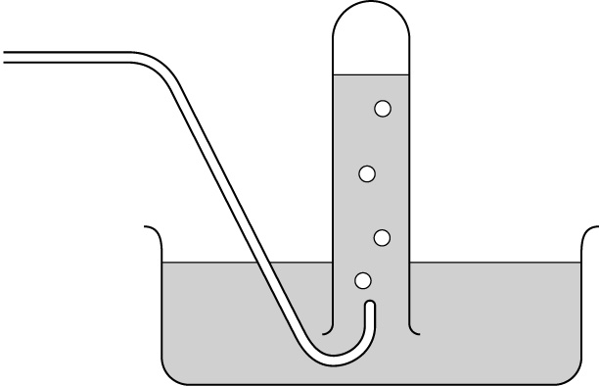
delivery tube
ethene
water

(d) gas/ethene is insoluble in water [1]
3 (a) phosphoric acid catalyst used; not enzymes/yeast; reaction carried out at high temperature; rather than fairly low; steam needed; not liquid water [6]
(b) any 2 of: not as many side reactions/contaminating substances; quicker reaction; can be done continuously rather than as batch process; easier to separate product [2]
(c) C₂H₄ + H₂O → C₂H₅OH
(1 for LHS and 1 for RHS of equation) [2]
4 (a) formula that can be applied to write the molecular formula of a particular family of organic compounds [1]
(b) C_{n}H_{2n+1}OH [1]
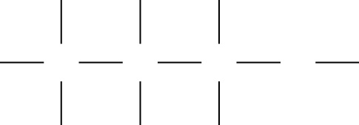
(c) [1]
H
H
H
H
H
H
H
H
O
C
C
C

(d) Ge₂H₅OH [1]

C6d Chemistry of NaCl

Foundation
1 (a) sodium chloride [1]
(b) hot water pumped down; dissolves the salt; salt solution pumped up; water evaporated [1]
(c) subsidence [1]
2 (a) bleach [1]
(b) (i) making soap (ii) sterilise water/make plastics/make solvents [2]
3 (a) B; chlorine formed here; chloride ions are negative [3]
(b) litmus paper; bleached [2]
(c) graphite/platinum [1]
(d) in solid ions are in foxed position/
can’t move; in solution ions free to move [2]
(e) blue colour due to alkali; hydroxide ions formed near B; since they are negative ions; fewer hydroxide ions near A as they are not discharged there/only get there by diffusion [4]

Higher
1 (a) graphite is inert [1]
(b) bubbles of gas/gas formed; at both electrodes [2]
(c) (i) chlorine (ii) hydrogen [2]
(d) (i) hydrogen formed because positive H⁺ ions; from breakdown of water; move to negative electrode; 2H⁺ +2e⁻ → H_{2 |}
(2 marks for equation -1 per error/omission) [5]
(ii) chlorine formed because negative Cl⁻ ions; from sodium chloride; move to positive electrode; 2Cl⁻ – 2e⁻ → Cl_{2|}
(2 marks for equation –1 per error/omission) [5]
(e) hydroxide ions; from breakdown of water; not discharged; hydroxide ions are alkaline [4]
2 (a) heat; high enough temperature to keep sodium chloride molten [2]
(b) ions free to move in molten sodium chloride; ions can’t move in solid [2]
(c) (i) chlorine formed at anode;
2Cl⁻ -e- → Cl₂ [2]
(ii) sodium formed at cathode;
Na⁺ +e- → Na [2]
3 any 8 of: in dilute solution not many chloride ions; chloride ions not discharged; hydroxide ions from electrolysis of water; are negative; so move to anode; and are discharged; as oxygen gas; in concentrated solution the chloride ions; are discharged; as chlorine gas. [8]

C6e The ozone layer

Foundation
1 (a) chlorofluorocarbon; chlorine; fluorine; carbon (ignore hydrogen) [4]
(b) refrigeration; aerosols [2]
(c) scientists had discovered they affected ozone layer; depleted ozone; stopped production because they wanted to stop ozone being destroyed; wanted to reduce harmful effects due to lack of ozone [4]
(d) hydrocarbons; hydrofluorocarbons [2]
(e) chemically inert; insoluble in water; low boiling point [3]
2 (a) 6 from: production figures went up between 1980 and 1985; because little known about hole in ozone layer; and more need for refrigerants/aerosols; then fell slowly between 1985 and 1990; when it became clear that CFCs had harmful effect; drastic fall in production between 1990 and 2000; as CFCs banned; other chemicals take their place [6]
(b) 10 (allow 5–20) [1]
(c) 2 of: important to their economy; still some market for CFCs; haven’t been willing to adapt to new technology/
production of alternative chemicals through lack of investment [2]
3 (a) O₃ [1]
(b) CFCs break down; in ultraviolet light; to form chlorine atoms/free radicals; which react with/destroy ozone [4]
(c) ozone absorbs ultraviolet light; not so much UV light absorbed; so more UV light reaches surface of the Earth [3]
(d) any 2 of: increase risk of sunburn; premature ageing of skin; skin cancer; increased possibility of cataracts [2]
4 They want to look good/have a good tan; enjoy lying in the sun/feel better in the sun; don’t believe/ignore what they have been told about effects of UV light [3]

Higher
1 (a) two of: There is less ozone in one particular part; thinner layer of ozone; not none at all [2]
(b) 4 of: ozone absorbs UV light; less ozone in particular regions; and thinner layer of ozone; leads to less absorption of UV light; so more gets through to Earth’s surface [4]
(c) CFCs stable in the atmosphere/only break down in the upper atmosphere; chlorine atoms reformed by chain reactions/very few termination reactions [2]
(d) diffusion of ozone from areas where layer is thicker; ban on CFC production is having an effect; ozone being reformed by action of UV light on oxygen [3]
2 (a) CFCs stable in lower atmosphere; only broken down in presence of strong UV light; stronger UV light in stratosphere/high in the atmosphere [3]
(b) 3 of: catalyst; CFCs break down to Cl free radicals; these undergo chain reactions; so reformed again [3]
(c) UV light breaks down CFCs; forms chlorine free radicals; breaks bond evenly; so free radical has unpaired electron [4]
(d) O₃ + Cl• → OCl• + O₂
(1 mark left hand side; 1 mark products;
1 mark free radical dots)
ClO• + O → Cl• + O₂
(1 mark left hand side; 1 mark products;
1 mark free radical dots) [6]
3 (a) 2 of: important to their economy; still some market for CFCs; haven’t been willing to adapt to new technology/
production of alternative chemicals through lack of investment [2]
(b) hydrocarbons; hydrofluorocarbons; do not contain chlorine atoms; which can form free radicals easily [4]
4 3 of: try and repeat his results; ask to see the evidence/raw data; test to see if CH₃Cl is broken down as well as CFCs by UV light; test to see if CH₃Cl gets into the stratosphere [3]

C6f Hardness of water

Foundation
1 (a) A [1]
(b) limescale [1]
(c) B [1]
(d) calcium; magnesium [1]
2 (a) before treatment Y was harder than X [1]
(b) X had only little temporary hard water; since not much difference in height of lather; from untreated and boiled water; X had lot of permanent hardness; as big difference in height of lather; when ion exchange and boiled water compared; Y had a lot of temporary hard water; since big difference in height of lather; from untreated and boiled water; Y had only little permanent hardness; as small difference in height of lather; when ion exchange and boiled water compared [12]
(c) temporary hardness due to dissolved calcium hydrogencarbonate; permanent hardness due to calcium sulfate [2]
(d) calcium hydrogencarbonate decomposes; on heating; to form solid deposit; of calcium carbonate; carbon dioxide; and water [6]
(e) 7 of: carbon dioxide; dissolves in (rain) water; forms acidic solution; this reacts with calcium carbonate rocks; to form soluble; calcium hydrogencarbonate; carbon dioxide + water → ‘carbonic acid’; carbon dioxide + water + calcium carbonate → calcium hydrogencarbonate [7]

Higher
1 10 of: take equal volumes of water samples; boil them; allow to cool; filter off any precipitate; shake with soap solution; equal quantities of soap; for the same time; measure height of lather produced; compare with sample of untreated water; under same conditions; more lather means less temporary hardness [10]
2 (a) permanently had water contains Ca²⁺ ions; pour hard water onto top of; resin column; softened water out at the bottom of the column; calcium ions replace sodium ions on the column; sodium ions come out the bottom of the column; sodium ions don’t cause hardness in water [6]
(b) the column becomes saturated with calcium ions/no more sodium ions left [1]
(c) salt is sodium chloride; pour very concentrated solution of sodium ions into column; these displace calcium ions; wash through with water to removed excess sodium ions [5]
3 (a) sodium carbonate [2]
(b) permanent [1]
(c) carbonate ions; removed by reacting with calcium ions in washing soda; as a solid; Ca²⁺ + CO₃²⁻ → CaCO₃ [3]
4 (a) hardness that can be removed by boiling [1]
(b) calcium bicarbonate → calcium carbonate + carbon dioxide + water;
Ca(HCO₃)₂ → CaCO₃ + CO₂ + H₂O [2]
(c) (i) CaCO₃ + 2HCl → CaCl₂ + CO₂ + H₂O
(1 reactants; 1 products; 1 balance) [3]
(ii) HCl might corrode/pit metal in the kettle; since it is a strong acid; use weak acid; named weak acid e.g. ethanoic; reacts much slower [5]

C6g Natural fats and oils

Foundation
1 (a) emulsion; e.g. milk [2]
(b) when shaken mixture becomes cloudy; emulsion formed; after a time oil and water separate; as two layers [4]
(c) has carbon–carbon double bonds/has one or more double bonds [1]
(d) bromine water; decolourised [2]
2 (a) any two e.g. milk; butter [2]
(b) any two e.g. sunflower; olive [2]
(c) esters [1]
(d) fats are solid; oils are liquids [2]
(e) not soluble in each other/will not dissolve in each other/don’t form stable mixture [1]
(f) hydrogen; nickel catalyst [2]
3 (a) sodium hydroxide [1]
(b) heat/boiling [1]
(c) fat broken down/hydrolysed [1]
(d) glycerol [1]
(e) saponification [1]
4 2 of: taste nice; they are used to the foods that contain them; they don’t believe they can be harmed; they can’t be bothered to find out which foods contain them [2]

Higher
1 (a) animal fats [1]
(b) does not contain double bonds/only contains single bonds [1]
(c) bromine water; decolourised [2]
(d) dissolve equal amounts of fat; in non-aqueous/suitable solvent; put bromine water in burette/pipette; add bromine water drop-wise; shaking fat ‘solution’ all the time; until faint orange coloration remains; record volume/number of drops of bromine water added; more bromine water = more unsaturation [8]
2 (a) saturated fats lead to more cholesterol production; blocking of arteries by fatty deposits/atherosclerosis; and heart problems [3]
(b) A [1]
(c) C; has about four times the amount of polyunsaturated fat as B; and much more than A and D; and similar amounts of monounsaturated fats as A and D; although has half monounsaturated fat compared with B this is outweighed by polyunsaturates [5]
(d) contains more than one double bond [1]
(e) the polyunsaturated fats may contain a great number of double bonds/not certain from the data how many double bonds they have [1]
(f) A; contains highest cholesterol; and highest amount of saturated fats [3]
3 (a) add (concentrated) sodium hydroxide; heat; for long period/more than ½ hour; skim off soap from the surface; salt out the soap with sodium chloride [5]
(b) saponification [1]
(c) hydrolysis [1]
(d) fat + sodium hydroxide → soap + glycerol (1 for reactants; 1 for products) [2]

C6h Analgesics

Foundation
1 (a) analgesic [1]
(b) paracetamol; ibuprofen [2]
(c) any 3 of: reduces pain; lowers body temperature; thins blood; reduces inflammation; may prevent bowel cancer; may slow senile dementia [3]
(d) too low dose does not reduce pain etc; too high a dose may cause irritation of stomach; damage to liver/brain [3]
(e) no irritation to stomach; advised to be taken safely by children [2]
2 (a) substance that modifies/affects the chemical reaction in the body [1]
(b) to reduce contamination; prevent adverse reactions of other substances in the body [2]
(c) to limit side reactions/unwanted chemical reactions; which might affect purity of the drug/which might make necessary extra stages in purification [2]
(d) 2 of: can be dissolved outside the body quicker; can get into the bloodstream quicker; can get to the source of the pain quicker [2]
3 (a) oil of wintergreen [1]
(b) similarities: both have CO₂CH₃ group; both have (six carbon) ring structure; both have four hydrogen atoms joined to the ring; differences: oil of wintergreen has fewer carbon atoms/fewer atoms OR reverse argument for aspirin; has OH group; aspirin has CO₂H group OR reverse argument for oil of wintergreen [5]
(c) C₈H₈O₃ [1]
(d) (i) grind plant; with suitable solvent; use chromatography to separate oil/separate oil from solvent by shaking with water [3]
(ii) made from simpler starting chemicals; by a series of chemical reactions [2]

Higher
1 (a) substance that modifies/affects the chemical reaction in the body [1] [15]
(b) 2 of: can be dissolved outside the body quicker; can get into the bloodstream quicker; can get to the source of the pain quicker [2]
(c) advantages of paracetamol: no irritation to stomach; advised to be taken safely by children; advantage of aspirin: anti-inflammatory [3]
(d) liver [1]
(e) (i) nitrogen [1]
(ii) 6 of: similarities: both have six carbon ring; both have CH₃ group; allow – both have C=O group; differences: paracetamol has four hydrogens in ring; aspirin has five; paracetamol has fewer oxygen atoms; paracetamol does not have CO₂H group (allow reverse arguments) [6]
2 (a) has sodium; ionic structure [2]
(b) soluble aspirin has ion; ionic substances tend to be soluble in water; normal aspirin is molecule/not an ion [3]
3 (a) ethanoic anhydride [1]
(b) dissolve salicylic acid; in methylbenzene; heat; at 90 °C; for 20 hours [5]
(c) cool reaction mixture; leave to crystallise; filter off aspirin [3]

Energy transfers – fuel cells
1 Unscramble these words and phrases to give three sets of three words or phrases referring to hydrogen, oxygen and fuel cells. [F]
a fuel cell a glowing splint efficiently gives a squeaky pop
gives electrical energy hydrogen oxygen relights with a lighted splint
(a) ____________________________________________
(b) ____________________________________________
(c) ____________________________________________
2 Give the word equation for the overall reaction in a fuel cell. [F]
____________________________________________
3 True or false? Put T or F in the boxes. [F]
The reaction between hydrogen and oxygen is endothermic. | F
The energy produced in a fuel cell creates a potential difference. | T
Fuel cells do not pollute the environment. | T
Fuel cells are not as efficient as conventional methods of generating electricity. | F
4 On the energy level diagram below write: [H]
- 2H₂ + O₂
- 2H₂O
- energy released.
Course of reaction
Energy kJ/mol

5 Look at these equations. Which one represents the reaction that occurs in a fuel cell [H]
A O₂ + 4H⁺ + 4e⁻ → 2H₂O B H₂ → 2H⁺ + 2e⁻
C 4OH⁻ → 2H₂O + O₂ + 4e⁻ D CH₄ + 2O₂ → CO₂ + 2H₂O
(a) at the negative pole? __ (b) at the positive pole? __.
6 Complete the overall equation for the reaction in a fuel cell. [H]
__H₂ + __ → __H₂O

Redox reactions
1 Solve the clues across. The shaded column gives the name of a substance that prevents iron from rusting. [F]
1
2
3
4
5
1 Tin _______ protects iron from rusting.
2 Protecting iron with a coat of zinc is called _______.
3 S_________ protection is when a more reactive metal protects a less reactive one from corrosion.
4 A type of reaction where one atom replaces another in a compound.
5 Rust is a form of __________ iron(III) oxide.
2 Put the following metals in their correct order of reactivity. [F]
iron magnesium tin zinc
The order is (starting from the most reactive) ____________________.
3 Complete these word equations for the reactions between metals and their solutions. [F]
magnesium + tin chloride → ____________________.
____________________ → iron + zinc sulfate.
4 Select words from the list to complete the following sentence. [H]
displacement electrons gains loses neutrons redox
Rusting is a _____ reaction because the iron _____ electrons and oxygen __________.
5 Do the following half equations represent oxidation or reduction? Put O or R in the boxes. [H]
Fe → Fe²⁺ + 2e⁻
Fe³⁺ + e⁻ → Fe²⁺
2H⁺ + 2e⁻ → H₂
6 Copper is below magnesium in the reactivity series. Write a symbol equation for a reaction that occurs between two of the following chemicals. [H]
Cu; CuSO₄; Mg; MgSO₄
______________________________

Alcohols
1 Which of the following are the correct conditions for fermentation to make ethanol.
Put a tick or cross in the boxes. [F]
Temperature of 70 °C |  | Presence of oxygen
Presence of yeast |  | Presence of water
2 What type of chemical reactions are the following [F]
ethene → ethanol the type of reaction is _______.
ethanol → ethane the type of reaction is _______.
3 The displayed formula for ethanol is shown below. Write the molecular formula for ethanol. [F]
H H
│ │
H – C – C – O – H molecular formula is ______________
│ │
H H
4 From the list below, chose the correct catalyst for reactions (a), (b) and (c). [F]
aluminium oxide enzymes in yeast iron nickel phosphoric acid
(a) ethene + water → ethanol catalyst is ____________.
(b) ethanol → ethene + water catalyst is ____________.
(c) glucose → ethanol + carbon dioxide catalyst is ____________.
5 Complete these symbol equations. [H]
C₆H₁₂O₆ → _CO₂ + _C₂H₅OH
____ + H₂O → C₂C₅OH
6 Complete the following sentences: [H]
In fermentation, if the temperature is too ________, the yeast is ________ but if the temperature is too high the enzymes in the yeast are ________.
7 Which one of the following is the correct general formula for an alcohol. Tick one box. [H]
C_{n}H_{2n+2} |  | C_{n}H_{2n+1}CO₂H
C_{n}H_{2n}O |  | C_{n}H_{2n+1}OH

Chemistry of sodium chloride
1 Solve the clues across. The shaded column gives one of the elements present in salt. [F]
1
2
3
4
5
6
1 Liquids that are good at dissolving other substances.
2 A substance used to wash your hands.
3 Sodium chloride is used to make sodium ___________ (NaOH)
4 A gas produced when a concentrated solution of sodium chloride is electrolysed.
5 Chlorine bleaches moist red or blue ________ paper.
6 Hydrogen is used to manufacture this ‘spread’.
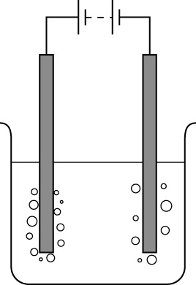
2 Label the diagram which shows the apparatus used to electrolyse a concentrated solution of sodium chloride. [F]
bubbles of
concentrated sodium
chloride solution
( )
bubbles of

3 Choose words from the list to complete the following sentences. [F]
avalanches potassium pure rock solution subsidence
Sodium chloride is mined as ________ salt and by ________ mining. Mining for salt underground can lead to ________.
4 Link the phrases on the left with those on the right putting A, B or C in the boxes on the right. (NaCl is sodium chloride.) [H]
When molten NaCl is electrolysed | A … oxygen is formed at the anode.
When very dilute aqueous NaCl is electrolysed | B … the products are chlorine and hydrogen.
When concentrated aqueous NaCl is electrolysed | C … sodium is formed at the cathode.
5 Complete these two equations for the electrode reactions that occur when a concentrated solution of sodium chloride is electrolysed. [H]
__H⁺ + __ → H₂ __Cl⁻ → __ +2e⁻

Depletion of the ozone layer
1 Solve the clues across. The shaded column gives a property of CFCs. [F]
1
2
3
4
5
1 One of the elements present in CFCs.
2 CFCs are ___________ in water.
3 CFCs used to be used as ____________ for cooling and freezing.
4 These are safe alternatives to CFCs.
5 Increased levels of ultraviolet light can lead to these eye problems.
2 Fill in the gaps in the following sentence. [F]
Ozone is a form of _______ that has a molecule with the formula ___.
3 Put these statements about the depletion of ozone in the correct order. [H]
1 chlorine free radicals are reformed again
2 CFCs rise into the stratosphere
3 CFCs escape when refrigerators are broken up
4 CFCs break down and chlorine free radical are formed
5 ultraviolet light reacts with the CFCs
6 chlorine free radicals react with ozone and destroy it
The correct order is __________.
4 True or false? Put T or F in the boxes. [H]
CFCs provide the large number of Cl atoms needed to deplete ozone.
Every country in the world has banned CFCs.
CFCs will continue to deplete the ozone layer after their use has been banned.
Scientists were originally enthusiastic about the use of CFCs.
5 Use the phrases to construct a sentence that describes the reaction Cl₂ → 2Cl• [H]
a covalent bond an ionic bond breaks evenly breaks unevenly
to form free radicals to form ions to form molecules
________________________________________________________

Hardness of water
1 Solve the clues across. The shaded column gives the name for a foamy substance formed when soap is shaken with soft water. [F]
1
2
3
4
5
6
1 Detergents can be _________ or soapy.
2 One of the ions that causes hard water.
3 The type of water hardness destroyed by boiling.
4 Water that does not readily form a lather with soap is called ______ water.
5 Hardness in water can be removed by passing the water through an ion __________ column.
6 Washing soda is sodium ______________.
2 Complete these word equations for (a) the formation of temporarily hard water and
(b) the decomposition of calcium hydrogencarbonate. [F]
(a) calcium carbonate + ______________ + water → ______________
(b) calcium hydrogencarbonate → ______________ + ______________ + water
3 Link the phrases on the left with those on the right putting A, B, C or D in the boxes on the right. (NaCl is sodium chloride.) [F]
Temporary hardness is caused by | A calcium carbonate
Permanent hardness is caused by | B dissolved carbon dioxide
Naturally acidic water is caused by | C dissolved calcium hydrogencarbonate
Limescale is | D dissolved calcium sulfate
4 Choose words from the list to complete the following sentences. [H]
calcium fixed to hard released from sodium softened zinc
When a column of ion exchange resin softens water, the _____ ions in the water displace _____ ions from the resin. The calcium ions are _____ the resin so are removed while the _____ water flows from the bottom of the column.
5 Balance this equation for the reaction of a weak acid with calcium carbonate. [H]
CaCO₃ + __CH₃CO₂H → Ca(CH₃CO₂)₂ + ___ + ___

Natural fats and oils
1 Solve the clues across. The shaded column gives the natural state of fats. [F]
1
2
3
4
5
1 This is formed by the reaction of sodium hydroxide with vegetable oil.
2 Milk is an ______ in water emulsion.
3 One liquid finely dispersed in another.
4 Fuel made from vegetable oil.
5 The state of oils at room temperature.
2 True or false? Put T or F in the boxes. [F]
Unsaturated fats decolourise bromine water.
Animal and vegetable fats are alcohols.
Unsaturated fats contain only single bonds.
Vegetable oil is immiscible with water.
3 Use words from the list to write word equations for the manufacture of (a) margarine and (b) soap. [F]
catalyst glycerol hydrogen margarine saturated fat soap
sodium hydroxide unsaturated oil
(a) ________________________________________________
(b) ________________________________________________
4 State the name of the type of chemical reaction involved in [H]
(a) margarine manufacture: ____________.
(b) soap making: ___________________.
5 Complete these sentences by filling in the gaps. [H]
Fats and oils can be saturated or unsaturated. Vegetable oils are usually ____________ while animal fats are ____________. Bromine water will remain ____________ when shaken with saturated fat but is ____________ when shaken with unsaturated fats.

Analgesics
1 Solve the clues across. The shaded column gives the name of a painkiller. [F]
1
2
3
4
5
6
7
1 Scientific word for a painkiller.
2 A substance made in the laboratory is said to be made s_______________.
3 A beneficial effect of aspirin is to lower the body ______________.
4 Aspirin was originally extracted from the bark of this tree.
5 The brand name of a common painkiller.
6 A person who dispenses drugs.
7 Aspirin ________ the blood to reduce the risk of clotting.
2 The displayed formula for aspirin is shown below. [F]
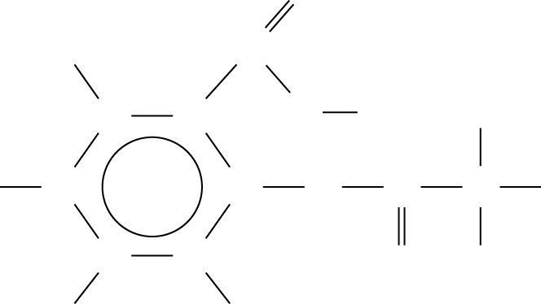
(a) Name the elements present in aspirin
______________
O
O
O
O
H
H
H
H
H
H
H
H
C
C
C
C
C
C
C
C
C
(b) Write the molecular formula for aspirin
______________

3 Put these statements about the synthesis of aspirin in the correct order. [H]
1 Leave the mixture to cool.
2 Add the ethanoic anhydride solution to salicylic acid.
3 Separate the aspirin by crystallisation.
4 Heat the mixture to 90ºC for 20 hours.
5 Make a solution of ethanoic anhydride in methylbenzene.
The correct order is ______________
4 Choose words from the list to complete the following sentences. [H]
adults bones brain ears children grams six stomach tablets three
Aspirin should not be given to ______ because it can lead to a disease that affects the liver and ______. The normal dose of aspirin for ______ is one to ______ ______with a maximum of twelve per day. One drawback of aspirin is that it irritates the ______.

Energy transfers – fuel cells
1 Unscramble these words and phrases to give three sets of three words or phrases referring to hydrogen, oxygen and fuel cells. [F]
a fuel cell a glowing splint efficiently gives a squeaky pop
gives electrical energy hydrogen oxygen relights with a lighted splint
(a) hydrogen – gives a squeaky pop – with a lighted splint
(b) oxygen – relights – a glowing splint
(c) a fuel cell – gives electrical energy – efficiently
2 Give the word equation for the overall reaction in a fuel cell. [F]
hydrogen + oxygen → water
3 True or false? Put T or F in the boxes. [F]
The reaction between hydrogen and oxygen is endothermic. | F
The energy produced in a fuel cell creates a potential difference. | T
Fuel cells do not pollute the environment. | T
Fuel cells are not as efficient as conventional methods of generating electricity. | F
4 On the energy level diagram below write: [H]
- 2H₂ + O₂
- 2H₂O
- energy released.
2H₂ + O₂
2H₂O
energy released
Course of reaction
Energy kJ/mol

5 Look at these equations. Which one represents the reaction that occurs in a fuel cell [H]
A O₂ + 4H⁺ + 4e⁻ → 2H₂O B H₂ → 2H⁺ + 2e⁻
C 4OH⁻ → 2H₂O + O₂ + 4e⁻ D CH₄ + 2O₂ → CO₂ + 2H₂O
(a) at the negative pole? A (b) at the positive pole? B.
6 Complete the overall equation for the reaction in a fuel cell. [H]
2H₂ + O₂ → 2H₂O

Redox reactions
1 Solve the clues across. The shaded column gives the name of a substance that prevents iron from rusting. [F]
 |  |  |  |  |  |  |  |  |  | 1 | P | L | A | T | E
 |  |  |  |  |  |  |  |  | 2 | G | A | L | V | A | N | I | S | I | N | G
 |  |  |  |  |  | 3 | S | A | C | R | I | F | I | C | I | A | L
4 | D | I | S | P | L | A | C | E | M | E | N | T
 |  |  |  |  | 5 | H | y | D | R | A | T | E | D
1 Tin _______ protects iron from rusting.
2 Protecting iron with a coat of zinc is called _______.
3 S_________ protection is when a more reactive metal protects a less reactive one from corrosion.
4 A type of reaction where one atom replaces another in a compound.
5 Rust is a form of __________ iron(III) oxide.
2 Put the following metals in their correct order of reactivity. [F]
iron magnesium tin zinc
The order is (starting from the most reactive) magnesium – zinc – iron – tin.
3 Complete these word equations for the reactions between metals and their solutions. [F]
magnesium + tin chloride → magnesium chloride + tin.
zinc + iron(II) sulfate → iron + zinc sulfate.
4 Select words from the list to complete the following sentence. [H]
displacement electrons gains loses neutrons redox
Rusting is a redox reaction because the iron loses electrons and oxygen gains electrons.
5 Do the following half equations represent oxidation or reduction? Put O or R in the boxes. [H]
Fe → Fe²⁺ + 2e⁻ | O
Fe³⁺ + e⁻ → Fe²⁺ | R
2H⁺ + 2e⁻ → H₂ | R
6 Copper is below magnesium in the reactivity series. Write a symbol equation for a reaction that occurs between two of the following chemicals. [H]
Cu; CuSO₄; Mg; MgSO₄
Mg + CuSO₄ → MgSO₄ + Cu

Alcohols
1 Which of the following are the correct conditions for fermentation to make ethanol.
Put a tick or cross in the boxes. [F]
Temperature of 70 °C | ✗ | Presence of oxygen | ✗
Presence of yeast | ✓ | Presence of water | ✓
2 What type of chemical reactions are the following [F]
ethene → ethanol the type of reaction is hydration.
ethanol → ethane the type of reaction is dehydration.
3 The displayed formula for ethanol is shown below. Write the molecular formula for ethanol. [F]
H H
│ │
H – C – C – O – H molecular formula is C₂H₅OH/C₂H₆O
│ │
H H
4 From the list below, chose the correct catalyst for reactions (a), (b) and (c). [F]
aluminium oxide enzymes in yeast iron nickel phosphoric acid
(a) ethene + water → ethanol catalyst is phosphoric acid.
(b) ethanol → ethene + water catalyst is aluminium oxide.
(c) glucose → ethanol + carbon dioxide catalyst is enzymes in yeast.
5 Complete these symbol equations. [H]
C₆H₁₂O₆ → 6CO₂ + 2C₂H₅OH
C₂H₄ + H₂O → C₂C₅OH
6 Complete the following sentences: [H]
In fermentation, if the temperature is too low, the yeast is inactive but if the temperature is too high the enzymes in the yeast are denatured.
7 Which one of the following is the correct general formula for an alcohol. Tick one box. [H]
C_{n}H_{2n+2} | ✗ | C_{n}H_{2n+1}CO₂H | ✗
C_{n}H_{2n}O | ✗ | C_{n}H_{2n+1}OH | ✓

Chemistry of sodium chloride
1 Solve the clues across. The shaded column gives one of the elements present in salt. [F]
 |  |  |  |  |  | 1 | S | O | L | V | E | N | T | S
 |  |  |  |  | 2 | S | O | A | P
 |  |  |  | 3 | H | Y | D | R | O | X | I | D | E
 | 4 | C | H | L | O | R | I | N | E
 |  | 5 | L | I | T | M | U | S
 |  |  |  |  |  | 6 | M | A | R | G | A | R | I | N | E
1 Liquids that are good at dissolving other substances.
2 A substance used to wash your hands.
3 Sodium chloride is used to make sodium ___________ (NaOH)
4 A gas produced when a concentrated solution of sodium chloride is electrolysed.
5 Chlorine bleaches moist red or blue ________ paper.
6 Hydrogen is used to manufacture this ‘spread’.
2 Label the diagram which shows the apparatus used to electrolyse a concentrated solution of sodium chloride. [F]
bubbles of
hydrogen
concentrated sodium
chloride solution
( brine )
bubbles of
chlorine
cathode
anode

3 Choose words from the list to complete the following sentences. [F]
avalanches potassium pure rock solution subsidence
Sodium chloride is mined as rock salt and by solution mining. Mining for salt underground can lead to subsidence.
4 Link the phrases on the left with those on the right putting A, B or C in the boxes on the right. (NaCl is sodium chloride.) [H]
When molten NaCl is electrolysed | A … oxygen is formed at the anode. | B
When very dilute aqueous NaCl is electrolysed | B … the products are chlorine and hydrogen. | A
When concentrated aqueous NaCl is electrolysed | C … sodium is formed at the cathode. | C
5 Complete these two equations for the electrode reactions that occur when a concentrated solution of sodium chloride is electrolysed. [H]
2H⁺ + 2e– → H₂ 2Cl⁻ → Cl₂ +2e⁻

Depletion of the ozone layer
1 Solve the clues across. The shaded column gives a property of CFCs. [F]
 | 1 | F | L | U | O | R | I | N | E
 |  |  |  |  | 2 | I | N | S | O | L | U | B | L | E
 |  |  |  |  | 3 | R | E | F | R | I | G | E | R | A | N | T | S
 |  |  | 4 | H | Y | D | R | O | C | A | R | B | O | N | S
 |  |  |  | 5 | C | A | T | A | R | A | C | T | S
1 One of the elements present in CFCs.
2 CFCs are ___________ in water.
3 CFCs used to be used as ____________ for cooling and freezing.
4 These are safe alternatives to CFCs.
5 Increased levels of ultraviolet light can lead to these eye problems.
2 Fill in the gaps in the following sentence. [F]
Ozone is a form of oxygen that has a molecule with the formula O₃.
3 Put these statements about the depletion of ozone in the correct order. [H]
1 chlorine free radicals are reformed again
2 CFCs rise into the stratosphere
3 CFCs escape when refrigerators are broken up
4 CFCs break down and chlorine free radical are formed
5 ultraviolet light reacts with the CFCs
6 chlorine free radicals react with ozone and destroy it
The correct order is 3 2 5 4 6 1.
4 True or false? Put T or F in the boxes. [H]
CFCs provide the large number of Cl atoms needed to deplete ozone. | F
Every country in the world has banned CFCs. | F
CFCs will continue to deplete the ozone layer after their use has been banned. | T
Scientists were originally enthusiastic about the use of CFCs. | T
5 Use the phrases to construct a sentence that describes the reaction Cl₂ → 2Cl• [H]
a covalent bond an ionic bond breaks evenly breaks unevenly
to form free radicals to form ions to form molecules
a covalent bond – breaks unevenly – to form free radicals

Hardness of water
1 Solve the clues across. The shaded column gives the name for a foamy substance formed when soap is shaken with soft water. [F]
 |  | 1 | S | O | A | P | L | E | S | S
 |  |  |  |  | 2 | C | A | L | C | I | U | M
 |  |  |  |  |  | 3 | T | E | M | P | O | R | A | R | Y
 |  |  |  |  |  | 4 | H | A | R | D
 |  |  |  |  |  | 5 | E | X | C | H | A | N | G | E
 |  |  |  | 6 | C | A | R | B | O | N | A | T | E
1 Detergents can be _________ or soapy.
2 One of the ions that causes hard water.
3 The type of water hardness destroyed by boiling.
4 Water that does not readily form a lather with soap is called ______ water.
5 Hardness in water can be removed by passing the water through an ion __________ column.
6 Washing soda is sodium ______________.
2 Complete these word equations for (a) the formation of temporarily hard water and
(b) the decomposition of calcium hydrogencarbonate. [F]
(a) calcium carbonate + carbon dioxide + water → calcium hydrogencarbonate
(b) calcium hydrogencarbonate → calcium carbonate + carbon dioxide + water
3 Link the phrases on the left with those on the right putting A, B, C or D in the boxes on the right. (NaCl is sodium chloride.) [F]
Temporary hardness is caused by | A calcium carbonate | C
Permanent hardness is caused by | B dissolved carbon dioxide | D
Naturally acidic water is caused by | C dissolved calcium hydrogencarbonate | B
Limescale is | D dissolved calcium sulfate | A
4 Choose words from the list to complete the following sentences. [H]
calcium fixed to hard released from sodium softened zinc
When a column of ion exchange resin softens water, the calcium ions in the water displace sodium ions from the resin. The calcium ions are fixed to the resin so are removed while the softened water flows from the bottom of the column.
5 Balance this equation for the reaction of a weak acid with calcium carbonate. [H]
CaCO₃ + 2CH₃CO₂H → Ca(CH₃CO₂)₂ + CO₂ + H₂O

Natural fats and oils
1 Solve the clues across. The shaded column gives the natural state of fats. [F]
 |  |  |  |  |  | 1 | S | O | A | P
 |  |  |  |  |  | 2 | O | I | L
 |  |  | 3 | E | M | U | L | S | I | O | N
 |  |  |  |  | 4 | B | I | O | D | I | E | S | E | L
 | 5 | L | I | Q | U | I | D
1 This is formed by the reaction of sodium hydroxide with vegetable oil.
2 Milk is an ______ in water emulsion.
3 One liquid finely dispersed in another.
4 Fuel made from vegetable oil.
5 The state of oils at room temperature.
2 True or false? Put T or F in the boxes. [F]
Unsaturated fats decolourise bromine water. | T
Animal and vegetable fats are alcohols. | F
Unsaturated fats contain only single bonds. | F
Vegetable oil is immiscible with water. | T
3 Use words from the list to write word equations for the manufacture of (a) margarine and (b) soap. [F]
catalyst glycerol hydrogen margarine saturated fat soap
sodium hydroxide unsaturated oil
catalyst
(a) unsaturated oil + hydrogen → margarine
(b) saturated fat + sodium hydroxide → soap + glycerol
4 State the name of the type of chemical reaction involved in [H]
(a) margarine manufacture: hydrogenation.
(b) soap making: saponification/hydrolysis.
5 Complete these sentences by filling in the gaps. [H]
Fats and oils can be saturated or unsaturated. Vegetable oils are usually unsaturated while animal fats are saturated. Bromine water will remain orange when shaken with saturated fat but is decolourised when shaken with unsaturated fats.

Analgesics
1 Solve the clues across. The shaded column gives the name of a painkiller. [F]
 |  |  |  |  |  |  | 1 | A | N | A | L | G | E | S | I | C
 |  |  |  |  |  |  | 2 | S | y | n | T | H | E | T | I | C | A | L | L | Y
 |  |  |  | 3 | T | E | M | P | E | R | A | T | U | R | E
 |  |  |  |  |  | 4 | W | I | L | L | O | W
 |  |  | 5 | I | B | U | P | R | O | F | E | N
6 | P | H | A | R | M | A | C | I | S | T
 |  |  |  | 7 | T | H | I | N | S
1 Scientific word for a painkiller.
2 A substance made in the laboratory is said to be made s_______________.
3 A beneficial effect of aspirin is to lower the body ______________.
4 Aspirin was originally extracted from the bark of this tree.
5 The brand name of a common painkiller.
6 A person who dispenses drugs.
7 Aspirin ________ the blood to reduce the risk of clotting.
2 The displayed formula for aspirin is shown below. [F]
O
O
O
O
H
H
H
H
H
H
H
H
C
C
C
C
C
C
C
C
C
(a) Name the elements present in aspirin
carbon hydrogen oxygen
(b) Write the molecular formula for aspirin
C₉H₈O₄

3 Put these statements about the synthesis of aspirin in the correct order. [H]
1 Leave the mixture to cool.
2 Add the ethanoic anhydride solution to salicylic acid.
3 Separate the aspirin by crystallisation.
4 Heat the mixture to 90ºC for 20 hours.
5 Make a solution of ethanoic anhydride in methylbenzene.
The correct order is 5 2 4 1 3
4 Choose words from the list to complete the following sentences. [H]
adults bones brain ears children grams six stomach tablets three
Aspirin should not be given to children because it can lead to a disease that affects the liver and brain. The normal dose of aspirin for adults is one to three tablets with a maximum of twelve per day. One drawback of aspirin is that it irritates the stomach.

