Questions
Q1.
The following cycle represents the enthalpy changes w, x, y and z, occurring when an
ionic solute, AX₂(s), dissolves in water.
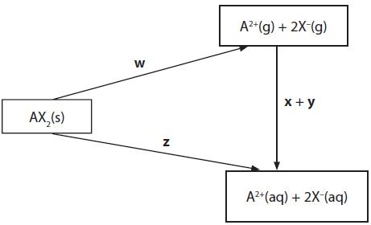
Which of the changes is the lattice energy of AX₂(s)?
A ½ w
B − w
C z
D z − x − y
(Total for question = 1 mark)

Q2.
The equation for the enthalpy of hydration for a magnesium ion is
A Mg²⁺(s) + aq → Mg²⁺(aq)
B Mg²⁺(g) + aq → Mg²⁺(aq)
C Mg²⁺(aq) → Mg²⁺(g) + aq
D Mg²⁺(aq) → Mg²⁺(s) + aq
(Total for question = 1 mark)

Q3.
Energy is evolved when one mole of gaseous calcium ions is hydrated.
This reaction is more exothermic than the corresponding value for barium ions, Ba²⁺, because the
A ionization energy of calcium is greater than that of barium.
B lattice energy of calcium oxide is more exothermic than that of barium oxide.
C solubility of calcium hydroxide in water is less than that of barium hydroxide.
D ionic radius of Ca²⁺ is less than that of Ba²⁺.
(Total for question = 1 mark)

Q4.
Which reaction has an enthalpy change equal to the enthalpy of hydration of the sodium ion?
A Na⁺(g) + excess H₂O(l) → Na⁺(aq)
B Na⁺(g) + 1 mol of H₂O(l) → Na⁺(aq)
C Na⁺(s) + excess H₂O(l) → Na⁺(aq)
D Na⁺(s) + 1 mol of H₂O(l) → Na⁺(aq)
(Total for question = 1 mark)

Q5.
This question is about the solubilty of some Group 1 halides.
(a) Potassium fluoride is a soluble, white, crystalline solid used in etching glass. A Hess cycle can be used to calculate its enthalpy of solution, using data including enthalpies of hydration of ions.
Define the term enthalpy of hydration of an ion.
(2)
.............................................................................................................................................
.............................................................................................................................................
.............................................................................................................................................
.............................................................................................................................................
.............................................................................................................................................
(b) Consider the Hess cycle below.
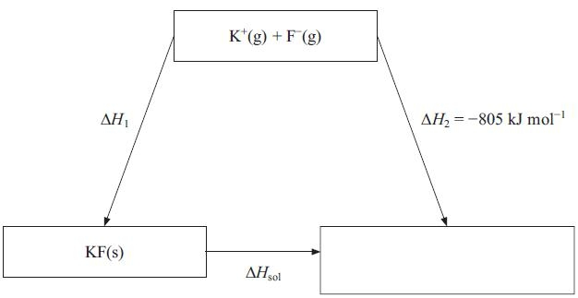
(i) Complete the cycle by filling in the empty box.
(1)
(ii) Apply Hess's Law to obtain an expression for ΔH_{sol} in terms of ΔH₁ and ΔH₂.
(1)
ΔH_{sol} =
(iii) Give the name of the energy change ΔH₁
(1)
.............................................................................................................................................
(iv) Referring to page 12 of the data booklet and your answer to (ii), calculate the standard enthalpy of solution of potassium fluoride.
(2)
(c) The standard enthalpy of solution of sodium chloride is + 3 kJ mol⁻¹.
(i) 1 g of sodium chloride was added to 250 cm³ of water in a beaker and stirred with a thermometer graduated in intervals of 1 °C. Describe and explain what would happen to the reading on the thermometer as the sodium chloride dissolves. No calculation is required.
(3)
.............................................................................................................................................
.............................................................................................................................................
.............................................................................................................................................
.............................................................................................................................................
.............................................................................................................................................
*(ii) Explain, in terms of entropy changes, why sodium chloride dissolves in water under standard conditions. No calculation is required.
(4)
.............................................................................................................................................
.............................................................................................................................................
.............................................................................................................................................
.............................................................................................................................................
.............................................................................................................................................
.............................................................................................................................................
.............................................................................................................................................
.............................................................................................................................................
.............................................................................................................................................
*(d) Lithium iodide is generally much more soluble in organic solvents than lithium chloride. Explain this observation using values of lattice energies from your data booklet and your knowledge of the trend in ionic radii down Group 7.
(4)
.............................................................................................................................................
.............................................................................................................................................
.............................................................................................................................................
.............................................................................................................................................
.............................................................................................................................................
.............................................................................................................................................
.............................................................................................................................................
.............................................................................................................................................
.............................................................................................................................................
(Total for question = 18 marks)

Q6.
(a) Crystals of hydrated cobalt(II) chloride, CoCl₂.6H₂O, lose water when they are heated, forming anhydrous cobalt(II) chloride, CoCl₂.
(i) Calculate the entropy change of the system, , at 298 K. Include a sign and units in your answer. You will need to refer to your data booklet.
(2)
(ii) Explain whether the sign of your answer to (a)(i) is as expected from the equation for the reaction.
(1)
.............................................................................................................................................
.............................................................................................................................................
.............................................................................................................................................
(iii) The standard enthalpy change for the reaction, , is +88.1kJ mol⁻¹.
Calculate the entropy change in the surroundings, , at 298 K for this reaction. Include a sign and units in your answer.
(2)
(iv) Calculate the total entropy change, , at 298 K for the reaction
(1)
(v) Does your answer to (a)(iv) indicate whether hydrated cobalt(II) chloride can be stored at 298 K without decomposition? Explain your answer.
.............................................................................................................................................
.............................................................................................................................................
.............................................................................................................................................
(b) A student attempted to measure the enthalpy change of solution of anhydrous cobalt(II) chloride by adding 2.00 g of cobalt(II) chloride to 50.0 cm³ of water in a well-insulated container. A temperature rise of 1.5 °C was recorded.
The student used a balance which reads to 0.01g, a 50.0 cm³ pipette, and a thermometer which can be read to 0.25 °C.
(i) Which measuring instrument should be changed to give a result which is closer to the accepted value? Justify your answer.
(2)
.............................................................................................................................................
.............................................................................................................................................
.............................................................................................................................................
.............................................................................................................................................
.............................................................................................................................................
.............................................................................................................................................
(ii) Suggest ONE other change the student could make to give a result which is closer to the accepted value. Justify your suggestion.
(2)
.............................................................................................................................................
.............................................................................................................................................
.............................................................................................................................................
*(c) The lattice energies of magnesium chloride, MgCl₂, calcium chloride, CaCl₂, and strontium chloride, SrCl₂ are shown in the table below.
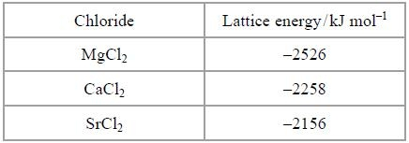
(i) Use data on ionic radii, from your data booklet, to explain the trend in these values. Estimate a value for the lattice energy of cobalt(II) chloride, giving ONE piece of data to justify your estimate.
(4)
.............................................................................................................................................
.............................................................................................................................................
.............................................................................................................................................
.............................................................................................................................................
.............................................................................................................................................
.............................................................................................................................................
.............................................................................................................................................
.............................................................................................................................................
.............................................................................................................................................
.............................................................................................................................................
(ii) Explain how lattice energy values, together with other data, can be used to predict the solubility of ionic compounds.
(3)
.............................................................................................................................................
.............................................................................................................................................
.............................................................................................................................................
.............................................................................................................................................
.............................................................................................................................................
.............................................................................................................................................
.............................................................................................................................................
.............................................................................................................................................
*(d) Cobalt forms another chloride, CoCl₃, but scientists predict that MgCl₃ cannot be made. Suggest a reason for this.
You should consider the enthalpy changes in the Born-Haber cycle, which provide evidence about why cobalt(III) chloride is known but magnesium(III) chloride is not.
(2)
.............................................................................................................................................
.............................................................................................................................................
.............................................................................................................................................
.............................................................................................................................................
.............................................................................................................................................
(Total for question = 20 marks)

