Q1.
This question is about the gas ethane, C₂H₆, and its reactions.
(a) Write the equation, including state symbols, which represents the reaction taking place when the standard enthalpy change of combustion of ethane is measured.
(2)
(b) Ethane can react with chlorine to form chloroethane and hydrogen chloride.

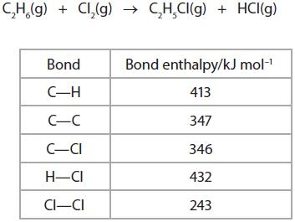
Rewrite this equation using displayed formulae.
Use the equation you have written, together with the bond enthalpy data, to calculate the enthalpy change for the reaction.
(4)

(c) This reaction takes place in a number of steps, some of which are shown below.

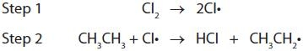

(i) State the type of reaction occurring in step 1 and the conditions needed for this step.
(2)
Type
.............................................................................................................................................
Conditions
.............................................................................................................................................

(ii) Complete the equation below for the third step of the reaction, and show the movement of electrons using the appropriate arrows.
(3)

(iii) Write equations for two termination steps in this reaction.
(2)
(d) Ethane can be cracked in industry. Write an equation for the cracking of ethane.

(1)

(e) Suggest two reasons why cracking of larger alkane molecules is important in industry.
(2)
Reason 1:
.............................................................................................................................................
.............................................................................................................................................
Reason 2:
.............................................................................................................................................
.............................................................................................................................................

(Total for question = 16 marks)

Q6.
Propanone, C₃H₆O, undergoes complete combustion to form carbon dioxide and water.

(a) In an experiment to calculate the enthalpy change of combustion for propanone,
2.90 g of propanone was burned completely in oxygen.
The heat energy from this combustion raised the temperature of 200 g of water from
20.2 °C to 78.4 °C.
The specific heat capacity of water is 4.18 J g⁻¹°C⁻¹.

(i) Calculate the number of moles of propanone present in 2.90 g.
[The molar mass of propanone is 58 g mol⁻¹.]
(1)
(ii) Use the expression

to calculate the heat energy transferred to raise the temperature of 200 g of water
from 20.2 °C to 78.4 °C.
(2)
(iii) Use your answers to (a)(i) and (ii) to calculate a value for the enthalpy change
of combustion of propanone. Give your answer to three significant figures and
include a sign and units.
(3)

(b) In another experiment, the enthalpy change of combustion for butanone, C₄H₈O, was
found to be −1300 kJ mol⁻¹.
A Data Book value for the standard enthalpy change of combustion for butanone is
−2440 kJ mol⁻¹.

(i) Suggest a reason why the value obtained in the experiment is so different from
the Data Book value.
(1)
.............................................................................................................................................

(ii) This Data Book value (−2440 kJ mol⁻¹) refers to the following equation.

How would the value be different if it referred to the formation of water in the
gaseous state? Justify your answer.
(2)
Difference
.............................................................................................................................................
Justification
.............................................................................................................................................
.............................................................................................................................................
.............................................................................................................................................
.............................................................................................................................................

(c) Standard enthalpy changes of combustion can be used to calculate the standard
enthalpy change of formation of a compound.

(i) Define the term standard enthalpy change of formation, making clear the
meaning of standard in this context.
(3)
.............................................................................................................................................
.............................................................................................................................................
.............................................................................................................................................
.............................................................................................................................................
.............................................................................................................................................

(ii) Use the standard enthalpy changes of combustion, ΔH_{c}, given in the table
below to find the standard enthalpy change of formation for ethanoic acid,
CH₃COOH, in kJ mol⁻¹.

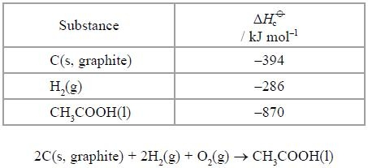
(3)
(Total for question = 15 marks)

Q8.
(a) State the general formula of the alkanes, using the letter n to denote the number of carbon atoms in each molecule.
(1)
(b) Alkanes are used as fuels. In the petrochemical industry, useful hydrocarbons are
often produced from longer chain molecules.
Name the type of reaction shown below.

(i)
(1)
Type of reaction ....................................

(ii) 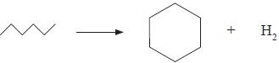
(1)
Type of reaction ....................................

(c) By what type of formula are the organic molecules in (b) represented?
(1)
...........................................................................................................................................................................

(d) Another reaction carried out in industry can be represented as shown below.
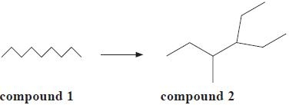
(i) Give the molecular formula of compound 2.

(1)
...........................................................................................................................................................................

(ii) Give the name of compound 2.
(1)
...........................................................................................................................................................................

(e) An equation for the reaction between methane and chlorine is:

The reaction occurs in the presence of ultraviolet (UV) light via a free-radical chain
mechanism.
The initiation step is Cl₂ → 2Cl
The next step could be

(i) Use the following data to calculate a value for the enthalpy change for each of
the Steps, A and B.
(3)
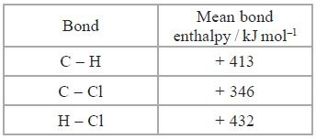

Answer ....................................... kJ mol⁻¹

Answer ....................................... kJ mol⁻¹

(ii) Use your answer to (i) to justify which of the Steps, A or B, is the more likely.
(1)
...........................................................................................................................................................................

...........................................................................................................................................................................

(f) Another halogenoalkane, bromomethane, CH₃Br, is a toxic gas used to protect plants
against insects.
Health and Safety advice states that concentrations above 5 parts per million (ppm)
by volume of this gas are harmful.
A research laboratory contains 2.5 × 10⁵ dm³ of air. Calculate the maximum volume
of bromomethane, in dm³, allowed in the laboratory to comply with the advice given.
(1)
(Total for question = 11 marks)

Q1.
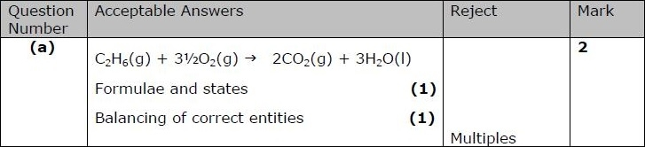
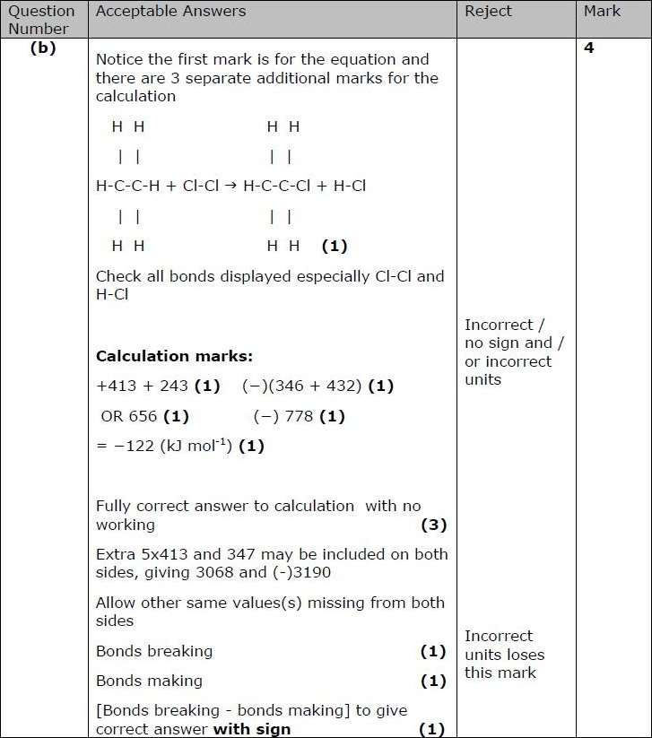
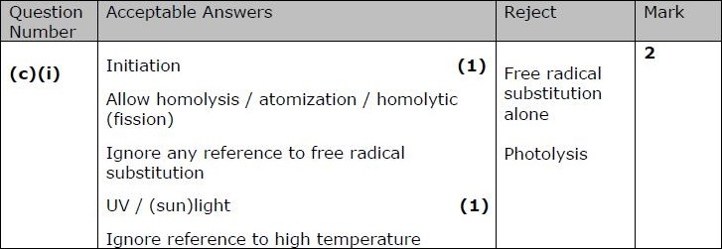
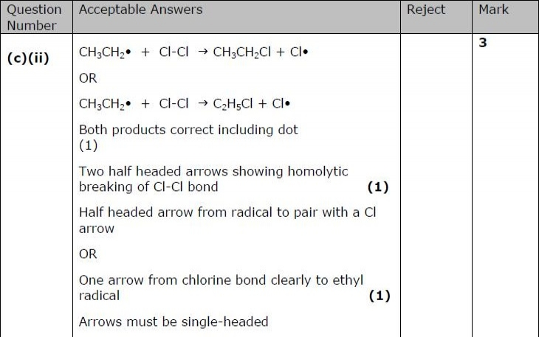
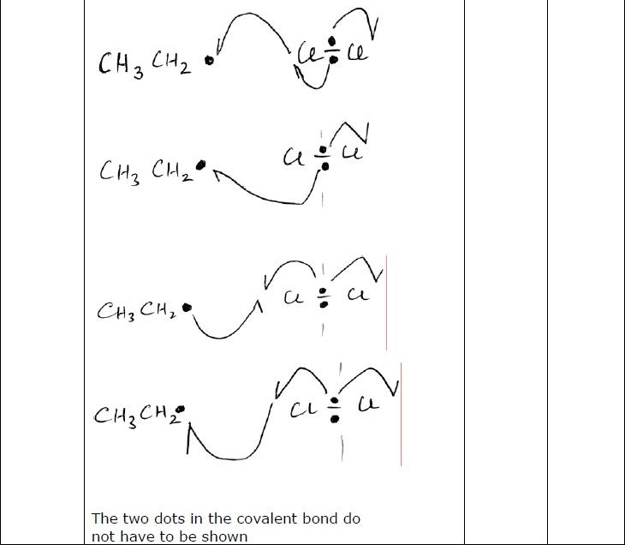
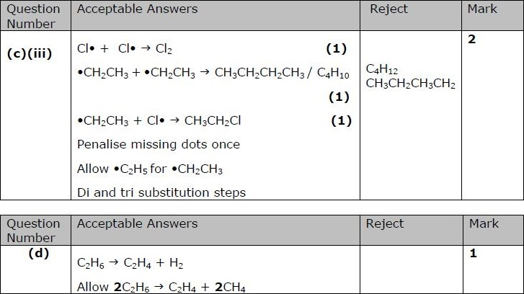
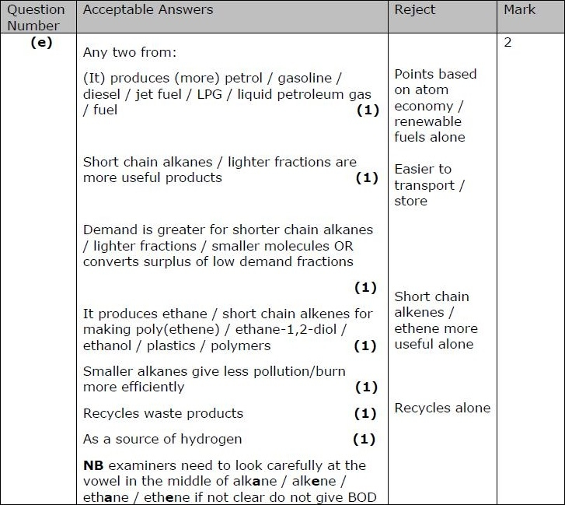

Q6.

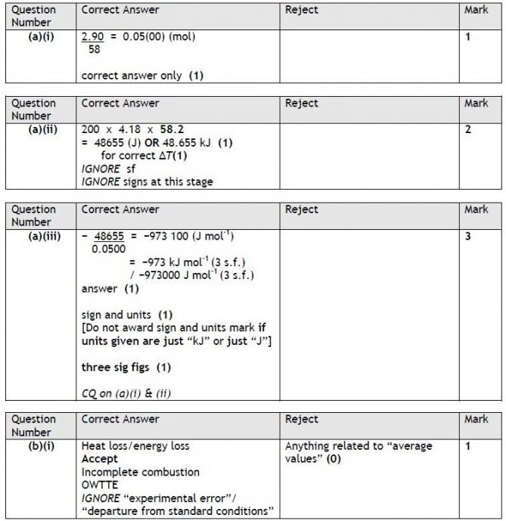
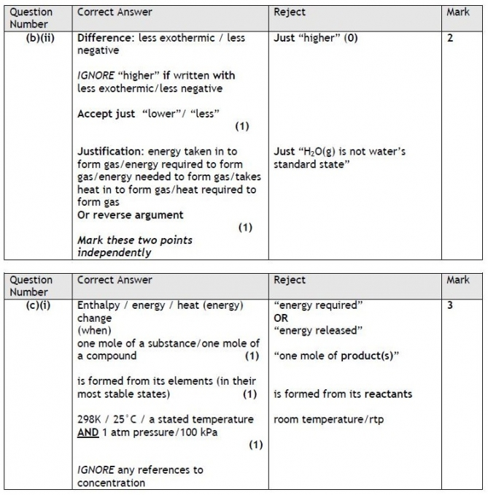
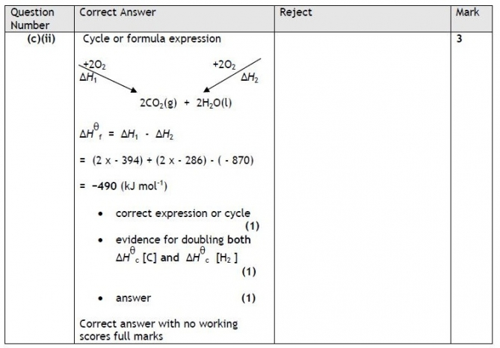

Q8.

