3. (a) (i) Enthalpy/heat change for formation of 1 mole of a
compound (1)
from its elements (1)
in their standard states / or stated temperature of 298K
(25°C) and 1 atm (or suitable unit) (1) 3
(ii) = -60.4 − (52.3−36.2) (1)
= -76.5 (Kj mol−1) (1) 2
(iii) negative sign means reaction exothermic/gives out heat (1)
if no answer given to part (ii) must give general explanation
that negative means exothermic and positive means
endothermic reaction 1
(b) Energy in = (612 + 366) = 978 (1)
Energy out = 348 + 412 + 276 = 1036 (1)
Energy change = 978 – 1036 = -58 (1) consequential
If candidates choose to include the four C-H bonds the above
figures are 2626, 2684 and -58 3
(c) Average values from many compounds used in bond
enthalpies (1)
Actual values for these compounds probably slightly different
/ or, calculation in (a) (ii) uses real / actual / experimental
/standard/ values (1)
n.b. do not accept arguments based on error 2
[11]

Old Edexcel - Unit Test 2 - June 2009

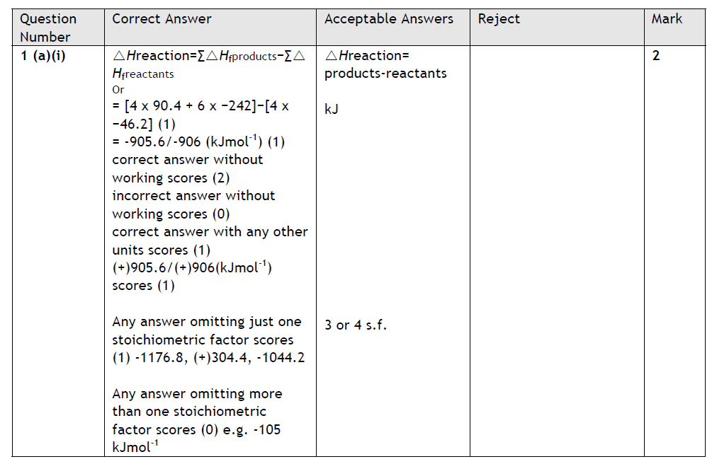

Old edexcel Unit Test 2 January 2006

Old edexcel Unit Test 2 June 2008

Old edexcel June 2006 Unit Test 2

