Questions
Q1.
Benzenecarboxylic acid (benzoic acid) and phenylmethanol (benzyl alcohol) are compounds which occur naturally and have a wide range of uses. For example, benzenecarboxylic acid is used as a food preservative and phenylmethanol is used as a solvent.
A laboratory sequence for the preparation of these two compounds is shown below.
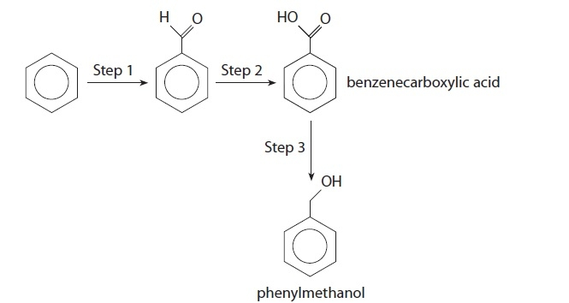
(a) In the first step of the synthesis, benzene reacts with hydrogen chloride and carbon monoxide in the presence of aluminium chloride in an electrophilic substitution called the Gattermann-Koch reaction. The hydrogen chloride and carbon monoxide together behave as if they form the unstable species methanoyl chloride (HCOCl).
(i) Explain why benzene undergoes substitution rather than addition reactions. A detailed description of the bonding in benzene is not required.
(2)
..............................................................................................................................................
..............................................................................................................................................
..............................................................................................................................................
..............................................................................................................................................

(ii) Give the mechanism for step 1, including the formation of the electrophile.
(4)
(iii) Identify the reagents and essential conditions used in the remaining steps of the sequence. You may assume that the correct reaction temperatures are being used.
(4)
Step 2
..............................................................................................................................................
..............................................................................................................................................
..............................................................................................................................................
Step 3
..............................................................................................................................................
..............................................................................................................................................
..............................................................................................................................................
*(b) Phenol reacts faster than phenylmethanol in electrophilic substitution reactions. Suggest why this is so.
(4)
..............................................................................................................................................
..............................................................................................................................................
..............................................................................................................................................
..............................................................................................................................................
..............................................................................................................................................
..............................................................................................................................................
..............................................................................................................................................
..............................................................................................................................................
(Total for question = 14 marks)

Q2.
Ibuprofen is a nonsteroidal anti-inflammatory drug (NSAID) widely used as an analgesic (pain reliever). It was discovered in the 1960s by the Boots Group which developed a six step synthesis from 2-methylpropylbenzene. The synthesis shown below was introduced in the 1990s by the BHC Company and received a Presidential Green Chemistry Challenge award in 1997. The citation noted that the synthesis has just three steps, all of which are catalytic, and an effective atom economy of 99%. Both syntheses are carried out in solution.
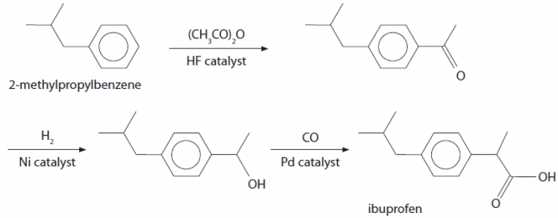
(a) (i) Suggest why a three step synthesis is likely to be 'greener' than a six step process.
(1)
.............................................................................................................................................
.............................................................................................................................................
(ii) Why does the use of catalysts make processes 'greener' (as well as faster)?
(1)
.............................................................................................................................................
.............................................................................................................................................
(b) The first step of the synthesis is an electrophilic substitution which is usually carried out in a school laboratory using ethanoyl chloride and an aluminium chloride catalyst.
(i) Write an equation showing the formation of the electrophile in the school experiment.
(1)

(ii) Give the mechanism for the electrophilic substitution of 2-methylpropylbenzene by ethanoyl chloride, using the electrophile you have given in (b)(i).
(3)
(iii) Suggest one environmental benefit of using (CH₃CO)₂O, rather than ethanoyl chloride, in the manufacture of ibuprofen.
(1)
.............................................................................................................................................
.............................................................................................................................................
.............................................................................................................................................
(c) The final stage of the modern synthesis for ibuprofen is shown below.
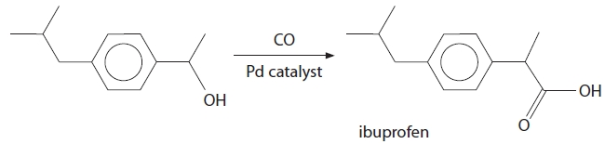
(i) Suggest a benefit of using a solid catalyst in this reaction.
(1)
.............................................................................................................................................
.............................................................................................................................................

(ii) The preparation in part (c) can be carried out in a laboratory in three reactions.
(3)
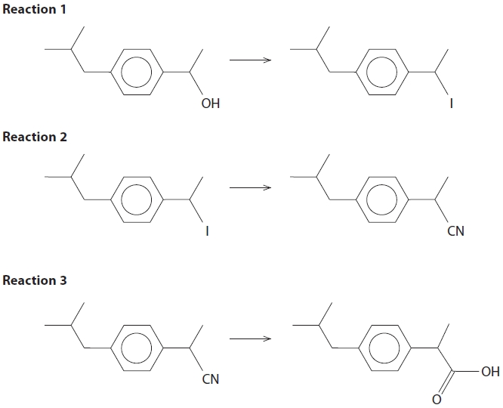
Give:
The reagents for Reaction 1
.............................................................................................................................................
.............................................................................................................................................
The reagents and conditions for Reaction 3
.............................................................................................................................................
.............................................................................................................................................
(iii) Using your Data Booklet, explain how infrared spectroscopy can be used to distinguish between the two structures shown below.
(2)
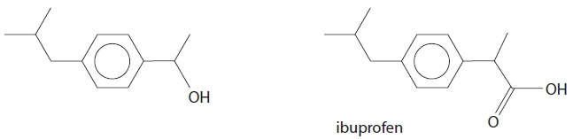
.............................................................................................................................................
.............................................................................................................................................
.............................................................................................................................................
.............................................................................................................................................
(d) Ibuprofen is a chiral molecule and only one of its enantiomers is biologically active. However, although the synthesis produces a racemic mixture, an isomerase enzyme in the body converts the inactive enantiomer into the active enantiomer.
(i) Explain the term 'chiral molecule'.
(1)
.............................................................................................................................................
.............................................................................................................................................
.............................................................................................................................................
(ii) Mark with an asterisk (*) the chiral centre on the structure of ibuprofen below.
(1)
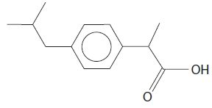

(iii) Explain the term 'racemic mixture'.
(1)
.............................................................................................................................................
.............................................................................................................................................
.............................................................................................................................................
(iv) Suggest two benefits that arise from the isomerization of the inactive enantiomer of ibuprofen.
(2)
.............................................................................................................................................
.............................................................................................................................................
.............................................................................................................................................
.............................................................................................................................................
.............................................................................................................................................
.............................................................................................................................................

(Total for question = 18 marks)

Mark Scheme
Q1.
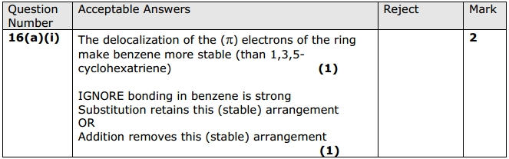
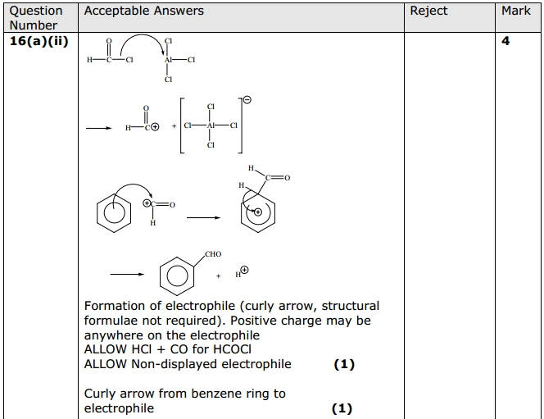
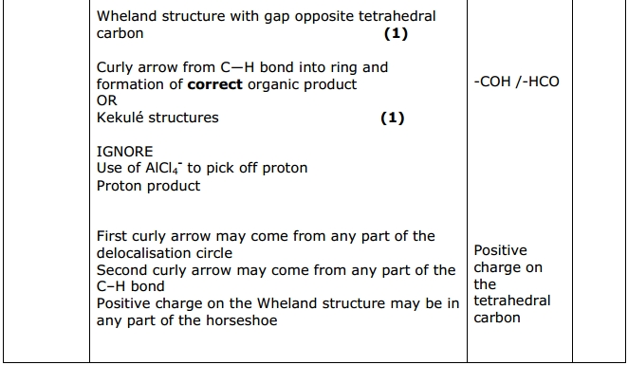
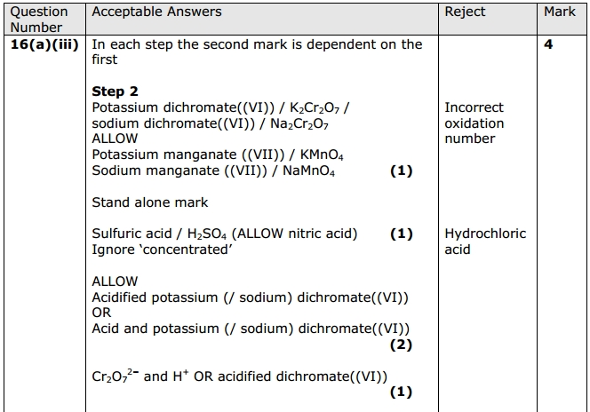
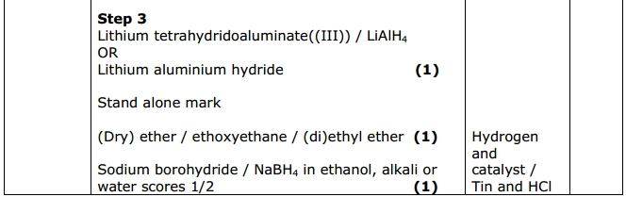
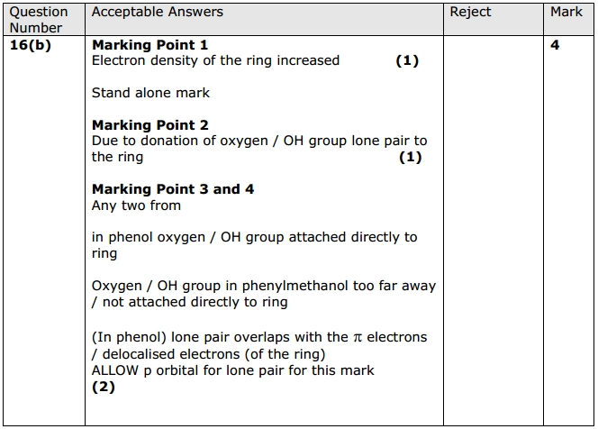

Q2.
