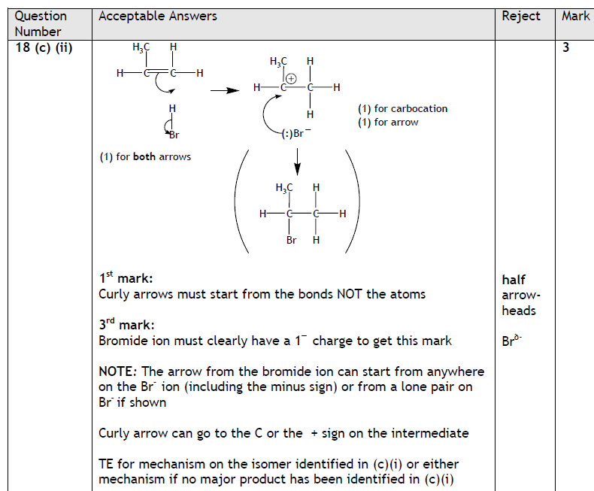
From Jan 2011n Unit 1

When teaching curly arrows please make sure students follow the method as shown in the mark scheme left:

