Q13.
The enthalpy change for the reaction to form hydrated sodium thiosulfate crystals cannot be measured directly.
The following Hess cycle can be used.
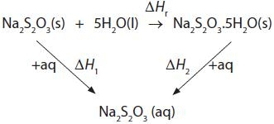

The enthalpy change for the reaction, ΔH_{r}, is equal to

A ΔH₁ + ΔH₂
B ΔH₁ − ΔH₂
C −ΔH₁ − ΔH₂
D −ΔH₁ + ΔH₂
(Total for question = 1 mark)
Q8.
Copper(II) sulfate exists as blue hydrated crystals and white anhydrous crystals. The
enthalpy changes of solution for these two substances may be represented by the
following simplified equations:
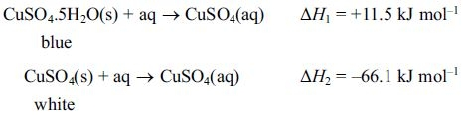
(a) (i) Fill in the box and add labelled arrows to complete the Hess cycle to enable you to calculate
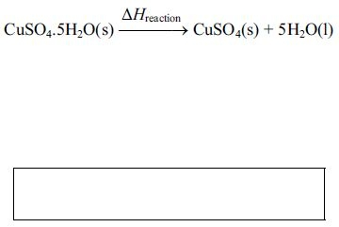
(3)

(ii) Calculate a value for the enthalpy change
(2)

(b) Suggest why it is not possible to directly measure the enthalpy change for the conversion of the blue hydrated copper(II) sulfate crystals into the white anhydrous crystals.
(1)
.............................................................................................................................................
.............................................................................................................................................
.............................................................................................................................................
.............................................................................................................................................

*(c) (i)
Describe briefly the experimental procedure that you would use to obtain the data necessary to calculate ΔH₁, given a known mass of hydrated copper(II) sulfate crystals, CuSO₄.5H₂O(s).
You should state the apparatus that you would use and any measurements that you would make.
You are not required to calculate the amounts of substances or to explain how you would use the data obtained.
(4)
.............................................................................................................................................
.............................................................................................................................................
.............................................................................................................................................
.............................................................................................................................................
.............................................................................................................................................
.............................................................................................................................................
.............................................................................................................................................
.............................................................................................................................................

(ii) The value for the enthalpy change from (c)(i) obtained by experiments in a school laboratory is likely to be significantly different from a data book value.

List three possible reasons for this which do not relate to the quality of the apparatus or chemicals used or possible mistakes in carrying out the procedure.
(3)
1
.............................................................................................................................................
.............................................................................................................................................

2
.............................................................................................................................................
.............................................................................................................................................

3
.............................................................................................................................................
.............................................................................................................................................

(Total for Question = 13 marks)

ANSWERS FOLLOW:
Q13.

Q8.
