Q11.
(a) On strong heating, calcium carbonate decomposes to calcium oxide and carbon
dioxide:
Owing to the conditions under which the reaction occurs, it is not possible to
measure the enthalpy change directly.
An indirect method employs the enthalpy changes when calcium carbonate and
calcium oxide are neutralized with hydrochloric acid.
(i) Write the equation for the reaction of calcium carbonate with hydrochloric acid.
State symbols are not required.
[ΔH₁ is the enthalpy change for this reaction]
(1)

.............................................................................................................................................................. ΔH₁

(ii) The reaction of calcium oxide with hydrochloric acid is

Use the equations in parts (i) and (ii) to complete the Hess's Law cycle below to show how you could calculate the enthalpy change for the decomposition of calcium carbonate, ΔH_{reaction}. Label the arrows in your cycle.
(3)
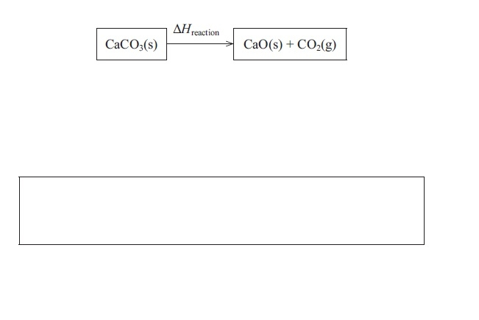

(iii) Complete the expression for ΔH_{reaction} in terms of ΔH₁ and ΔH₂ .
(1)
ΔH_{reaction} =

(b) Suggest two reasons why the value obtained by carrying out these two experiments and using the equation gives a value different to the data booklet value for the decomposition reaction of calcium carbonate.
(2)
..............................................................................................................................................
..............................................................................................................................................
..............................................................................................................................................
..............................................................................................................................................

(Total for question = 7 marks)
Q5.
The enthalpy change of combustion of ethanol was determined using the apparatus shown in the diagram below. In the experiment, the temperature increase of the water in the beaker is measured when a known mass of the ethanol is burned.
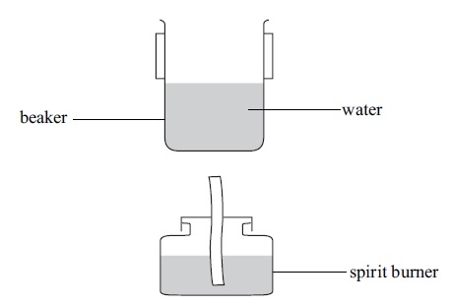
(a) The results of the experiment are summarised in the table below.
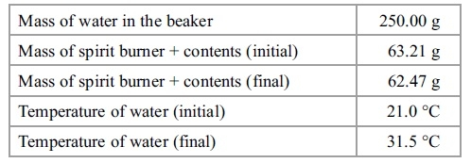

(i) Calculate the heat energy produced by the combustion of the alcohol using the equation.
heat energy produced (J) = mass of water x 4.18 x temperature change
(1)
(ii) Calculate the number of moles of ethanol burned in this experiment (the formula of ethanol is C₂H₅OH).
(3)
(iii) Use the equation below to calculate the enthalpy change of combustion of ethanol in kJ mol⁻¹. Give the value an appropriate sign.
ΔH = heat energy produced ÷ number of moles
(2)
(b) The data book value for the enthalpy change of combustion of ethanol is −1370 kJ mol⁻¹.
(i) Calculate the percentage error in the value calculated in (a)(iii) in comparison with the data book value.
(1)

(ii) List three ways in which the design of the experiment causes the results to be so different from the data book value. (You should be specific but detailed explanations are not required.)
(3)
1
.............................................................................................................................................
.............................................................................................................................................
2
.............................................................................................................................................
.............................................................................................................................................
3
.............................................................................................................................................
.............................................................................................................................................
(iii) Use the data book values for enthalpy changes of combustion given in the table below to calculate the enthalpy change of formation of ethanol.
(3)
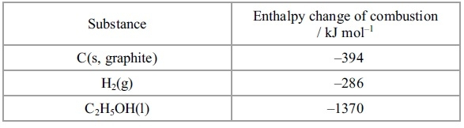

(Total for question = 13 marks)

Q11.

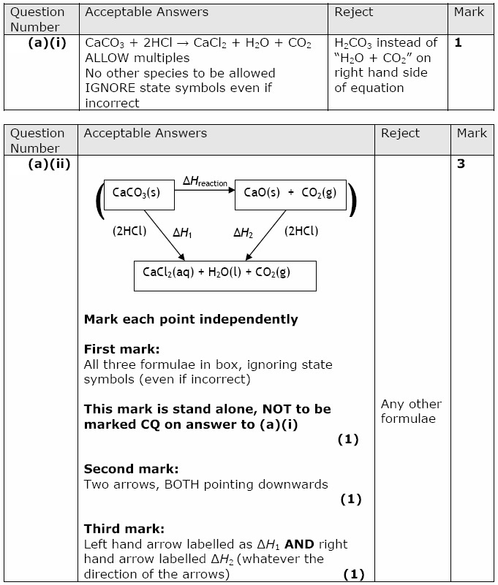
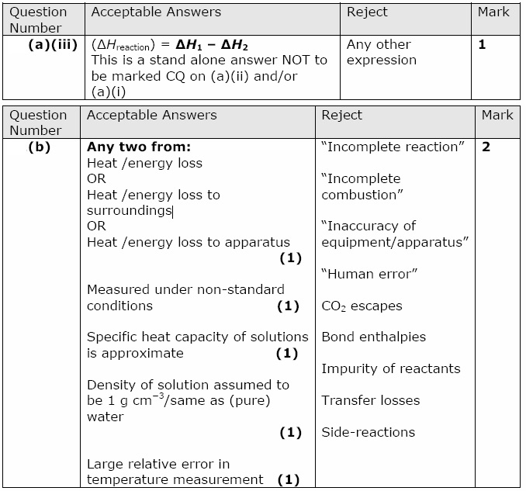

Q5.

