**3.** (a) (i) Define the term **standard enthalpy of formation**, *H*f.

..........................................................................................................................

..........................................................................................................................

..........................................................................................................................

..........................................................................................................................

(3)

(ii) The following table shows some values of standard enthalpy of formation.

|  |  |  |
| --- | --- | --- |
| Name | Formula | *H*f/kJ mol–1 |
| ethene | C2H4(g) | +52.3 |
| hydrogen bromide | HBr(g) | –36.2 |
| bromoethane | C2H5Br(g) | –60.4 |

Use the data in the table above to calculate the standard enthalpy change for the following reaction.

C2H4(g) + HBr(g)  C2H5Br(g)

(2)

(iii) State the significance of the sign of the value obtained in part (a)(ii) above.

..........................................................................................................................

..........................................................................................................................

(1)

(b) Enthalpy changes can also be calculated usingaverage bond enthalpy data.

|  |  |
| --- | --- |
| Bond | Average bond enthalpy/kJ mol–1 |
| C == C | +612 |
| C  C | +348 |
| C  H | +412 |
| C  Br | +276 |
| H Br | +366 |

Use the data in the table above to recalculate the enthalpy change for the reaction in part (a)(ii).

C2H4(g)  HBr(g)  C2H5Br(g)

(3)

(c) Suggest why the value obtained in part (b) above is likely to be less accurate than that obtained in part (a)(ii).

....................................................................................................................................

....................................................................................................................................

....................................................................................................................................

(2)

(Total 11 marks)

Old Edexcel - Unit Test 2 - June 2009

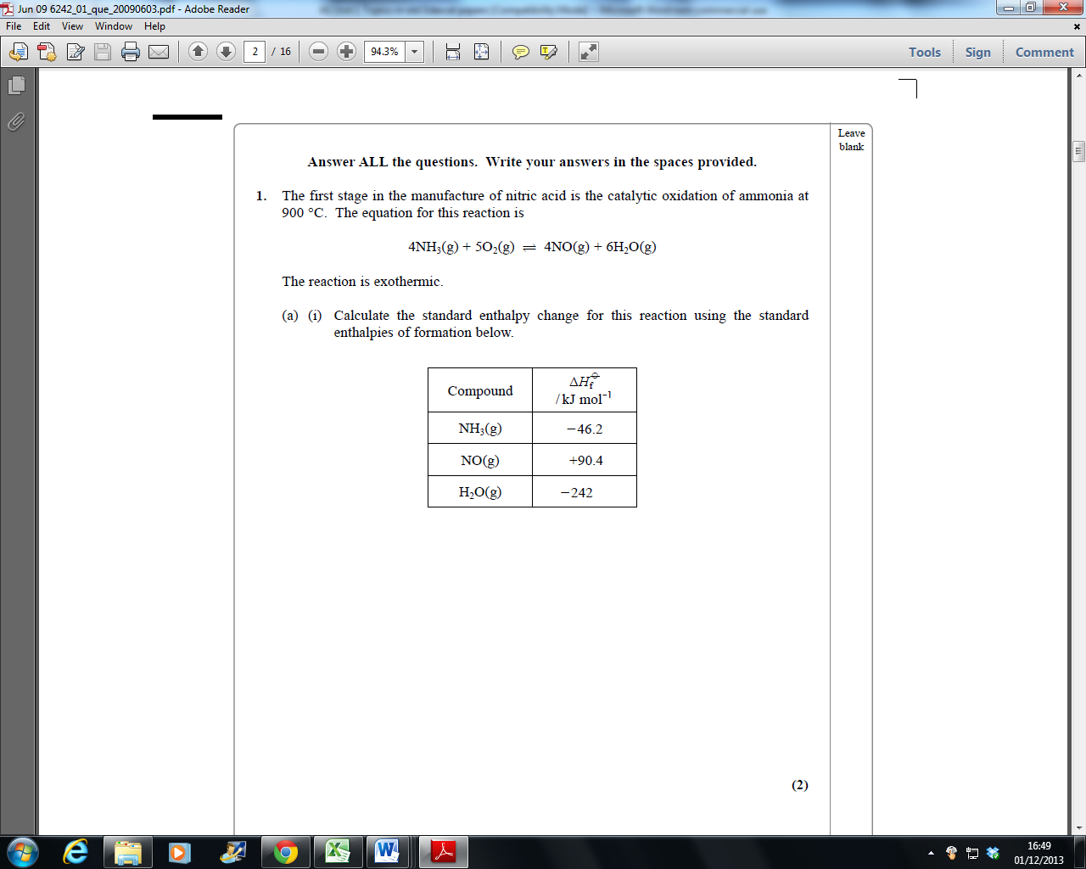

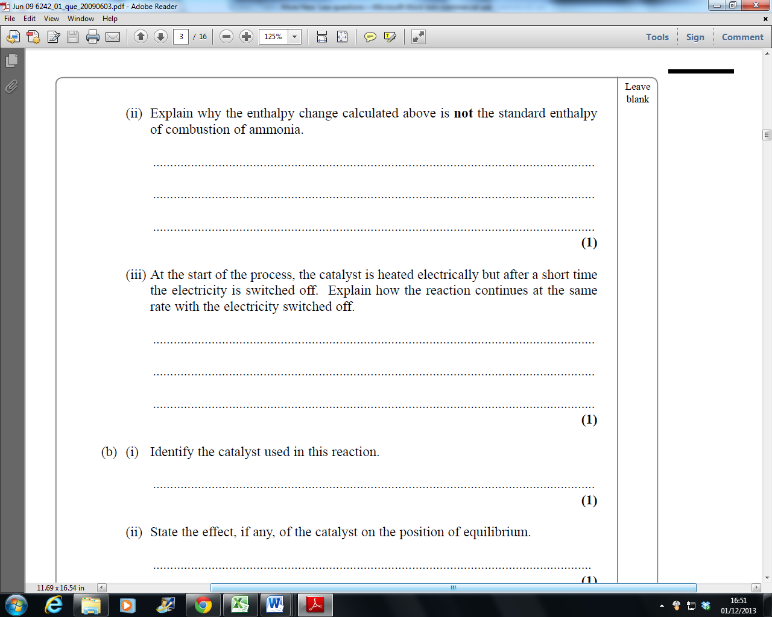

Old edexcel Unit Test 2 January 2006

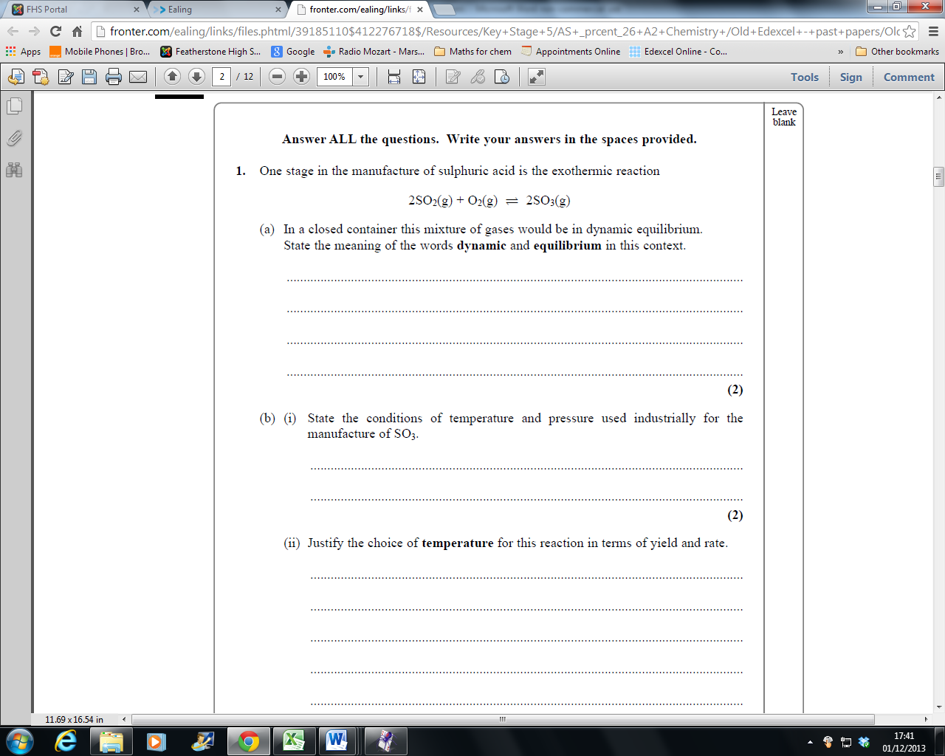

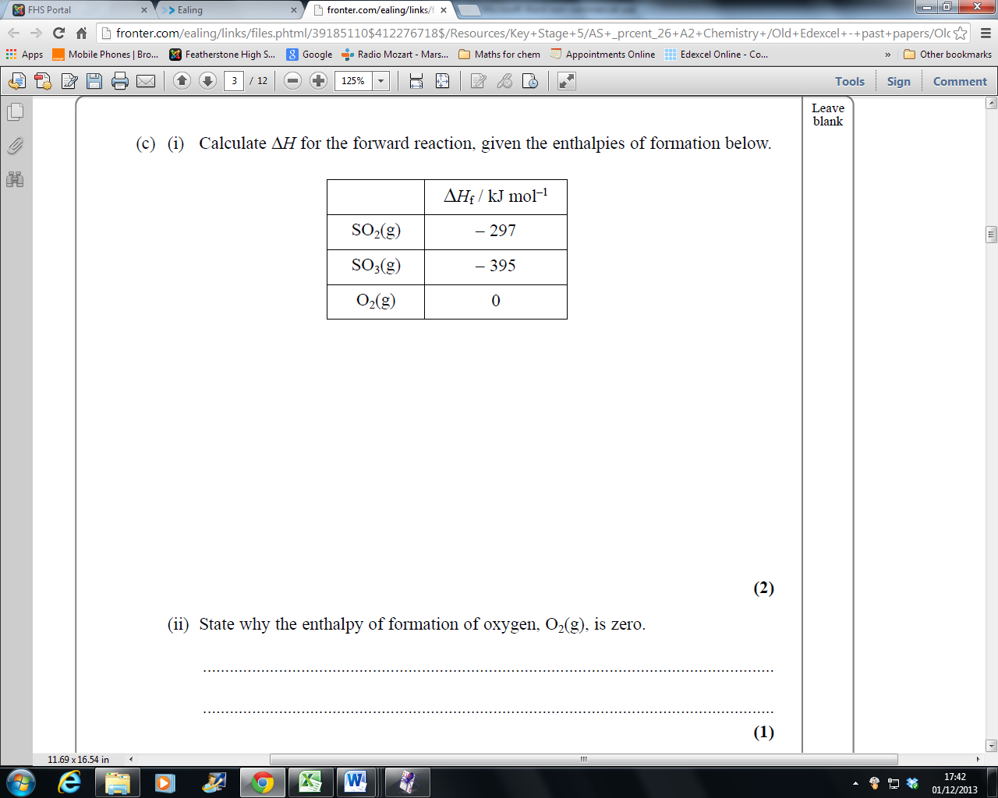

Old edexcel Unit Test 2 June 2008

Q2

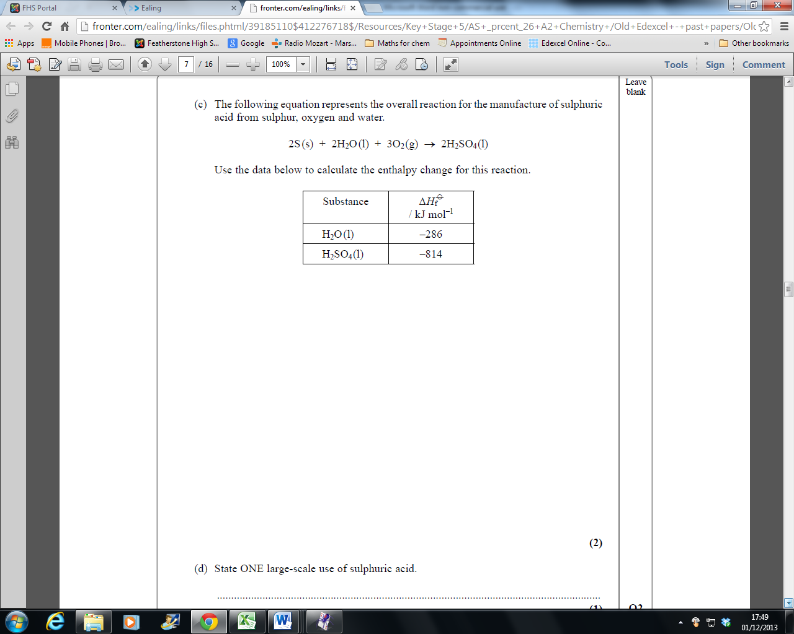

Old edexcel Unit Test 2 June 2007

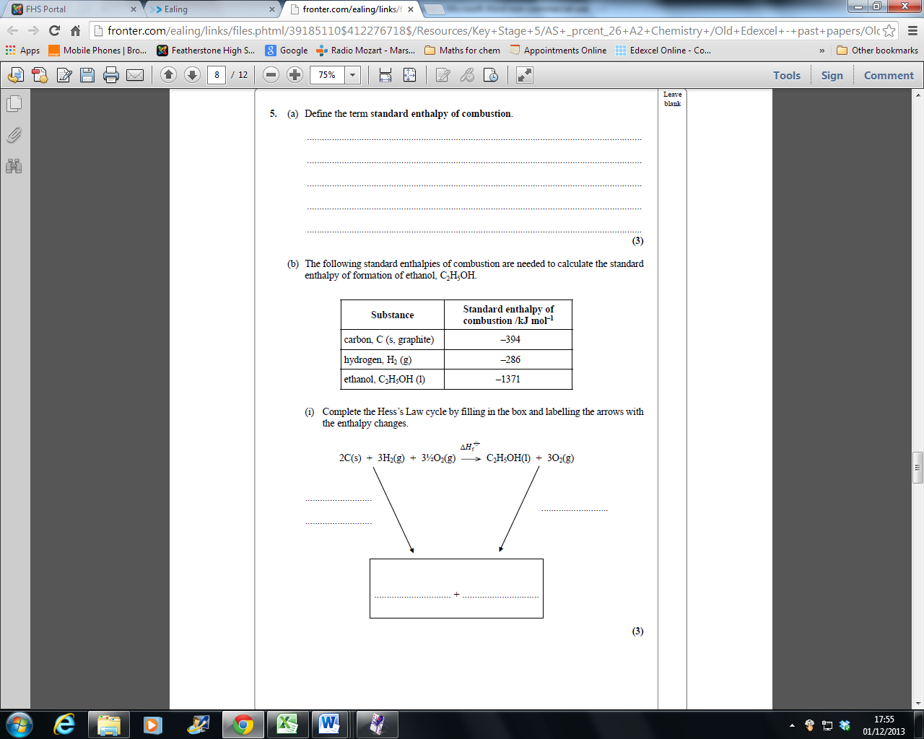

Old edexcel 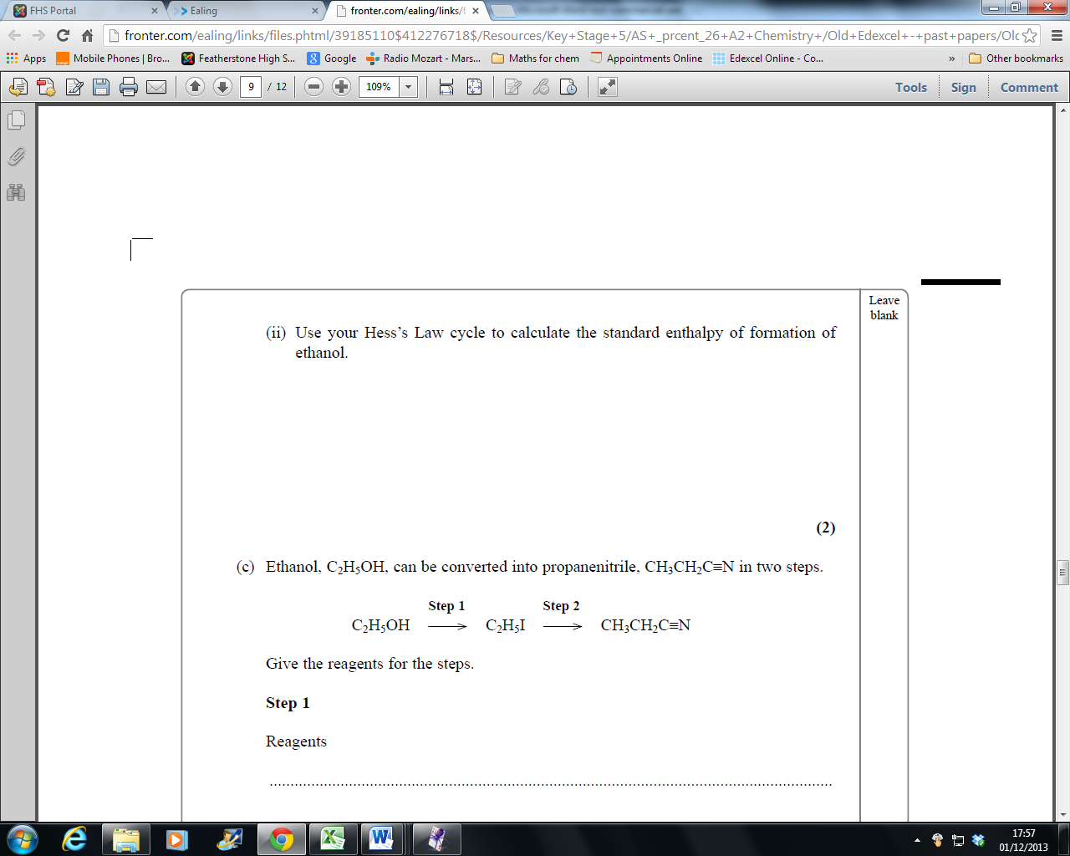 Unit Test 2 June 2006

